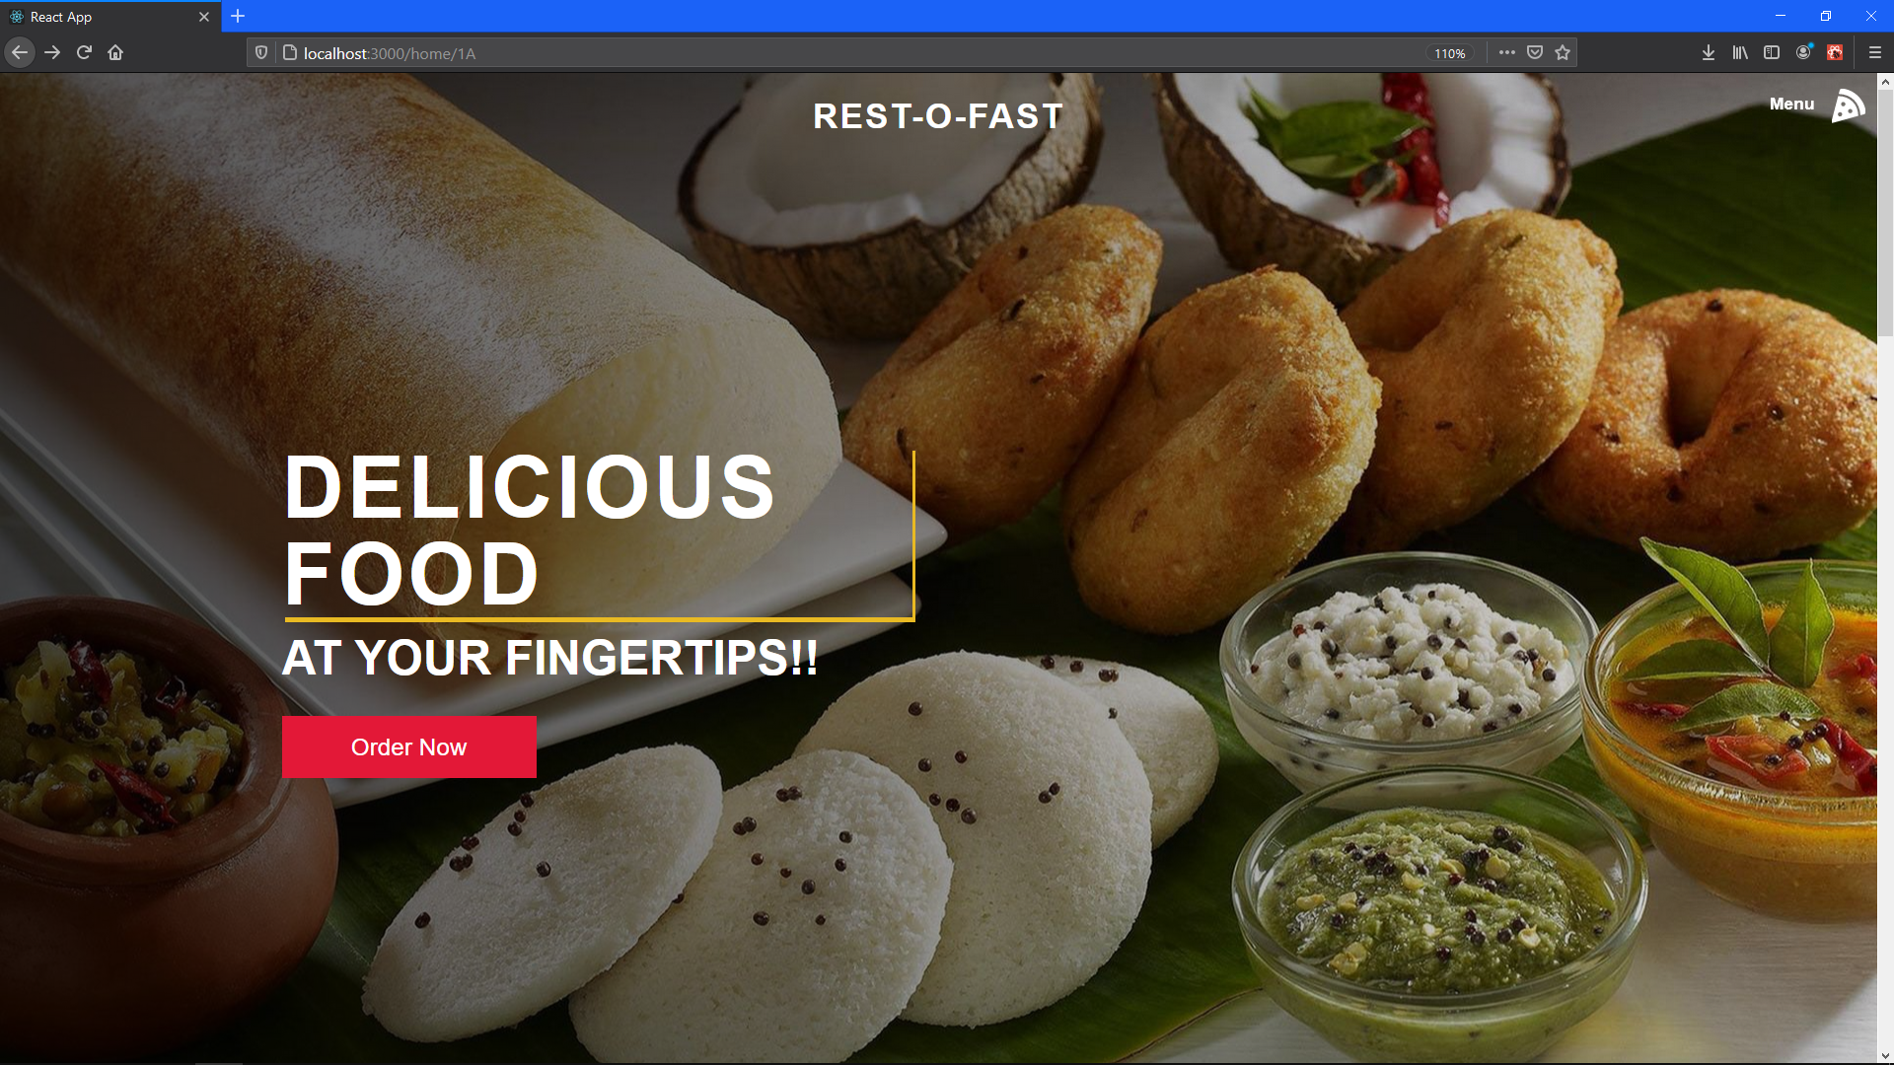

Home Page (Landing Page Notice the table number in URL field i.e., 1A.)

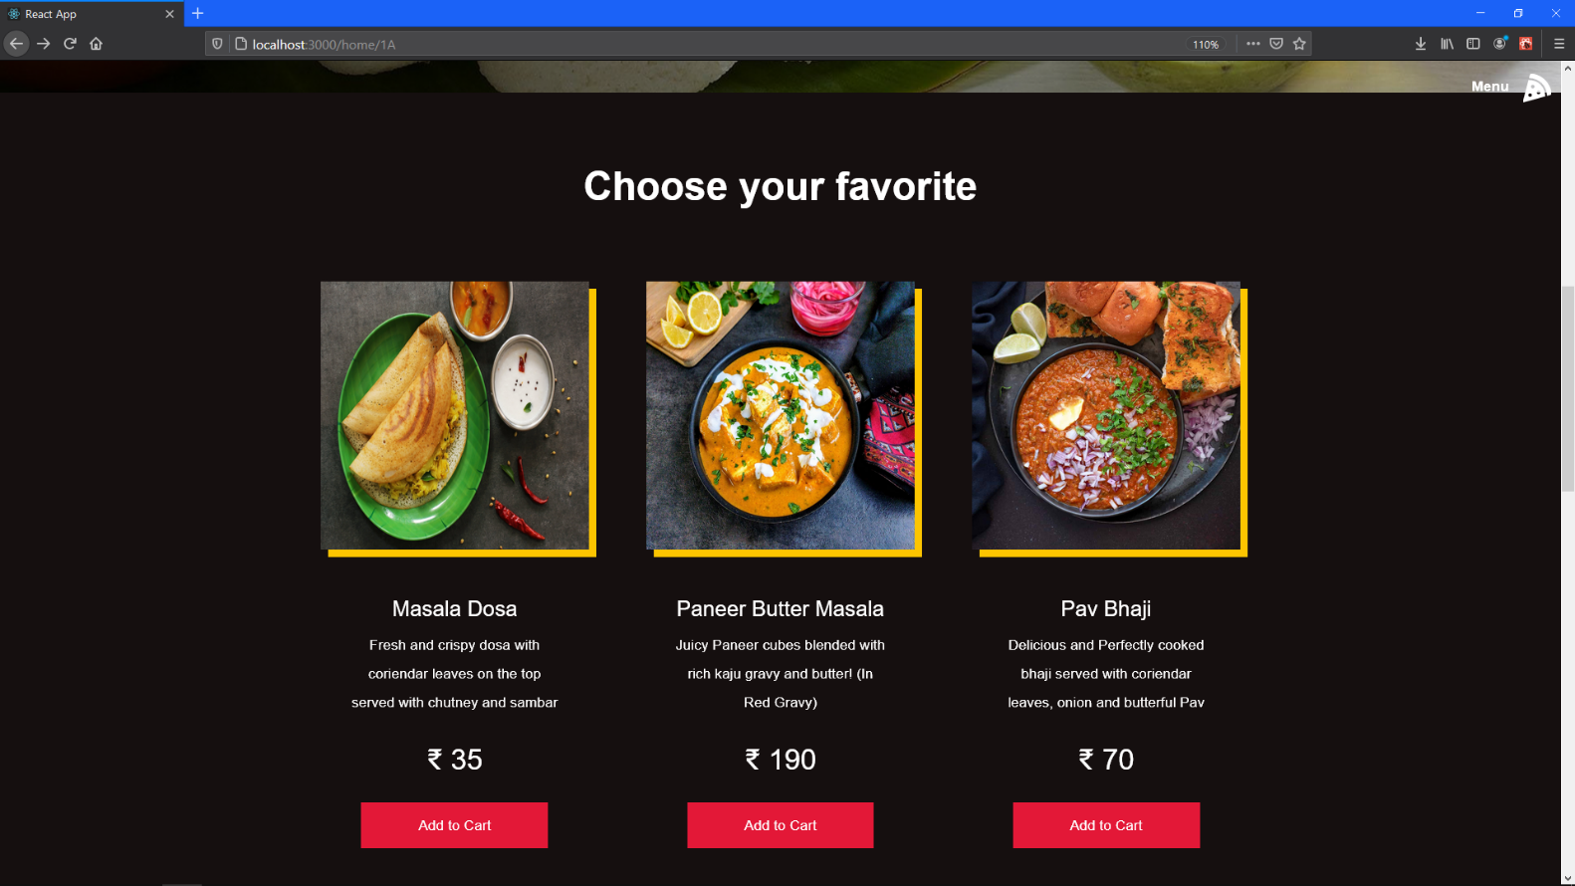

Home page product feature 1

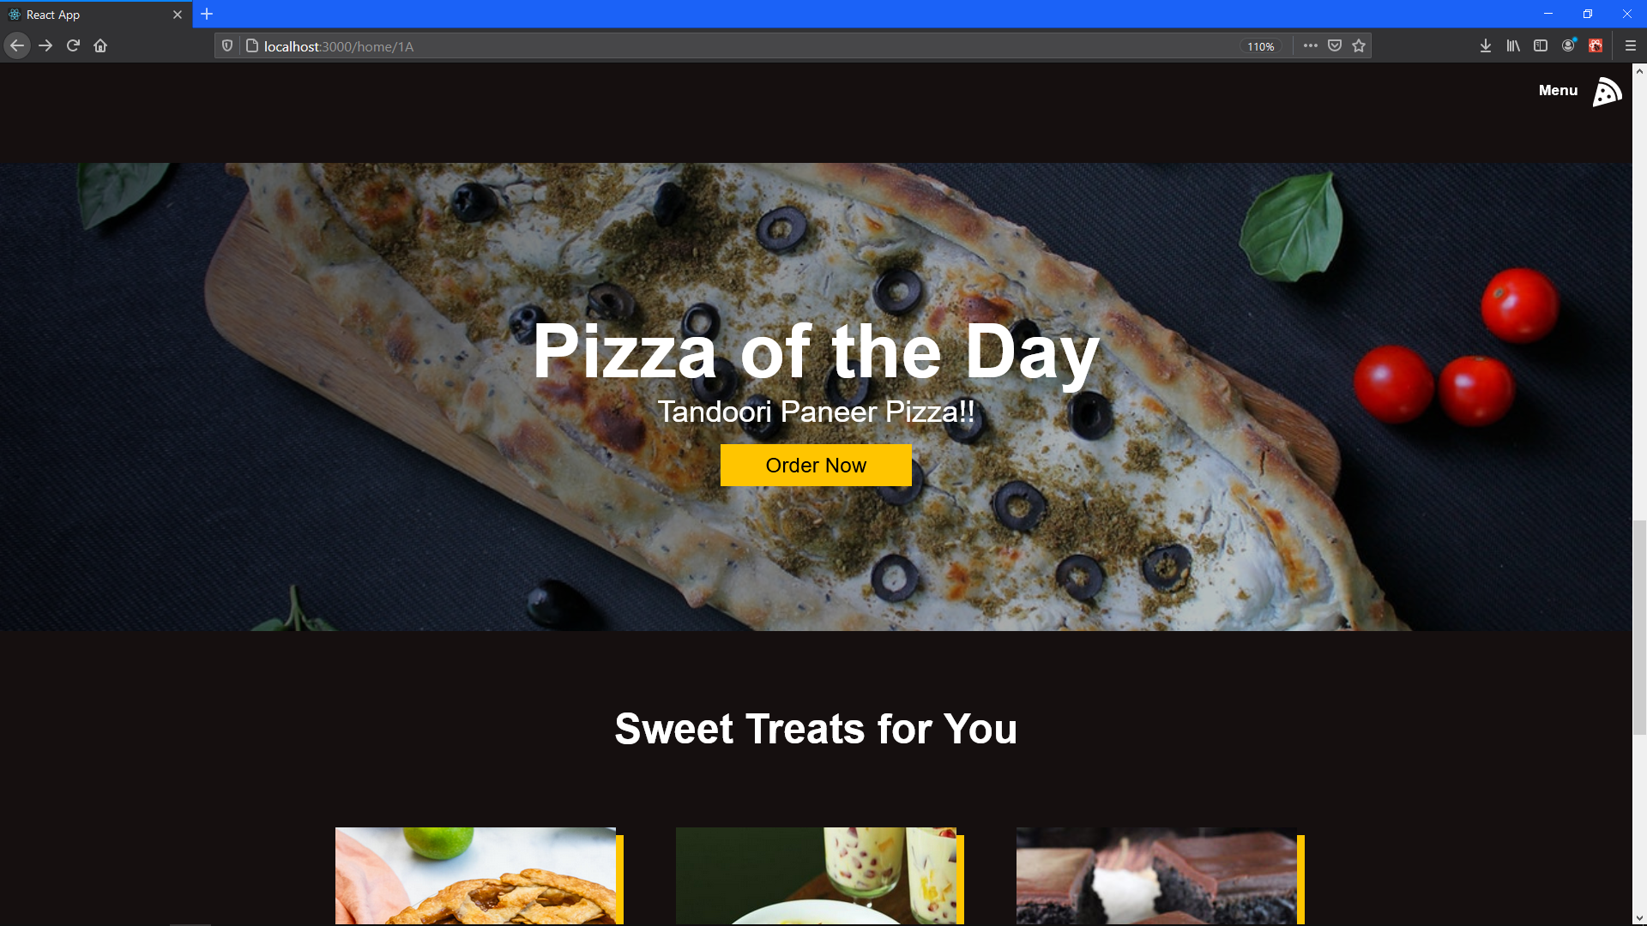

Home page product feature 2

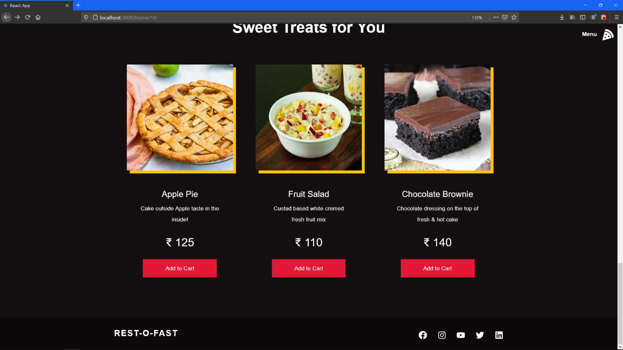

Home page product feature 3 + footer

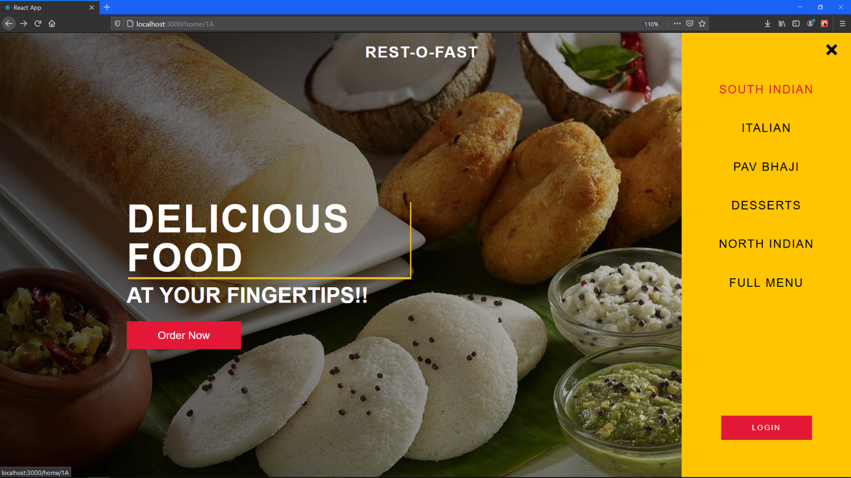

Menu Field (All the categories, full menu Notice user has not yet logged in that’s why LOGIN button is displayed.)

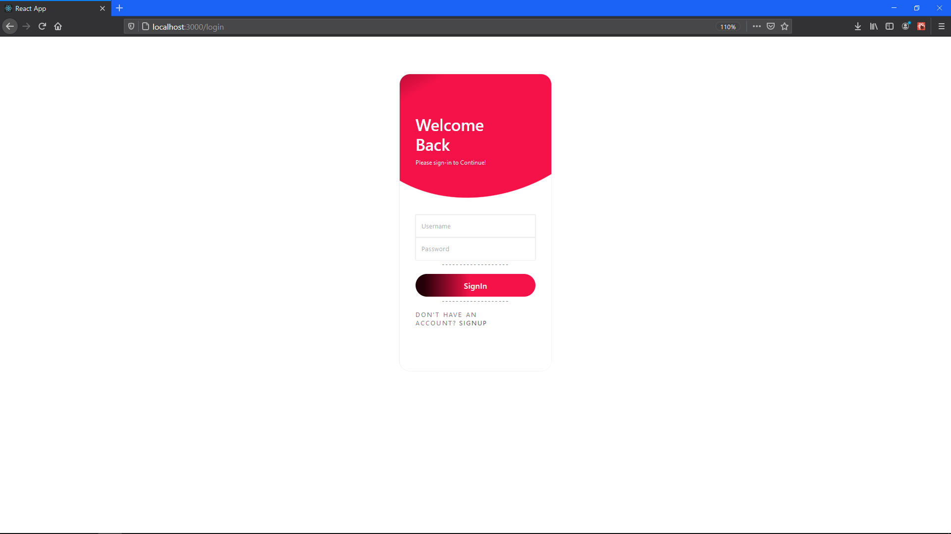

Login Screen

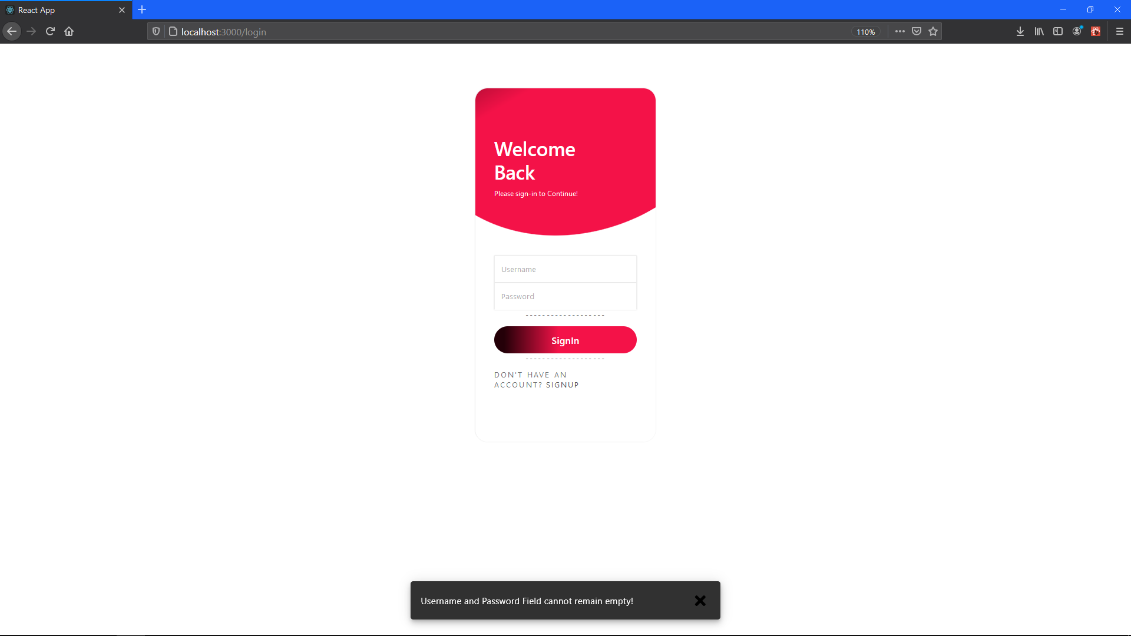

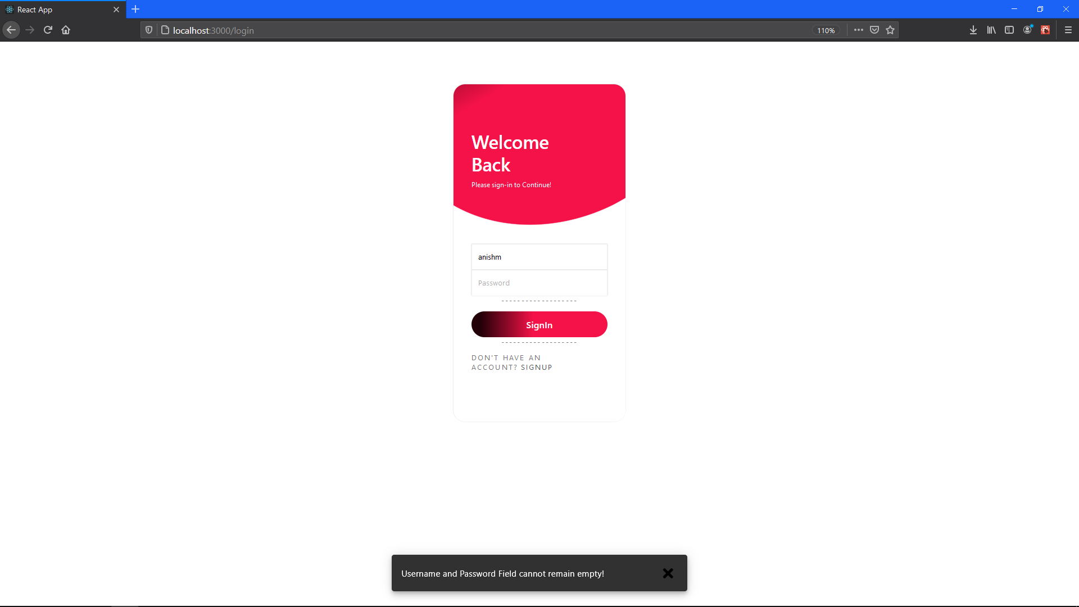Login Screen #Validation 1

Login Screen #Validation 2

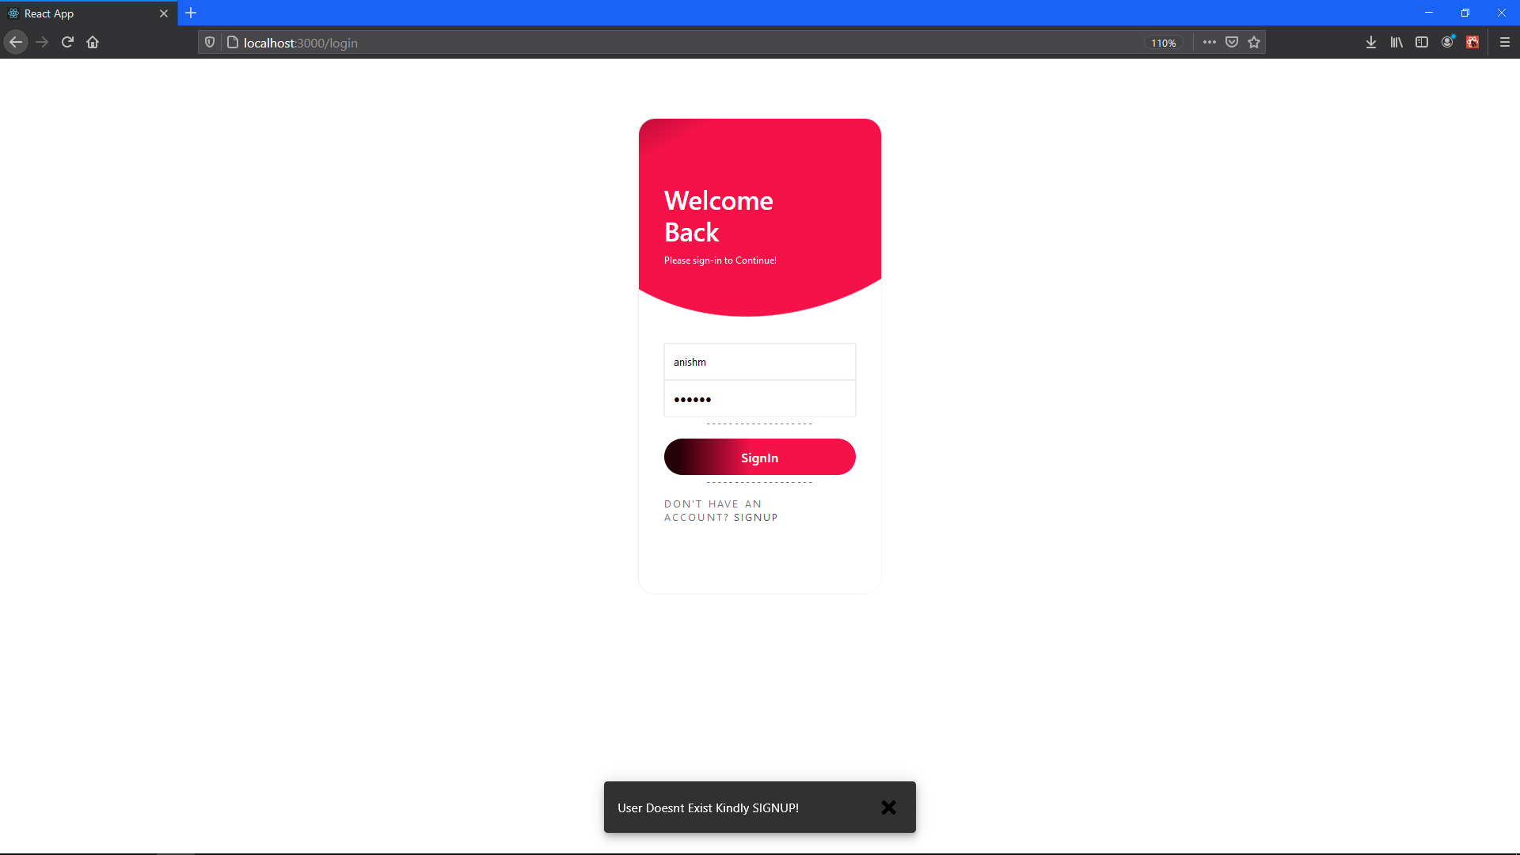

Login Screen #Validation 3

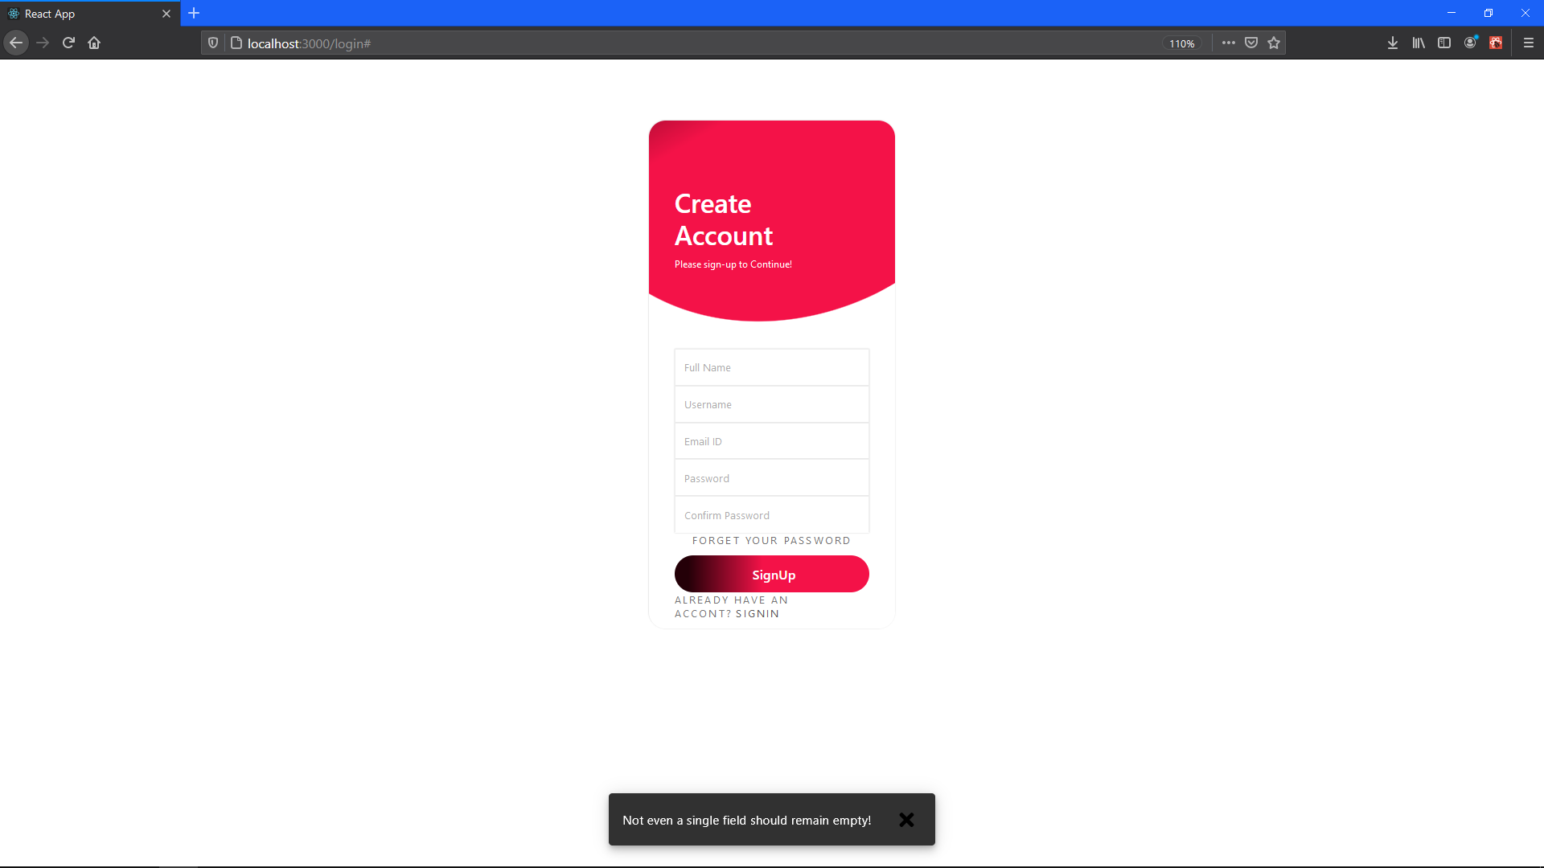

Registration Screen #Validation 1

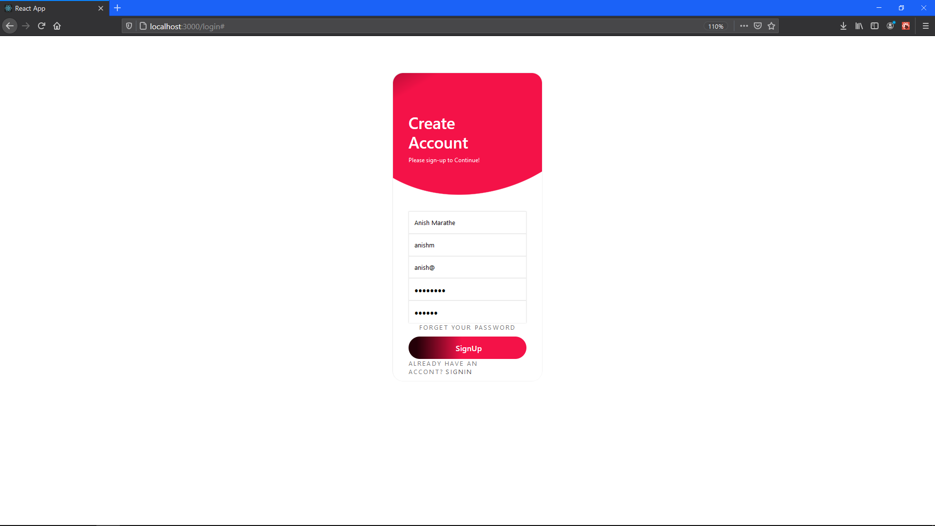

Registration Screen Inputs

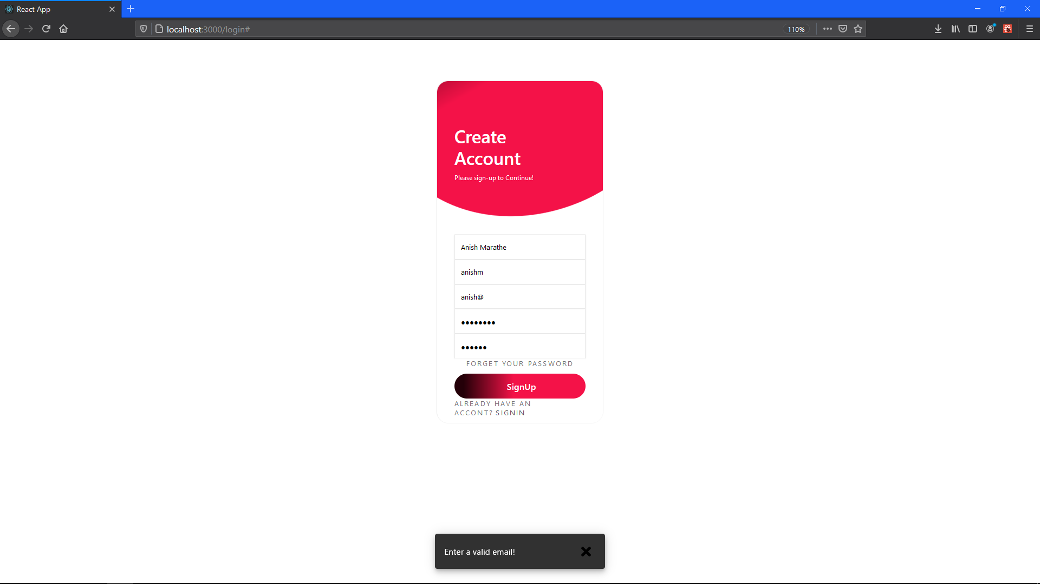

Registration Screen #EMAIL Validation 1

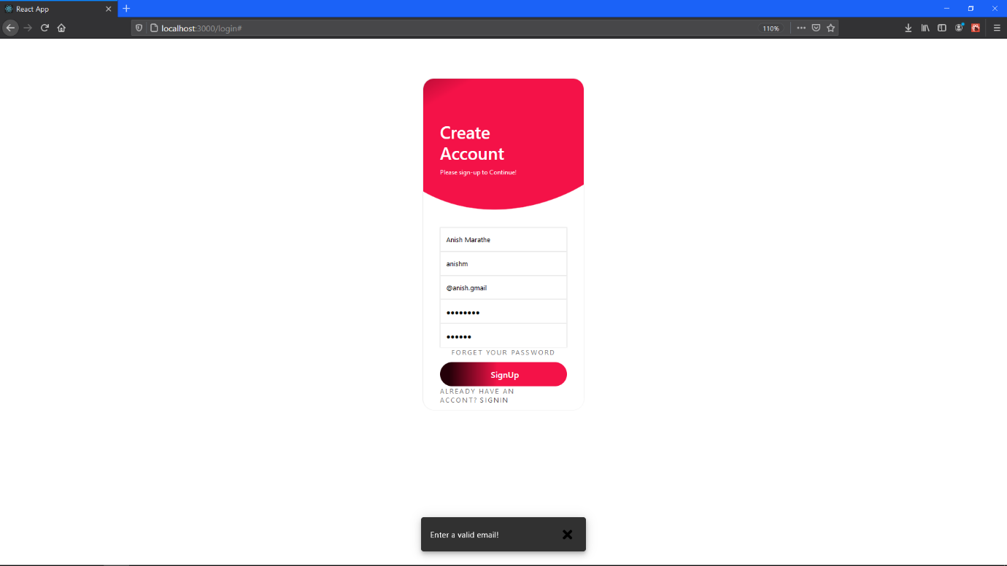

Registration Screen #EMAIL Validation 2

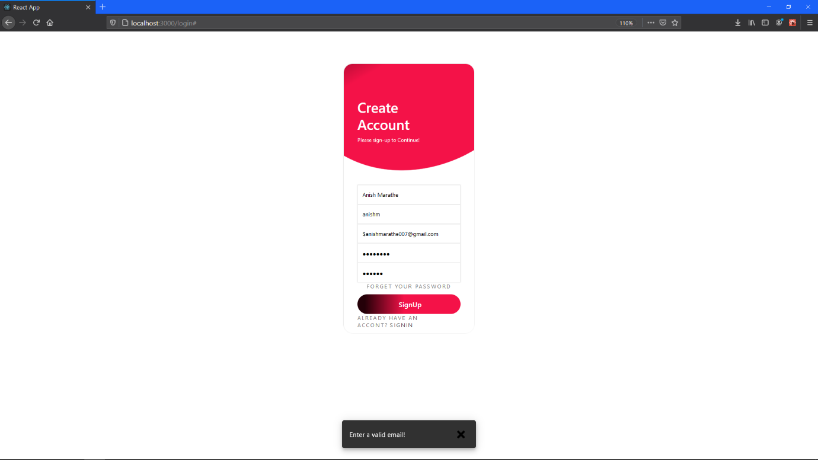

Registration Screen #EMAIL Validation 3

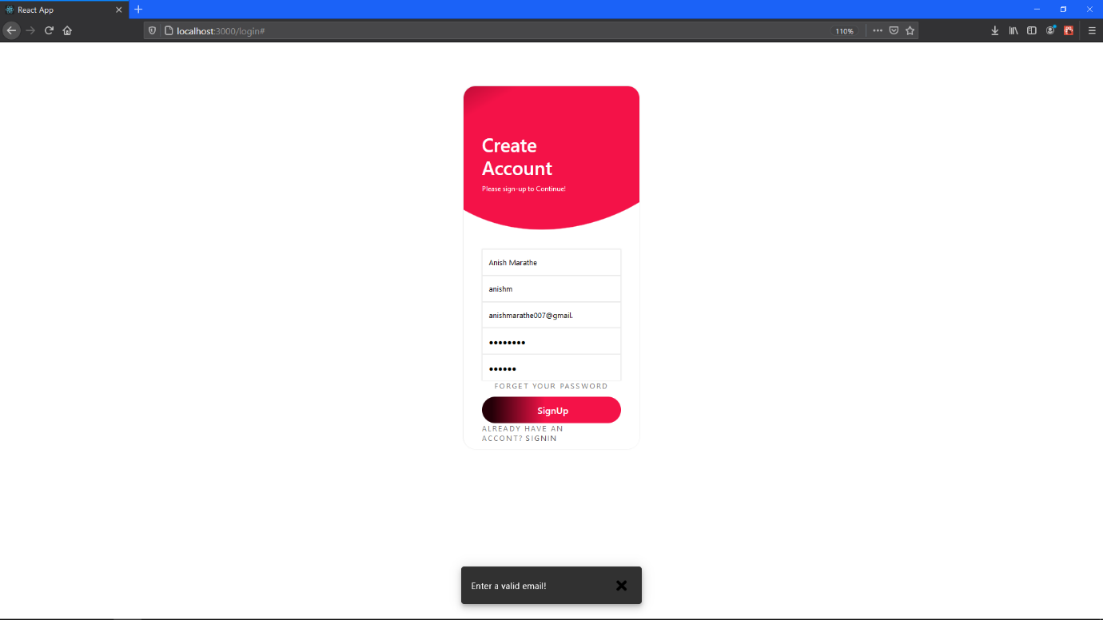

Registration Screen #EMAIL Validation 4

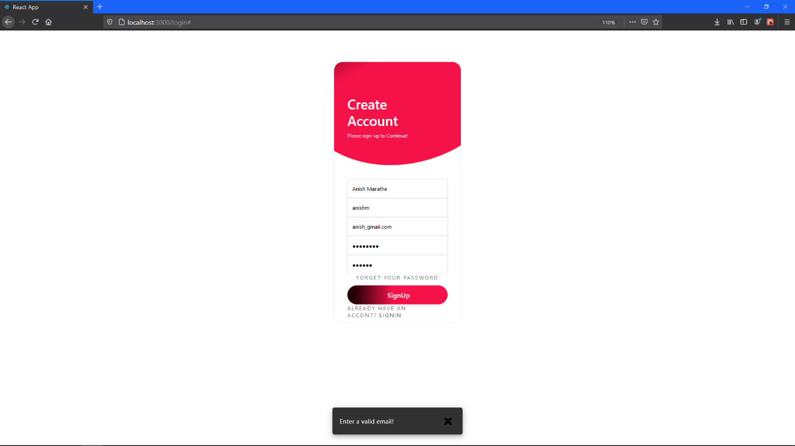

Registration Screen #EMAIL Validation 5

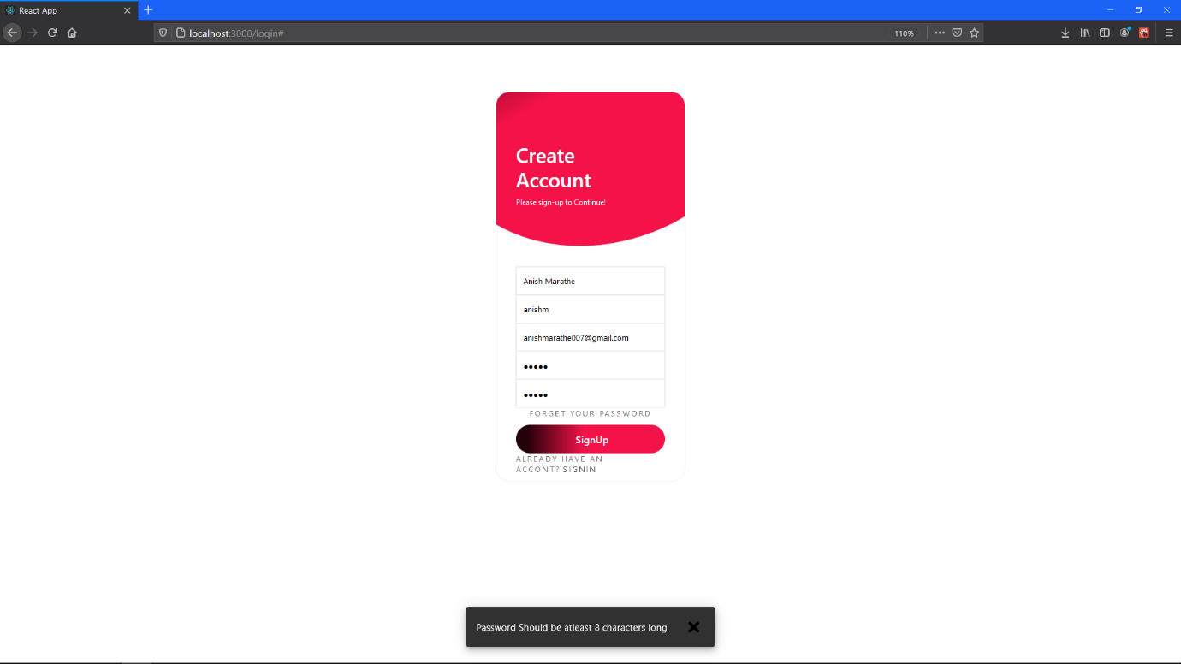

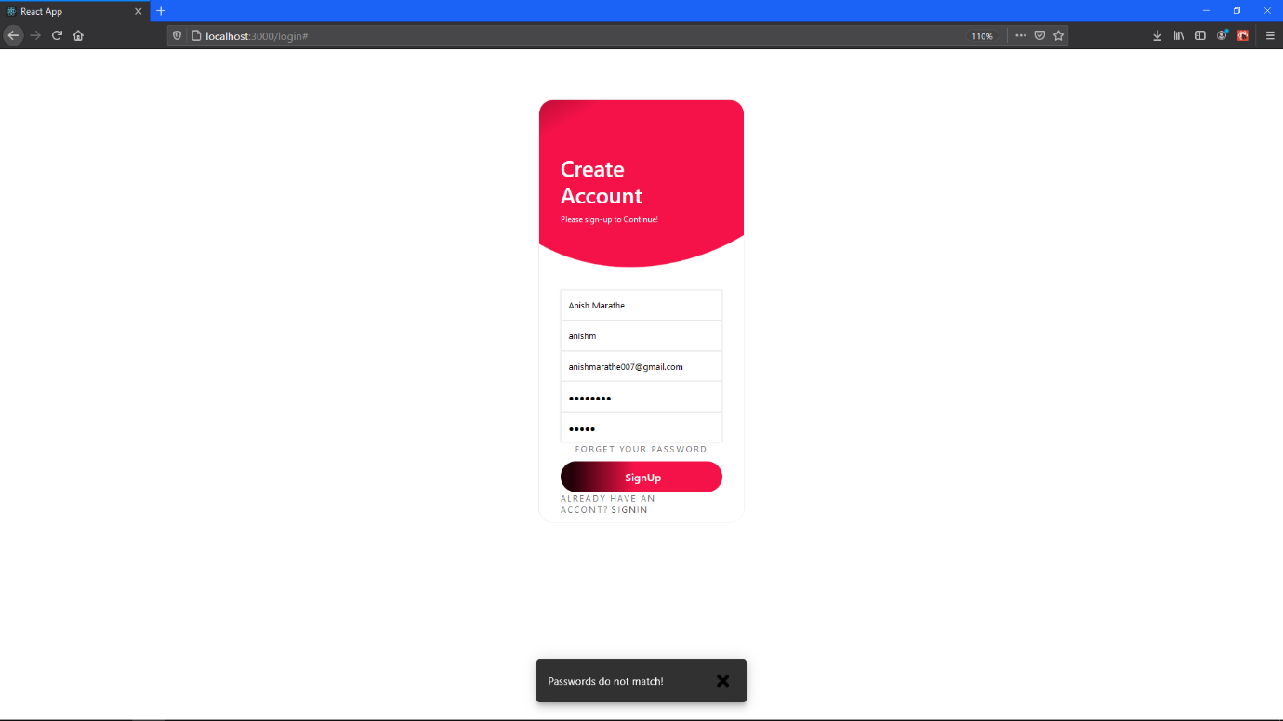Registration Screen #Validation 2

Registration Screen #Validation 3

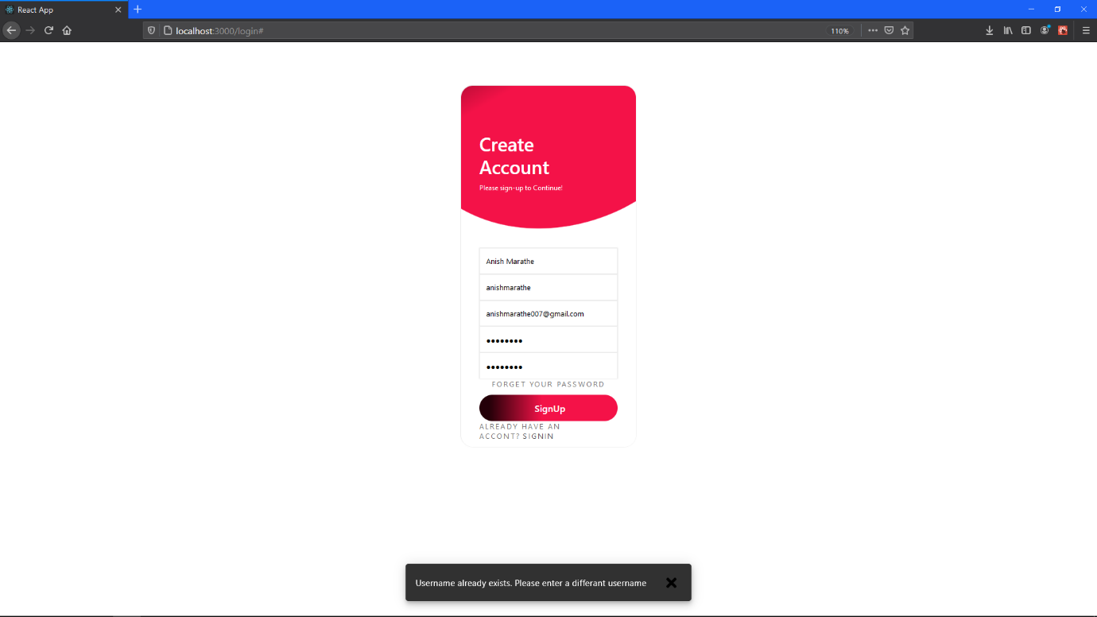

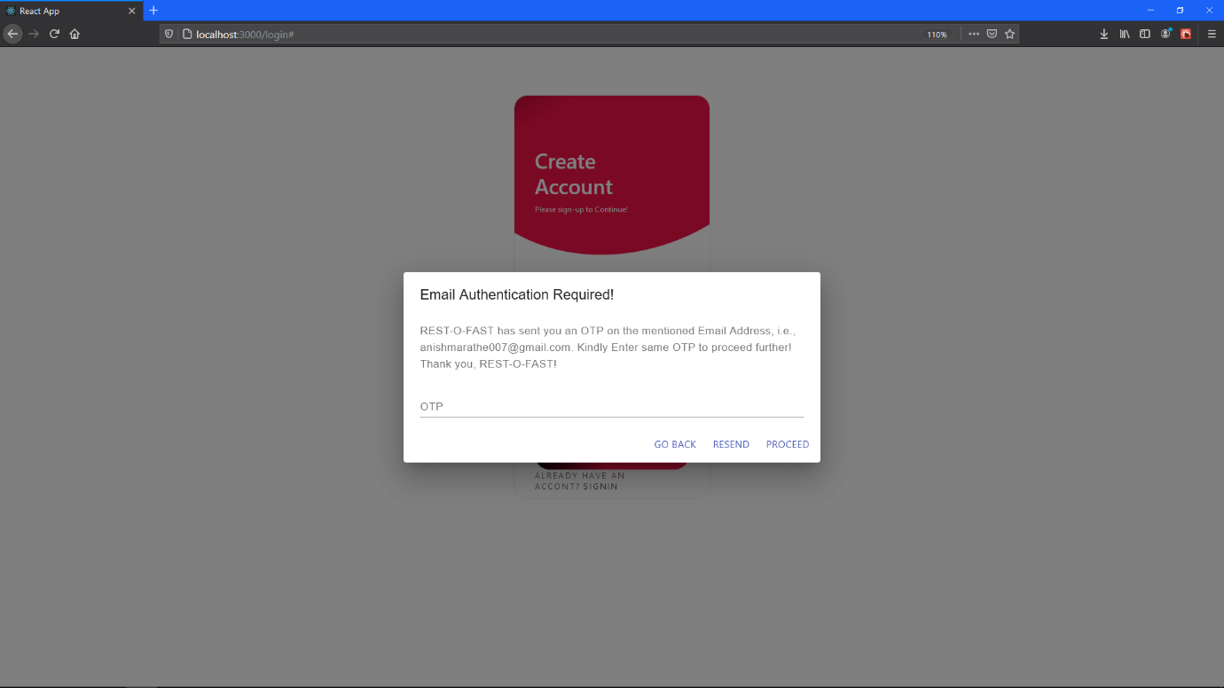Registration Screen #Validation 4

Registration Screen OTP pop up window

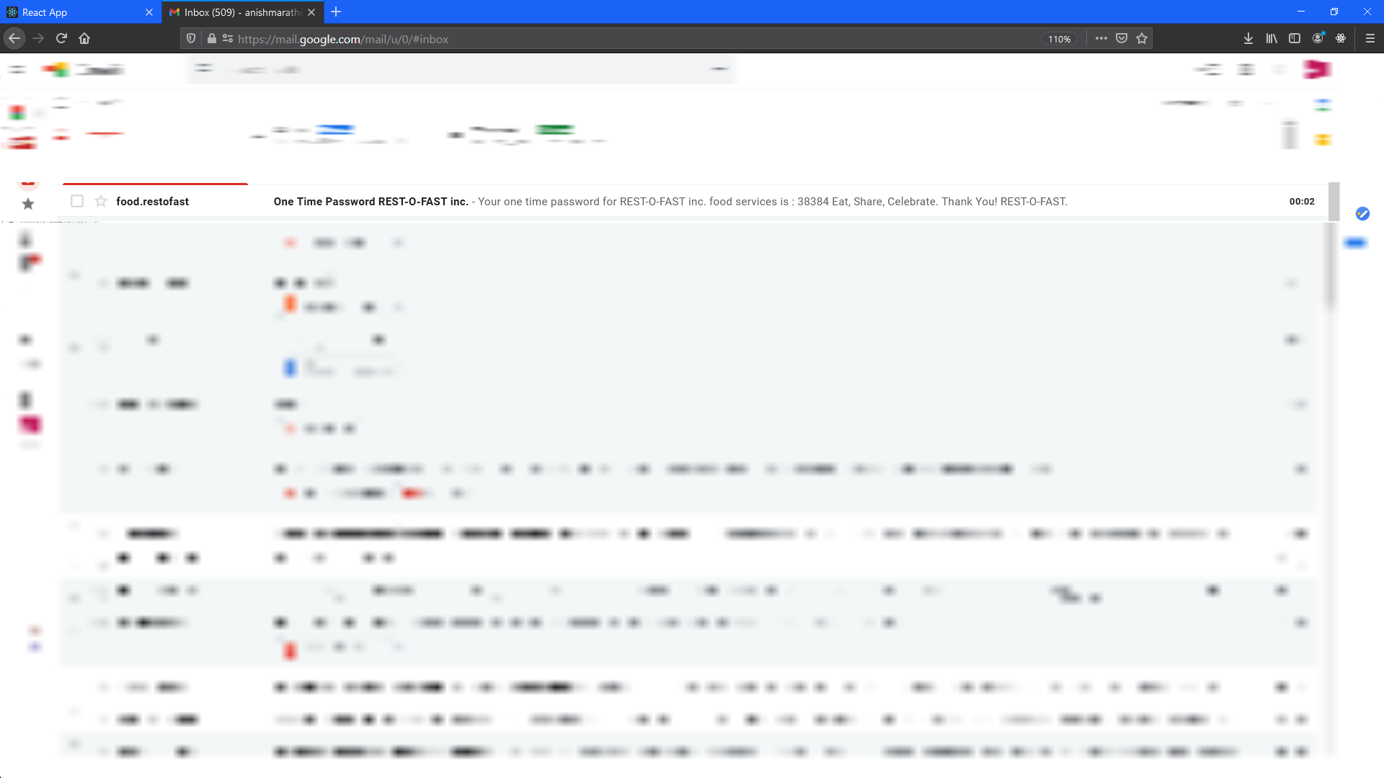

GMAIL window (To display that the mail has arrived)

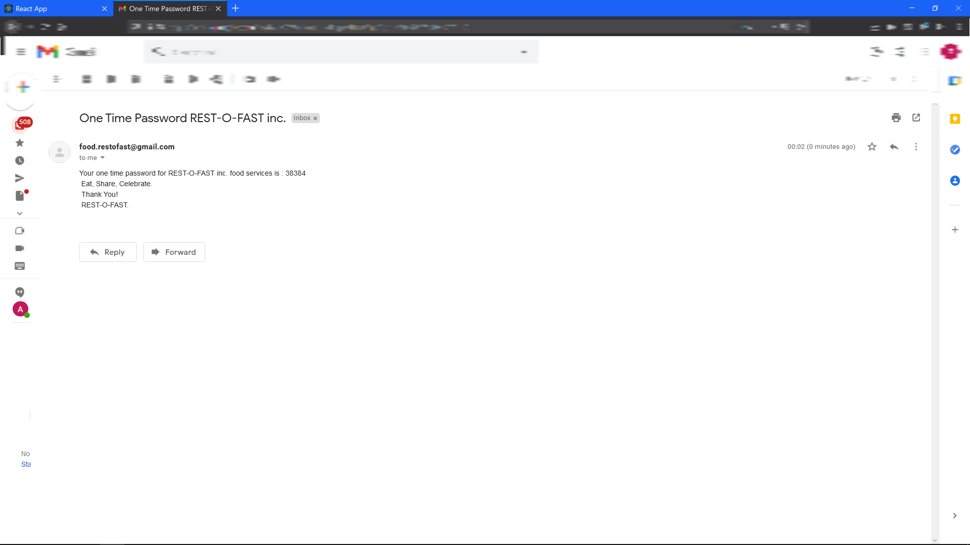

GMAIL window (displaying the actual mail content)

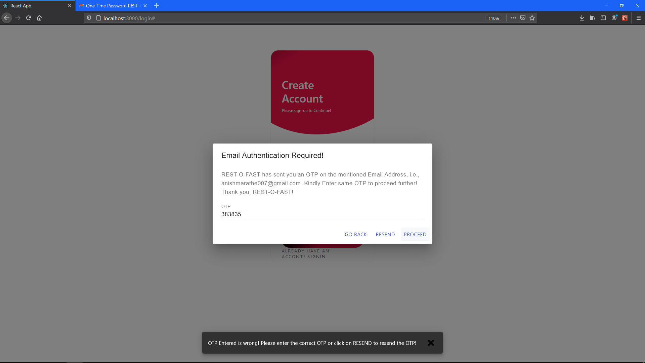

Registration Screen #OTP Validation 1

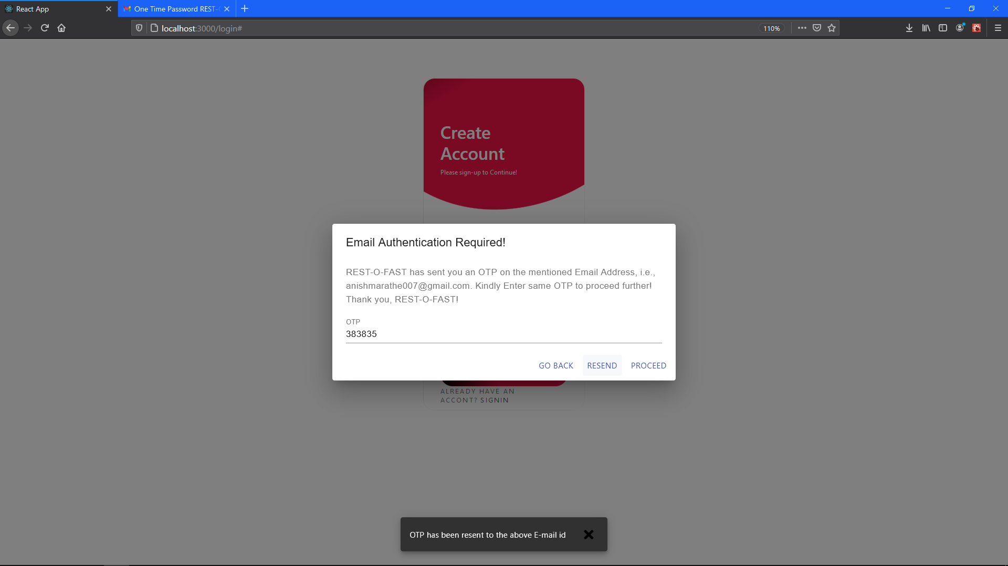

Registration Screen OTP Resend window

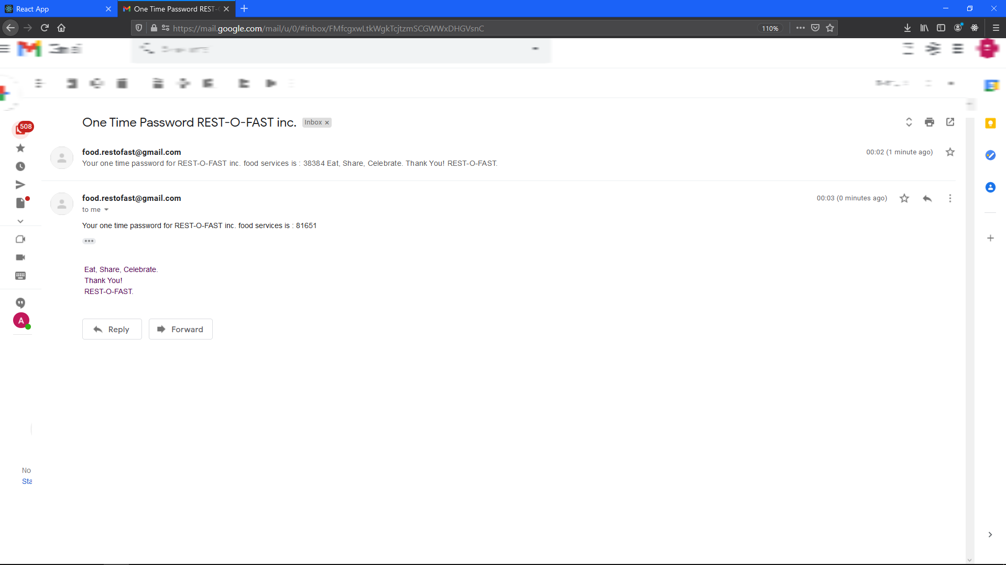

GMAIL window (To display that the second mail has arrived)

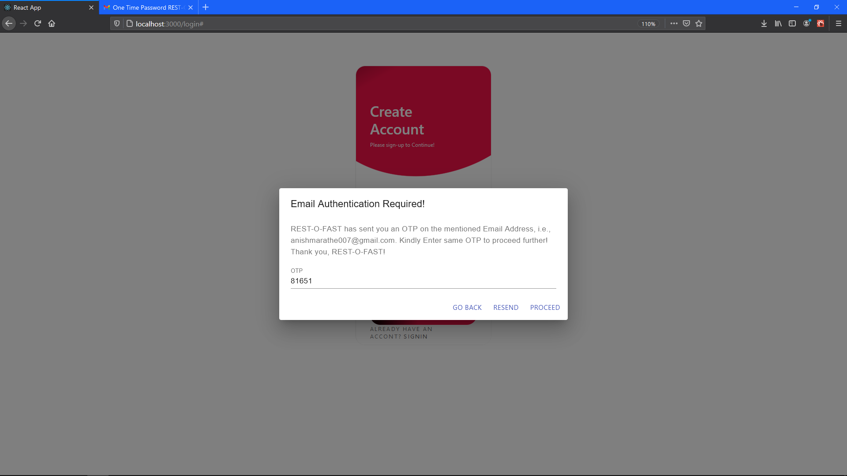

Registration Screen Correct OTP input

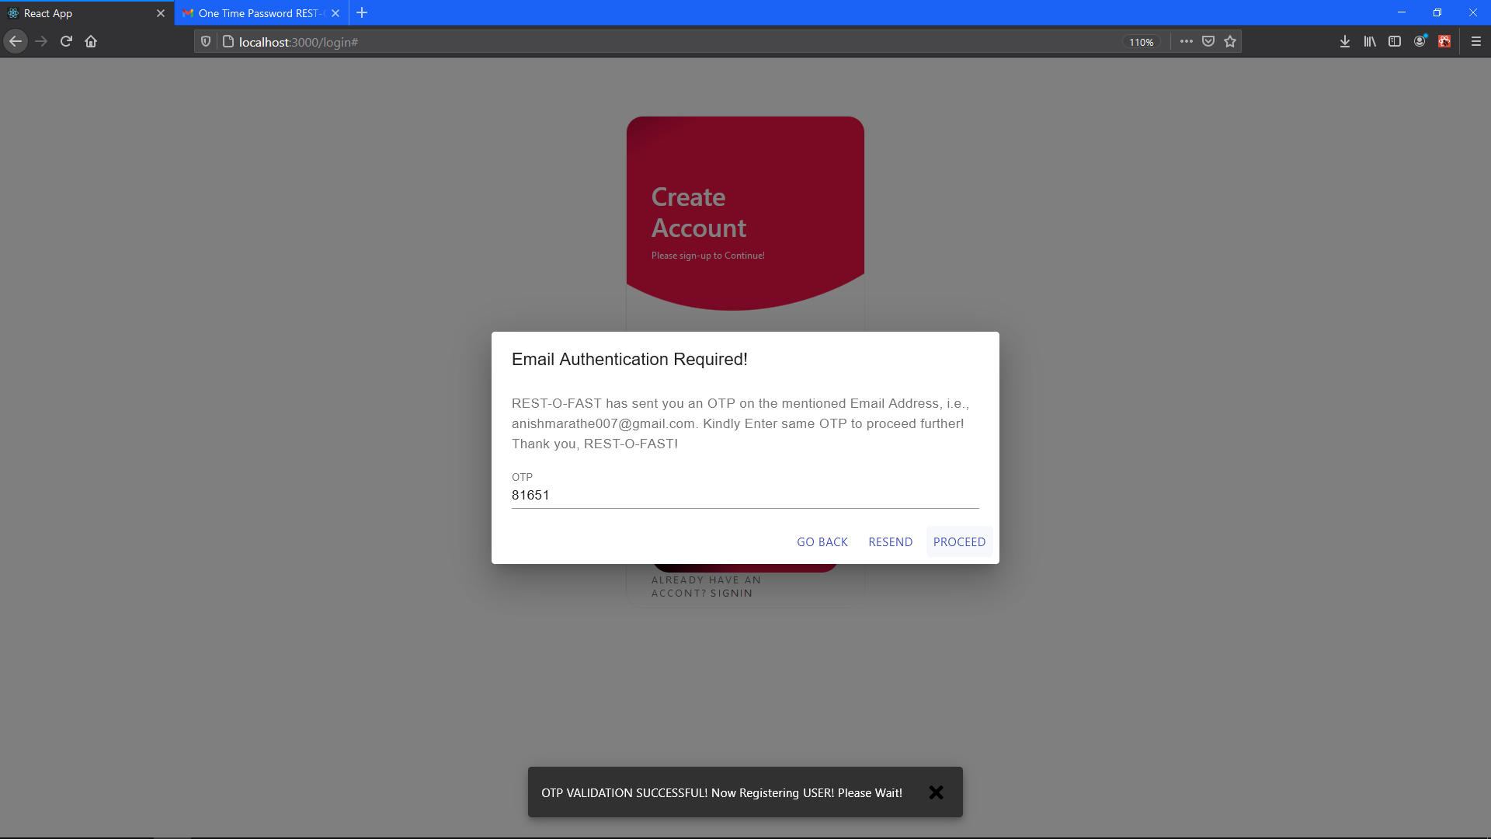

Registration Screen OTP validation message

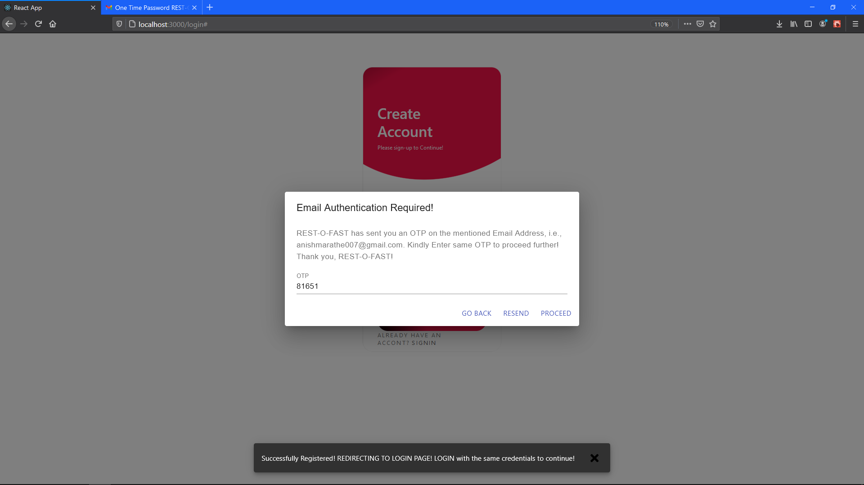

Registration Screen Redirecting message

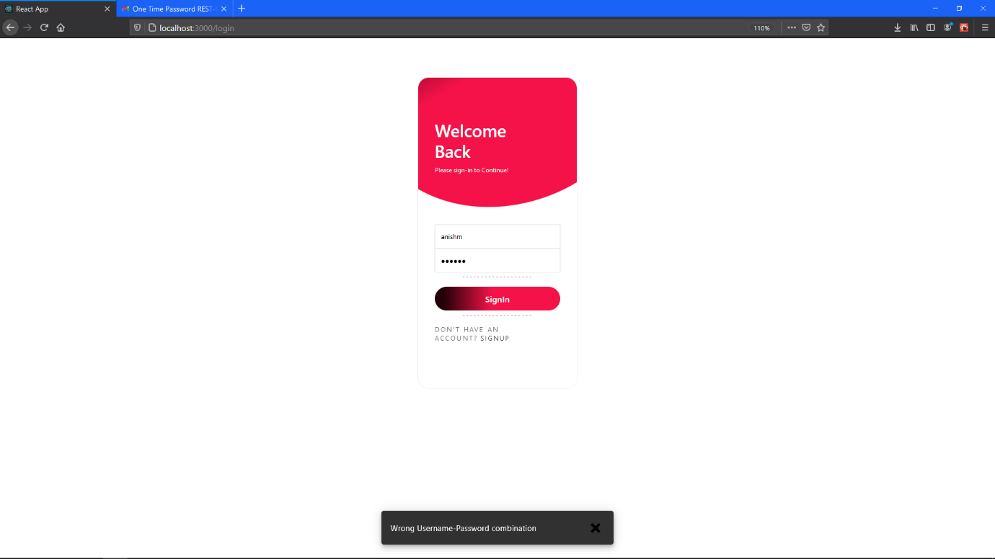

Login Screen #Validation 4

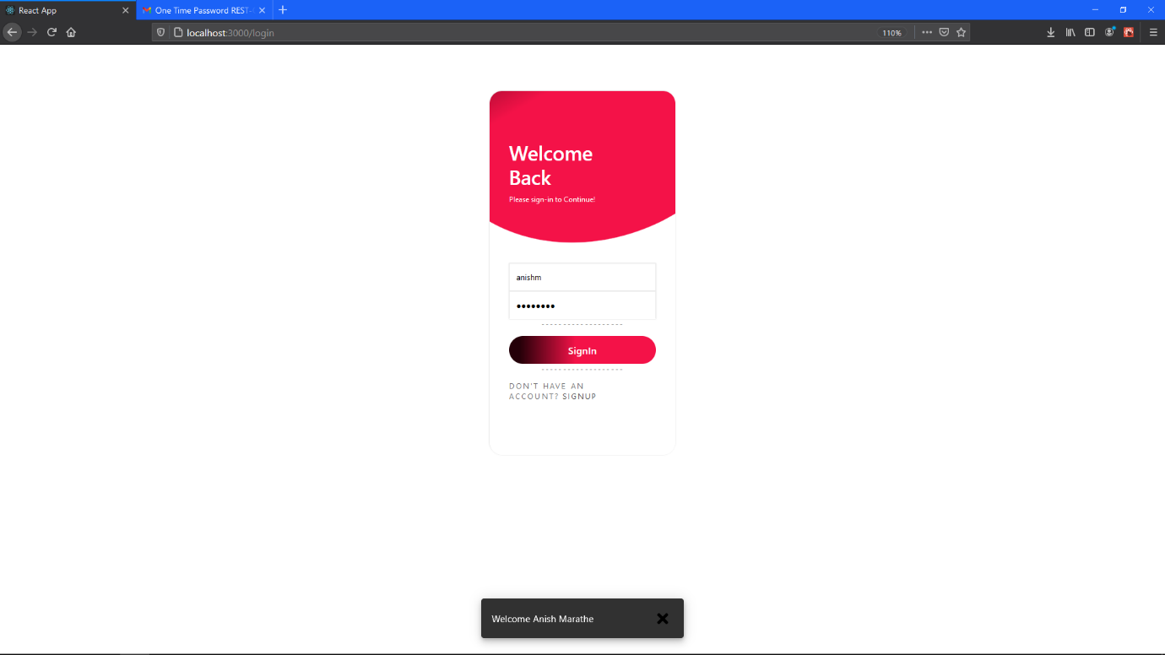

Login Screen success window!

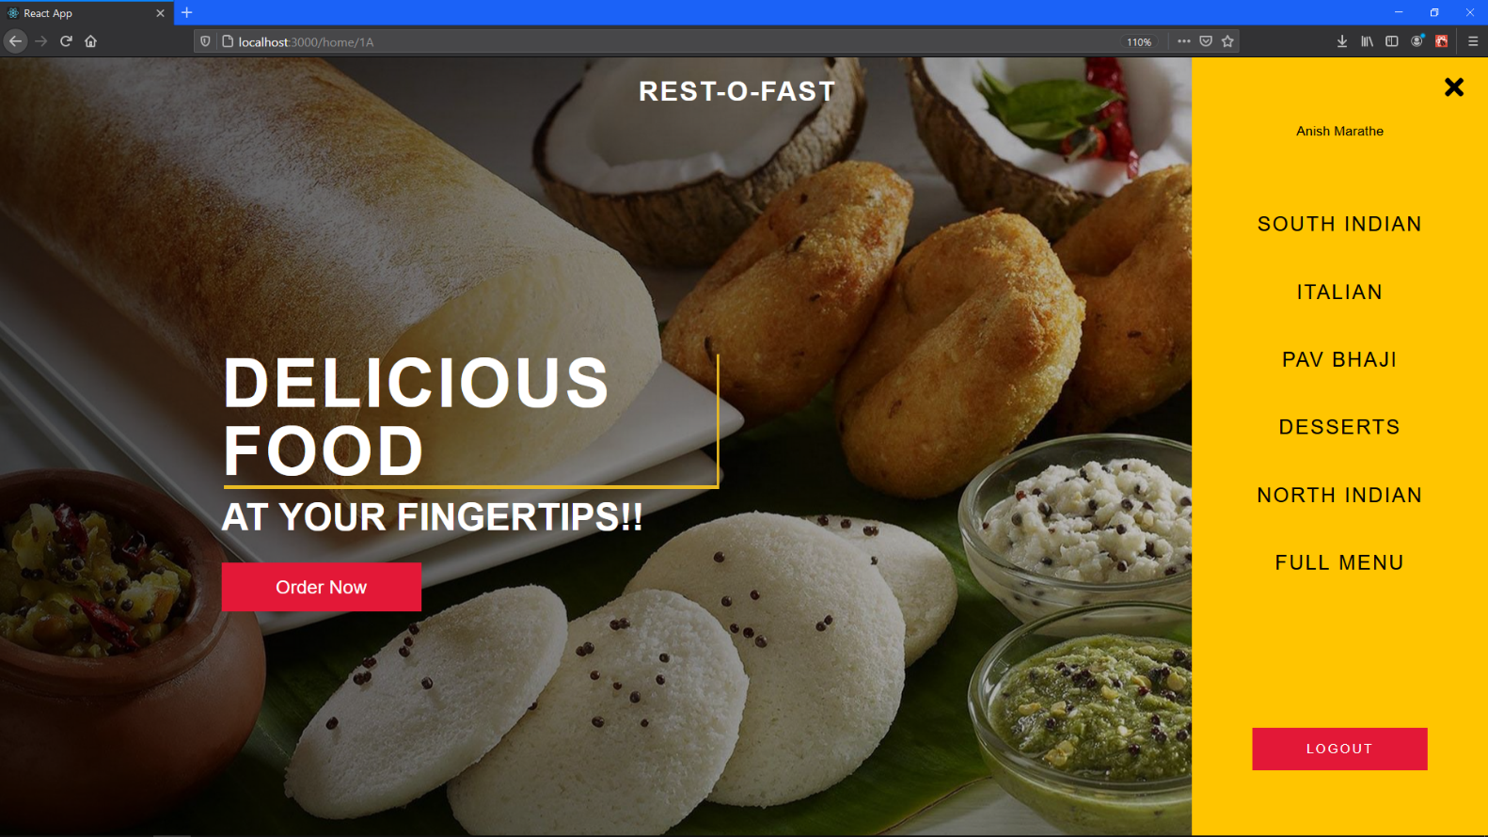

Menu Field (All the categories, full menu Notice that user is now logged in that’s why LOGOUT button is displayed along)

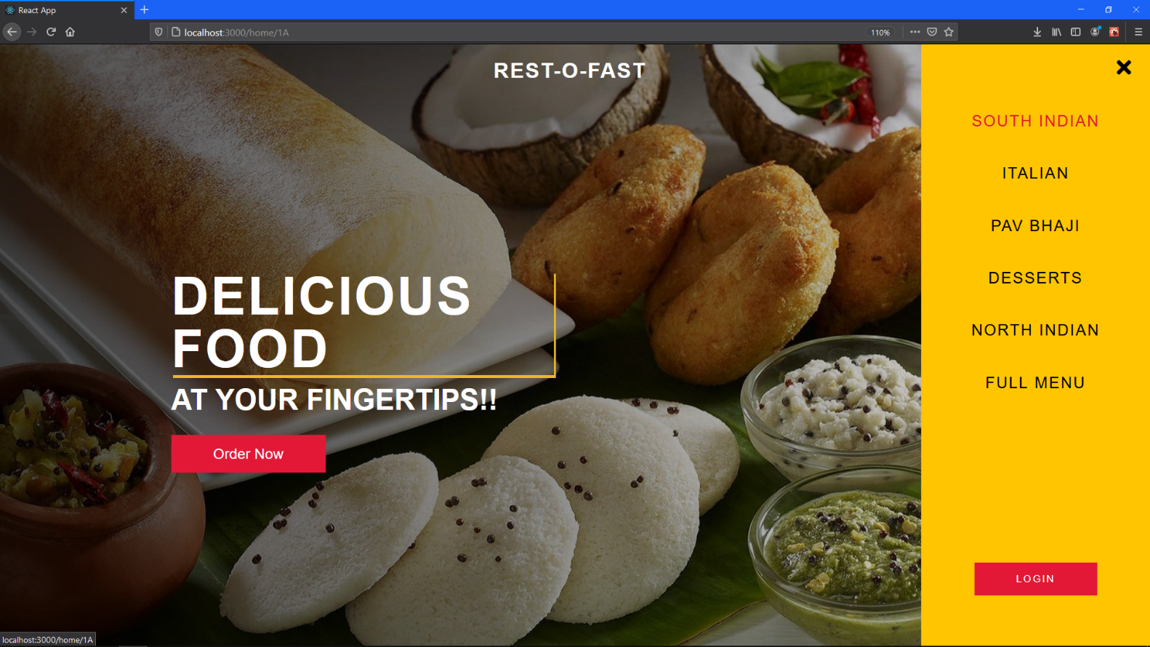

Home Page (Currently Logged out. Another way in which user can log in to the system.

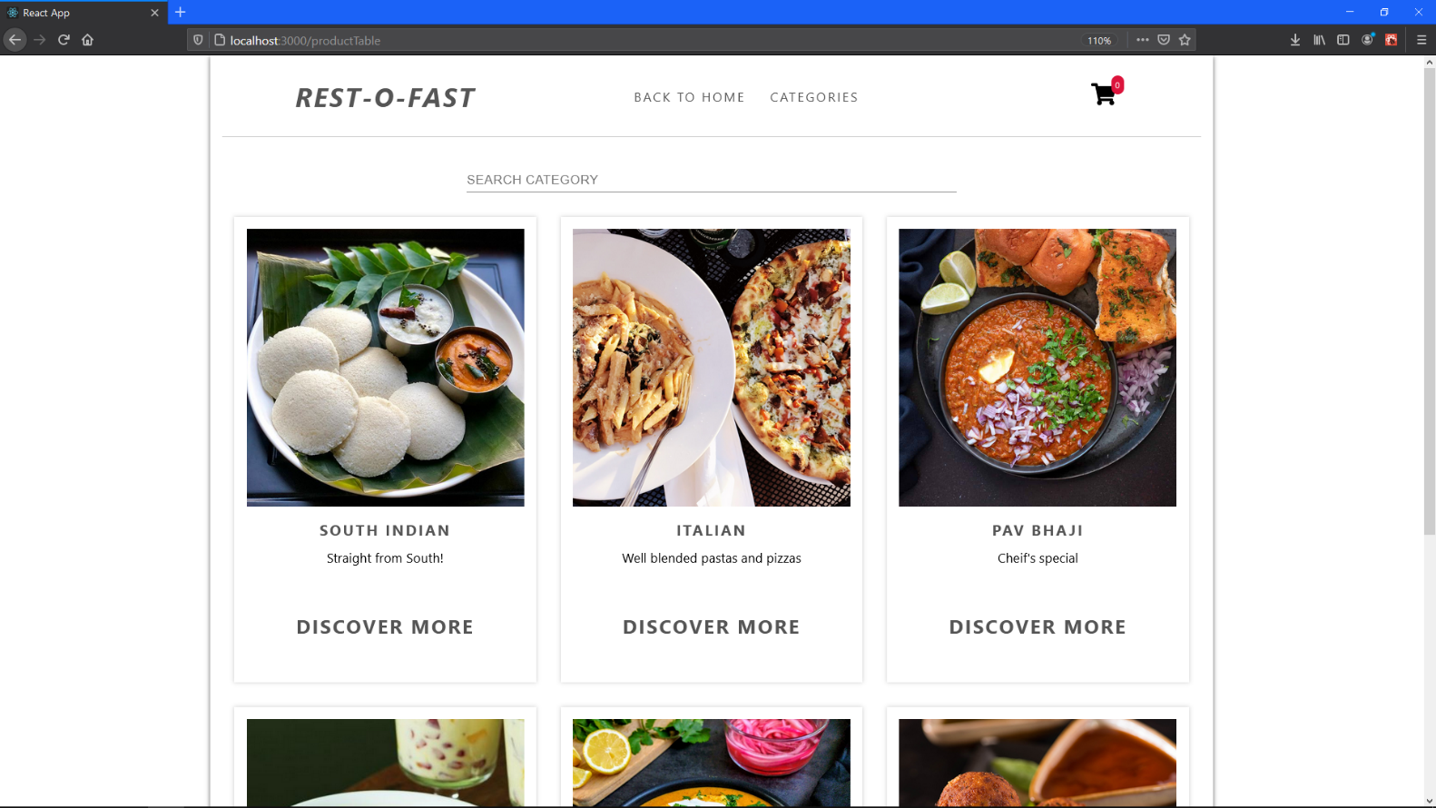

Category View

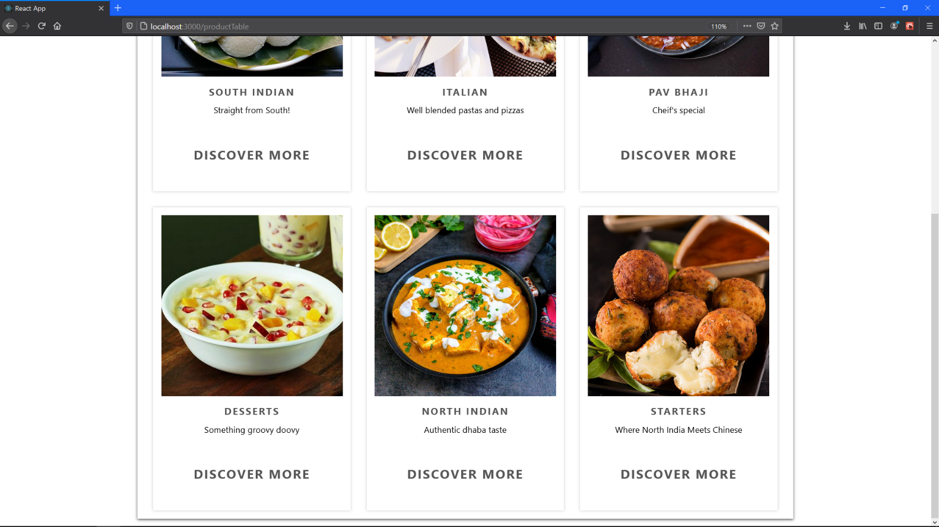

Category View

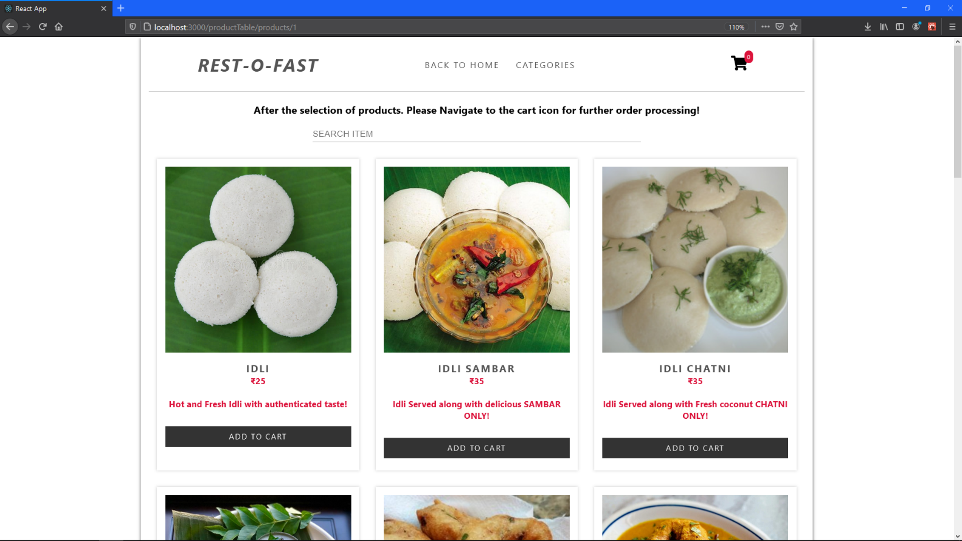

Item View (Selected Category ‘SOUTH INDIAN’)

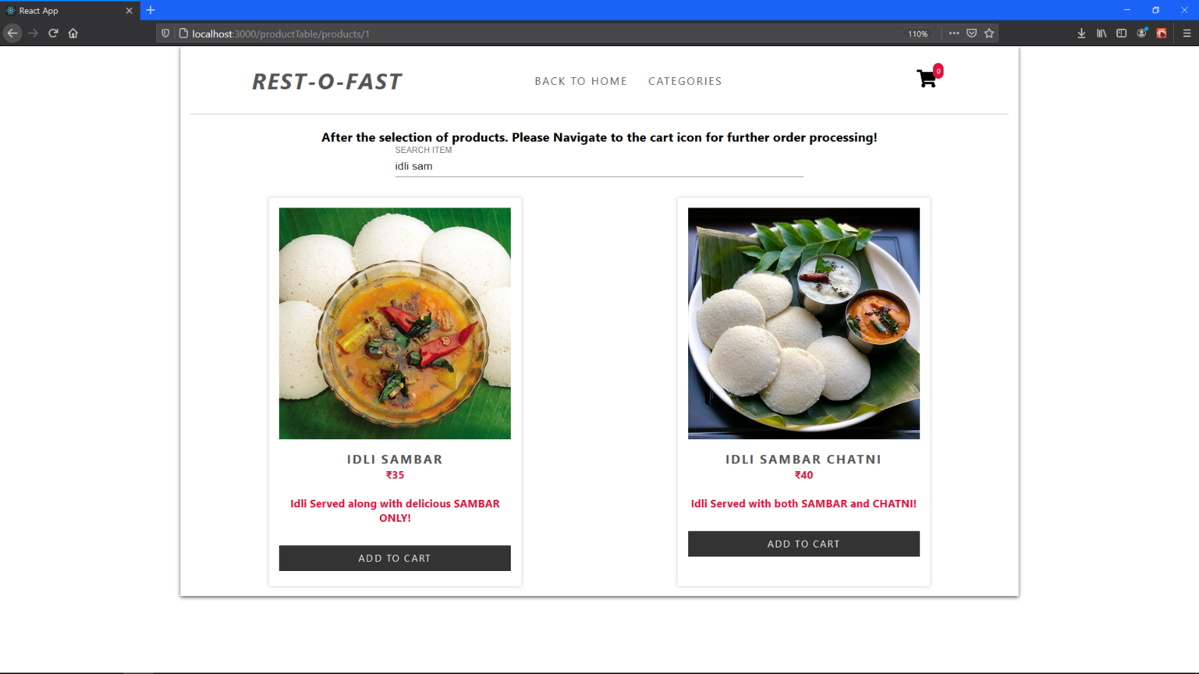

SEARCH BAR functionality (item view)

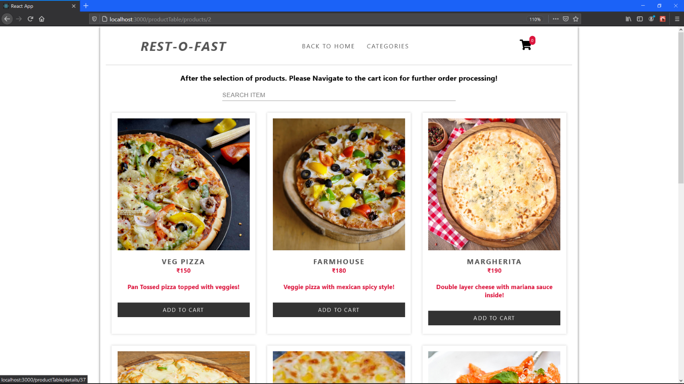

Item View (Selected Category ‘ITALIAN’)

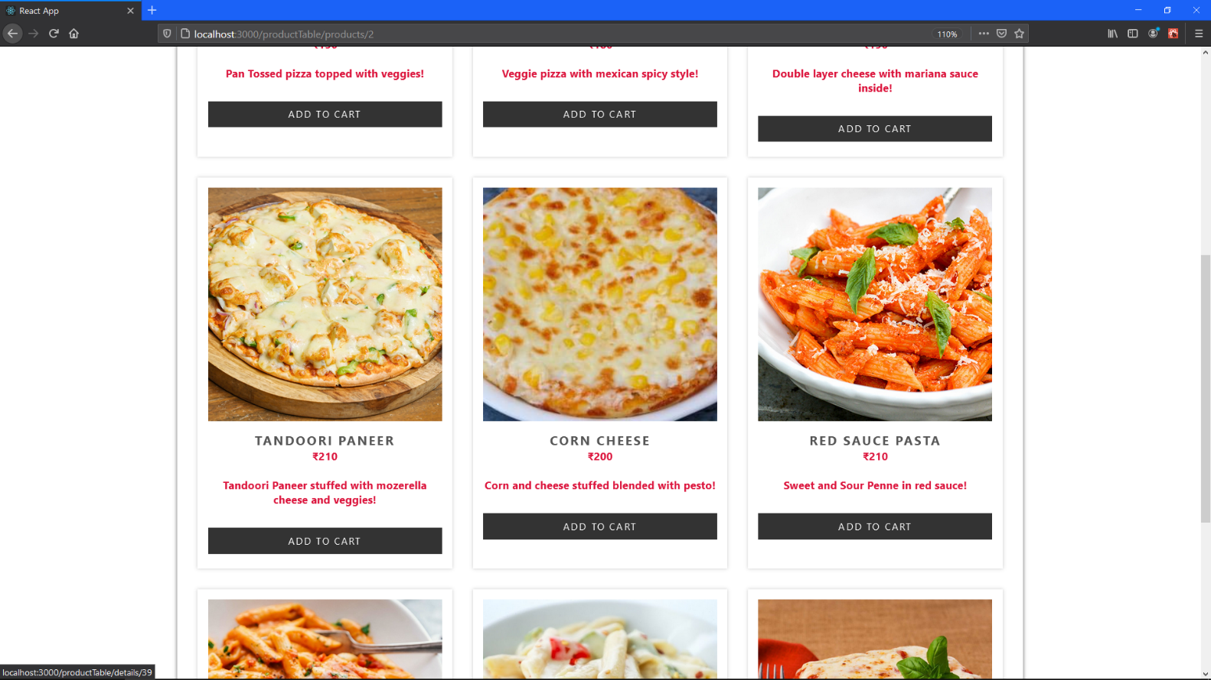

Item View (Selected Category ‘ITALIAN’)

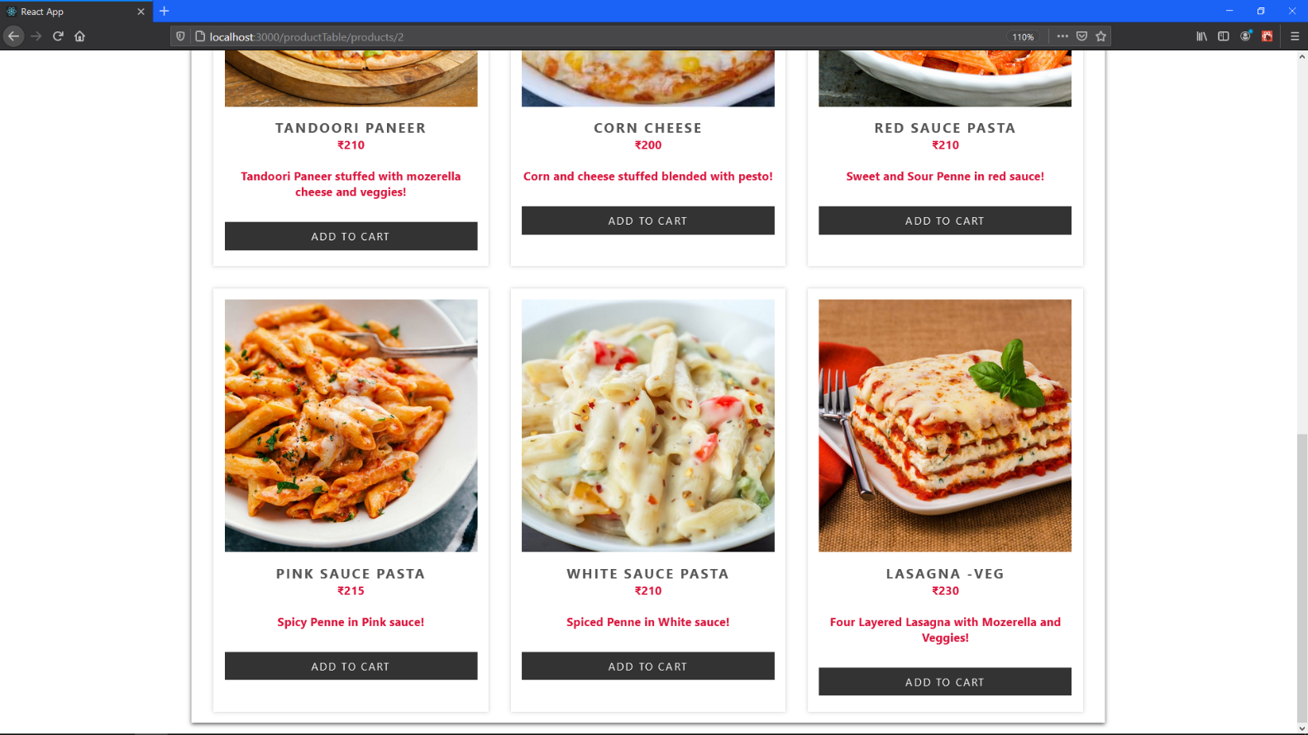

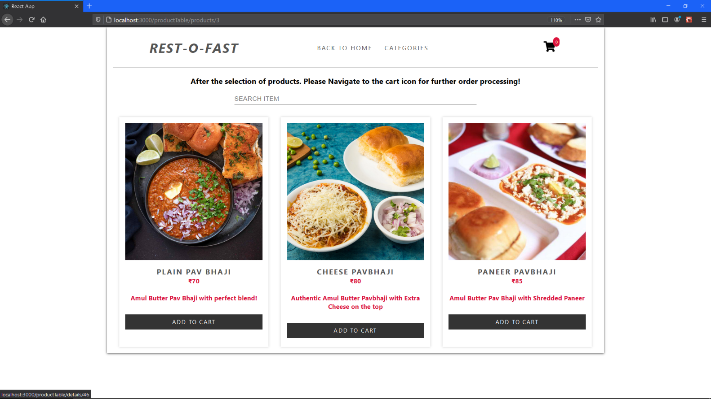Item View (Selected Category ‘ITALIAN’)

Item View (Selected Category ‘PAV BHAJI’)

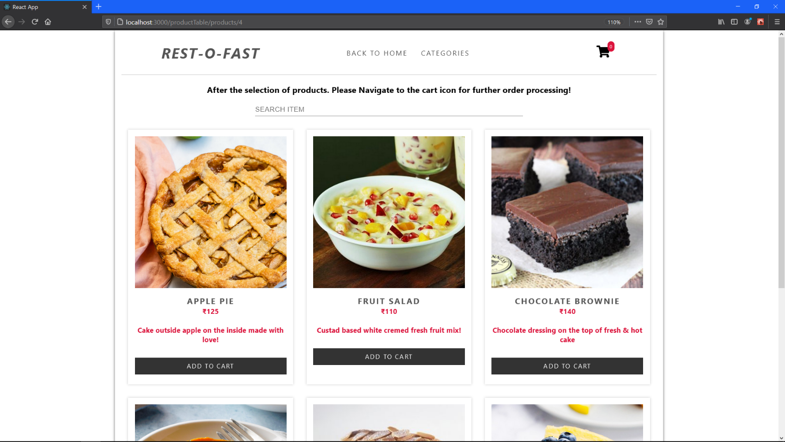

Item View (Selected Category ‘DESSERTS)

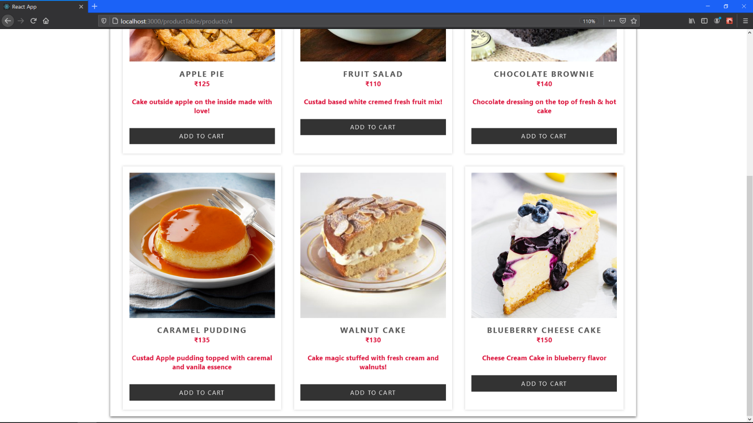

Item View (Selected Category ‘DESSERTS’)

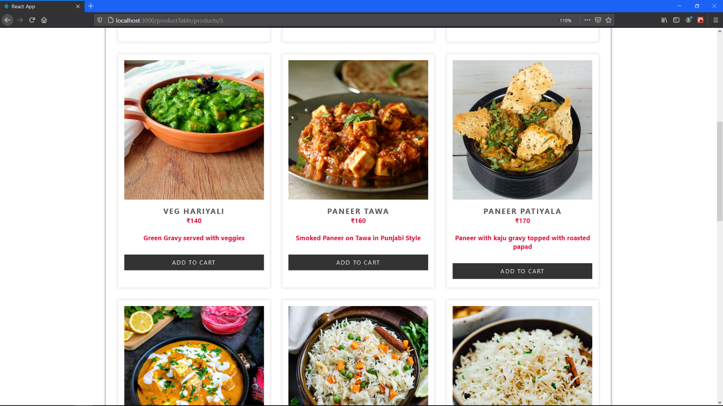

Item View (Selected Category ‘NORTH INDIAN’)

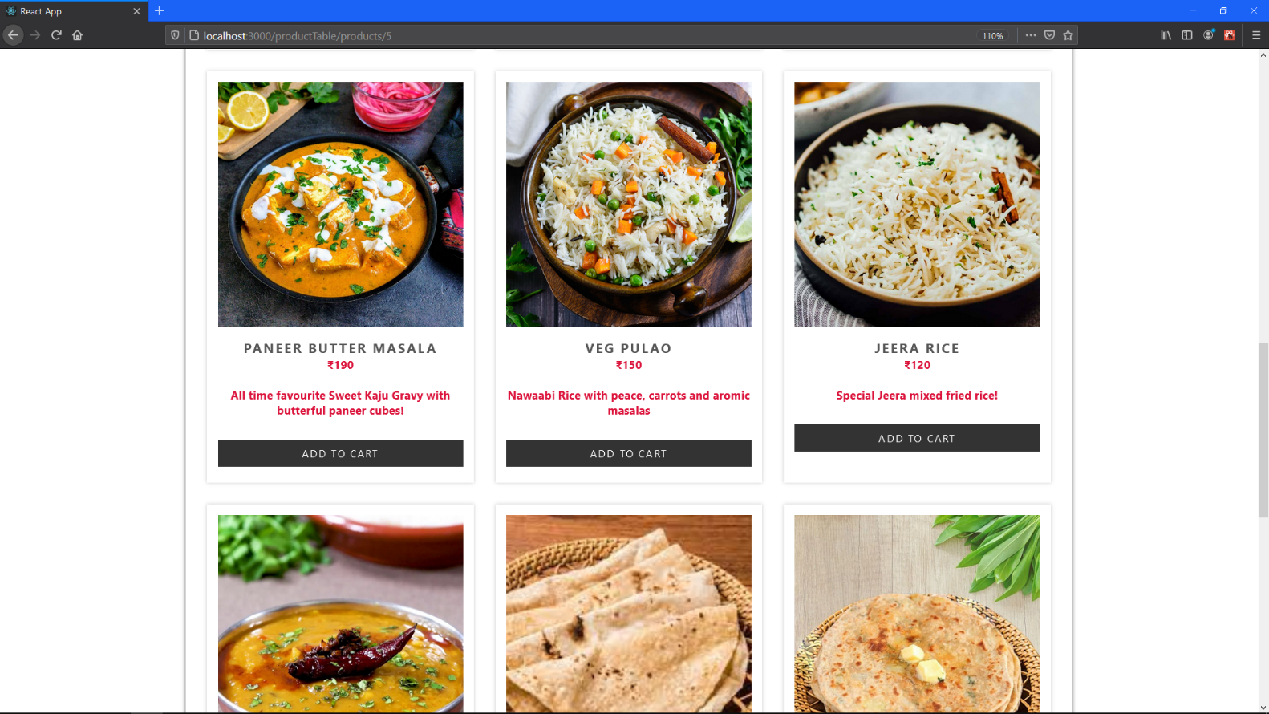

Item View (Selected Category ‘NORTH INDIAN’)

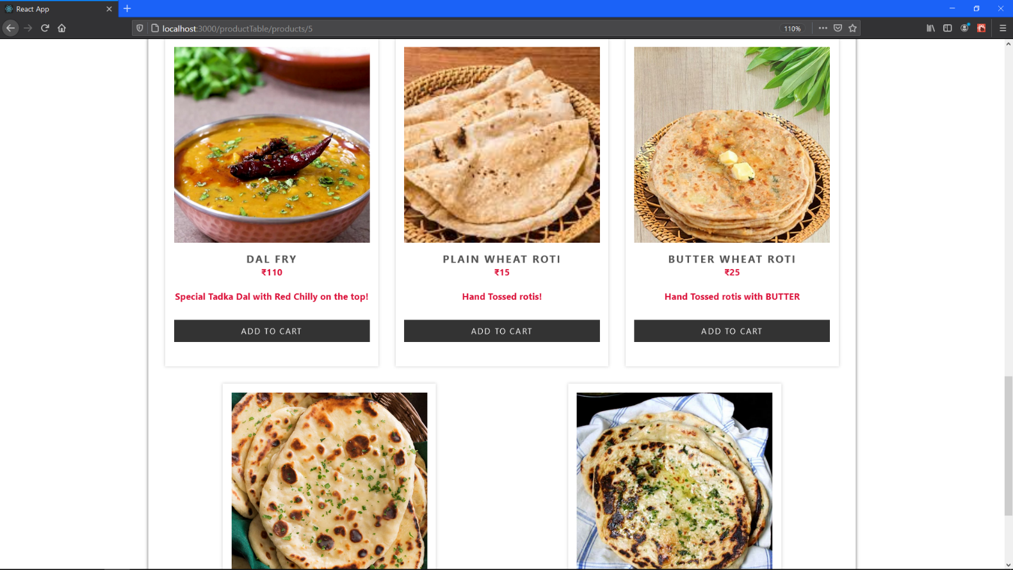

Item View (Selected Category ‘NORTH INDIAN’)

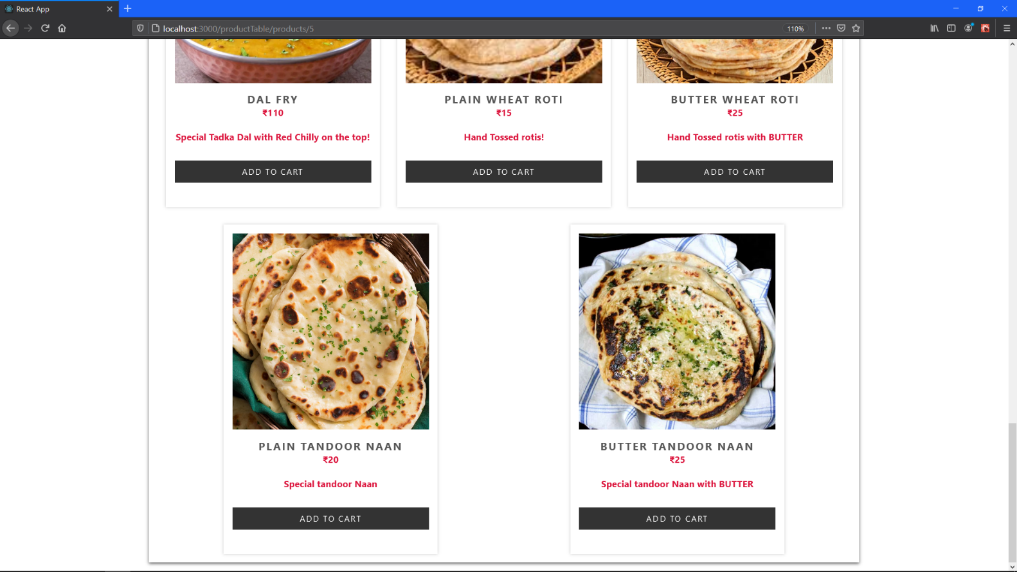

Item View (Selected Category ‘NORTH INDIAN’)

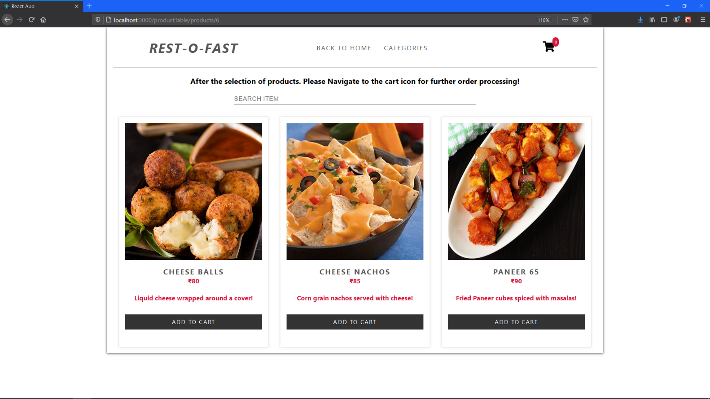

Item View (Selected Category ‘STARTERS’)

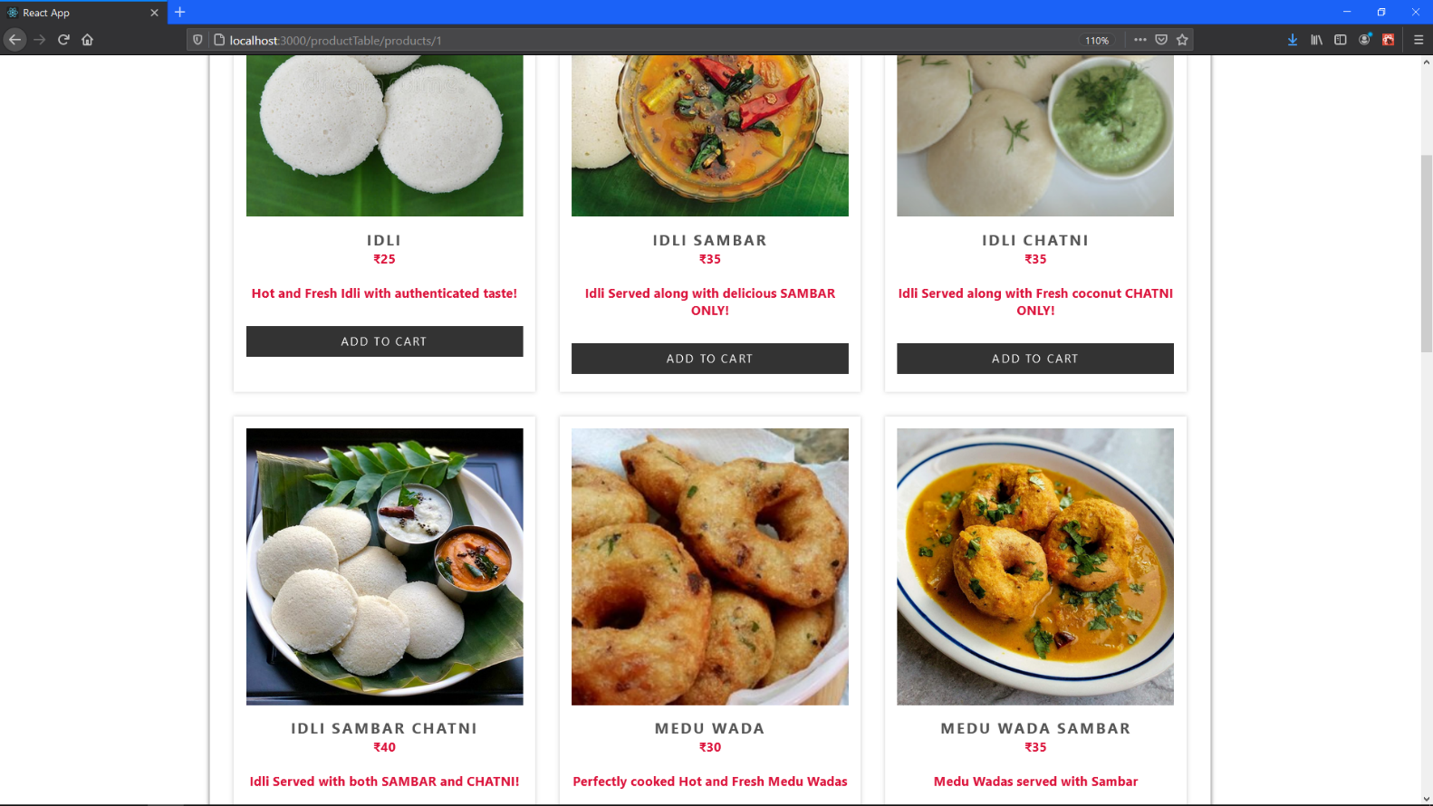

Item View (Selected Category ‘SOUTH INDIAN’)

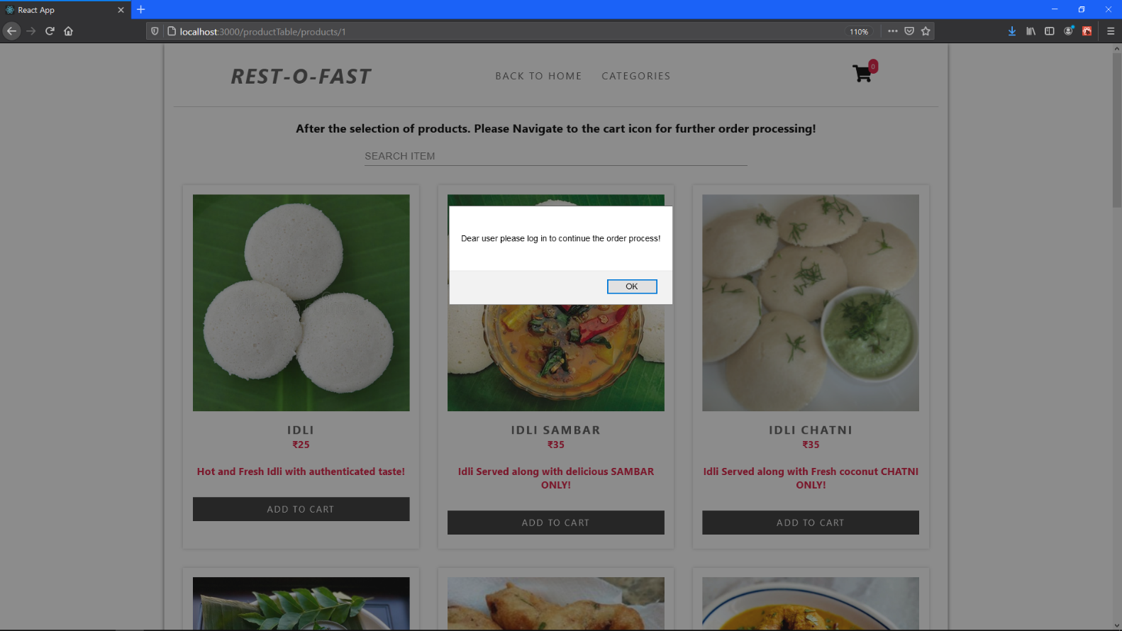

Selects ADD TO CART FOR menu item = IDLI. This is how a user can first view the menu, and then if he is not logged in he/she gets a prompt like this. This again will redirect user through all the login screens as mentioned above!

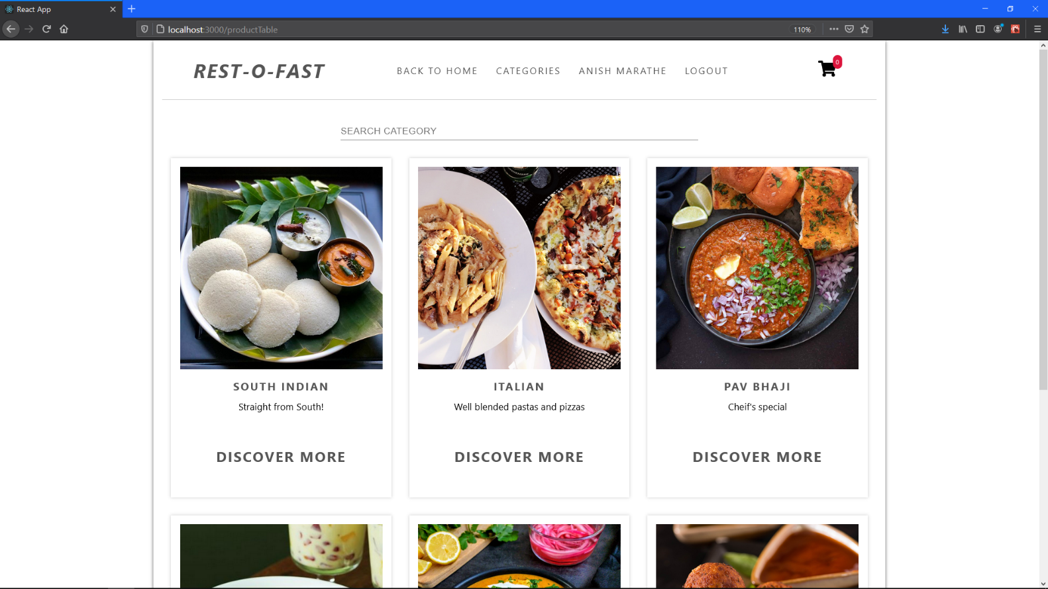

Here the user is logged in (Notice the header items being changed.)

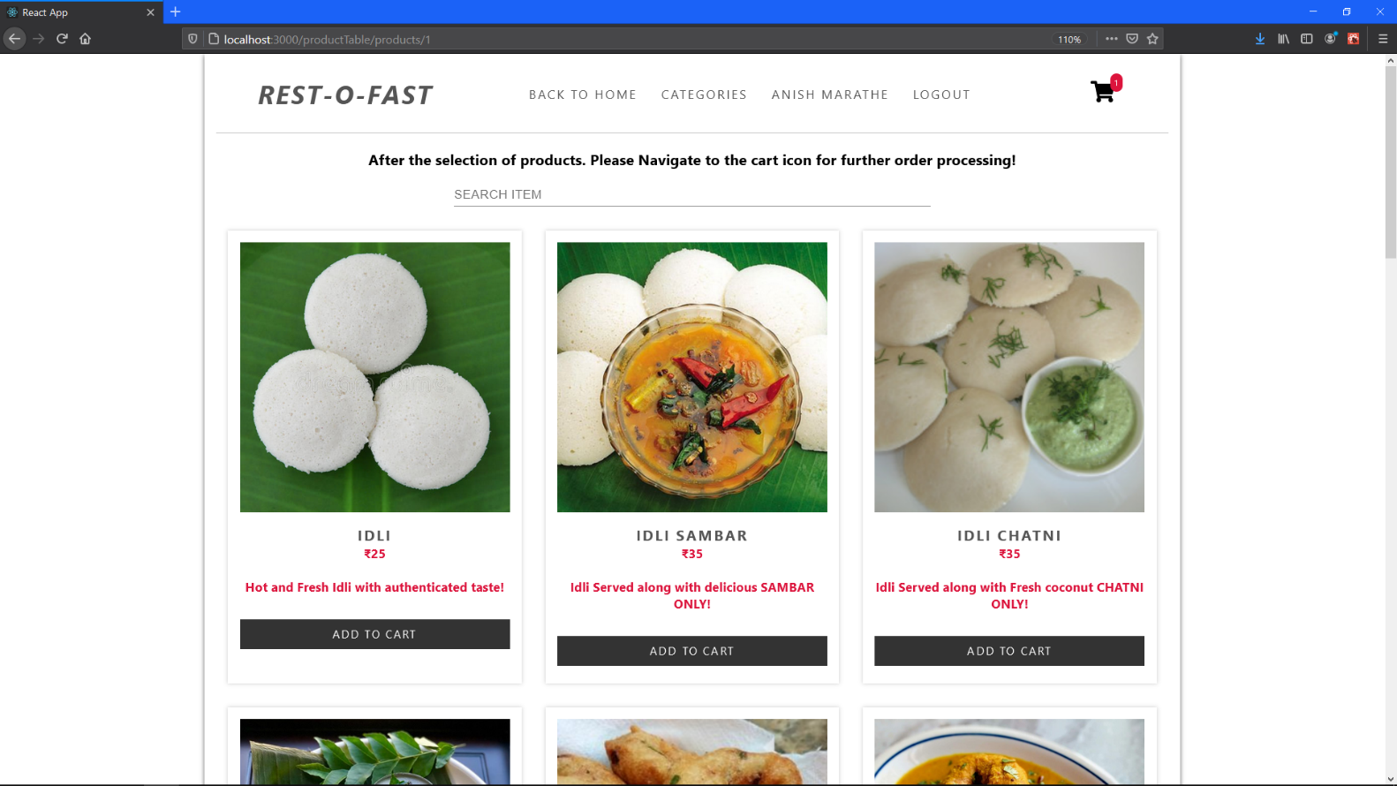

Now proceeding towards the placing the order!

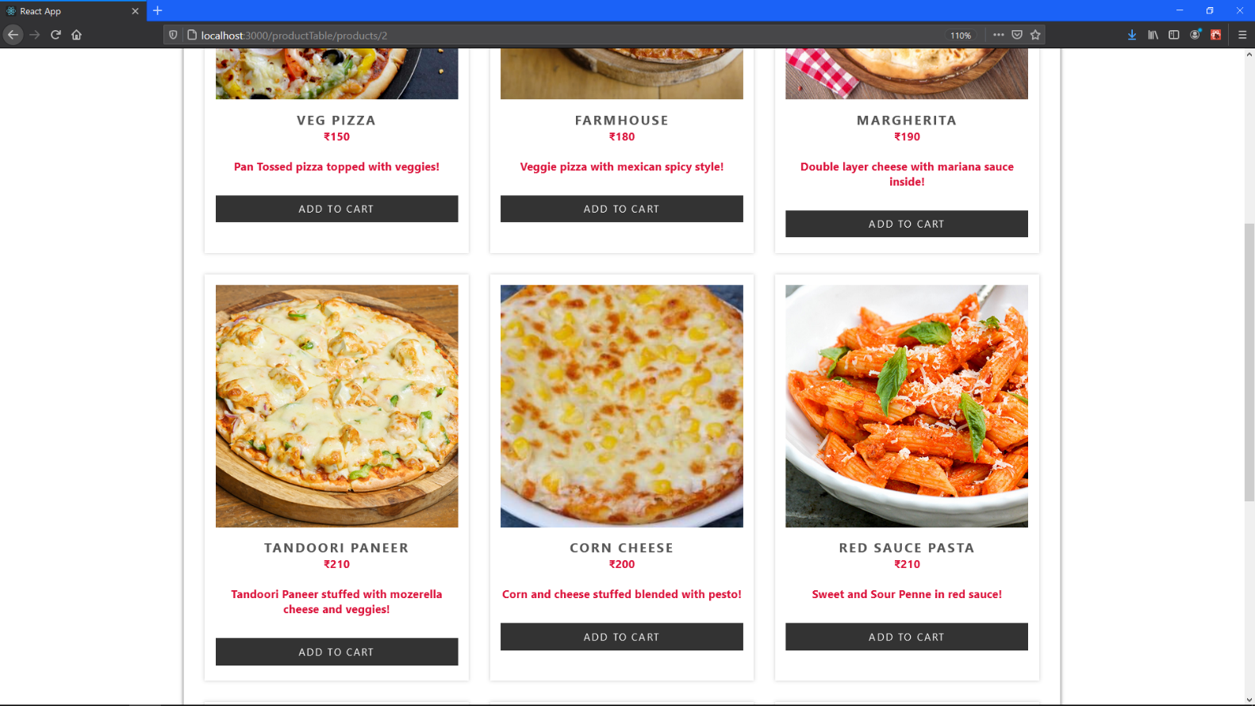

Selecting the menu items.

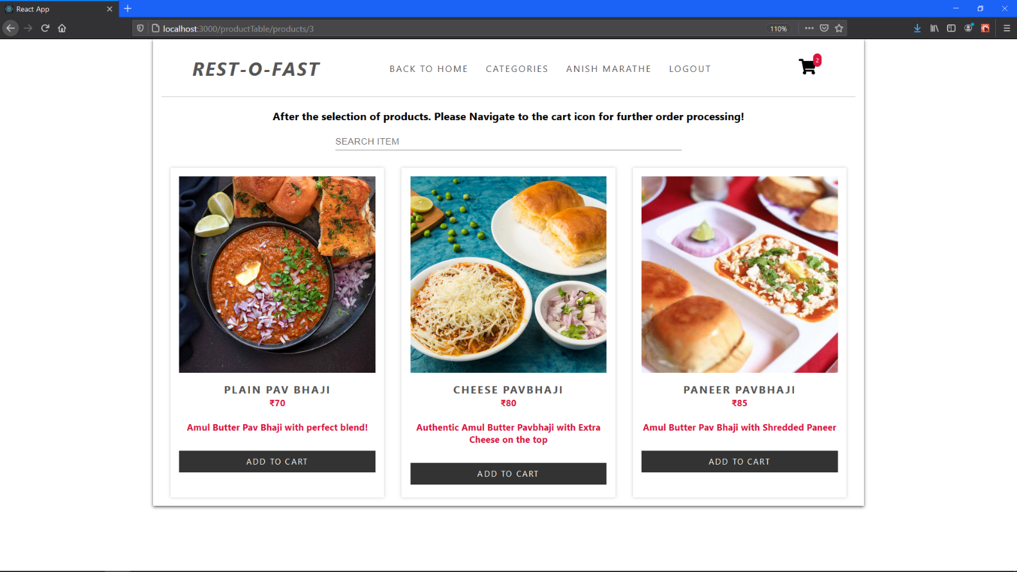

Selecting the menu items (Pav Bhaji).

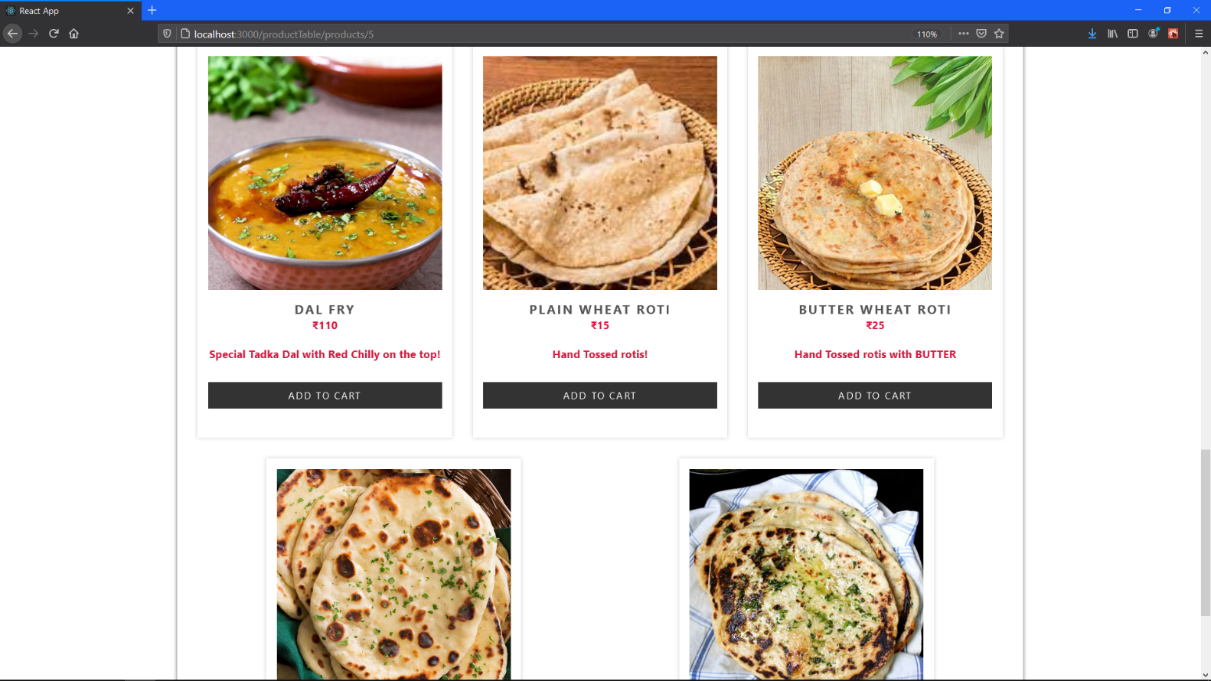

Selecting the menu items (Dal Fry).

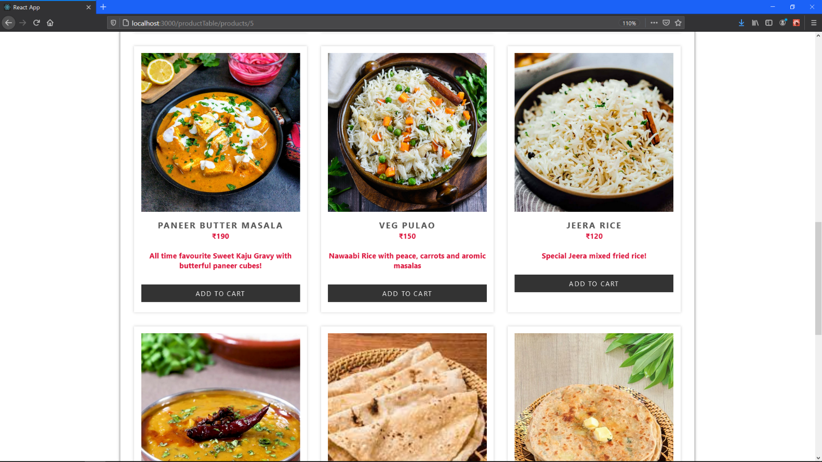

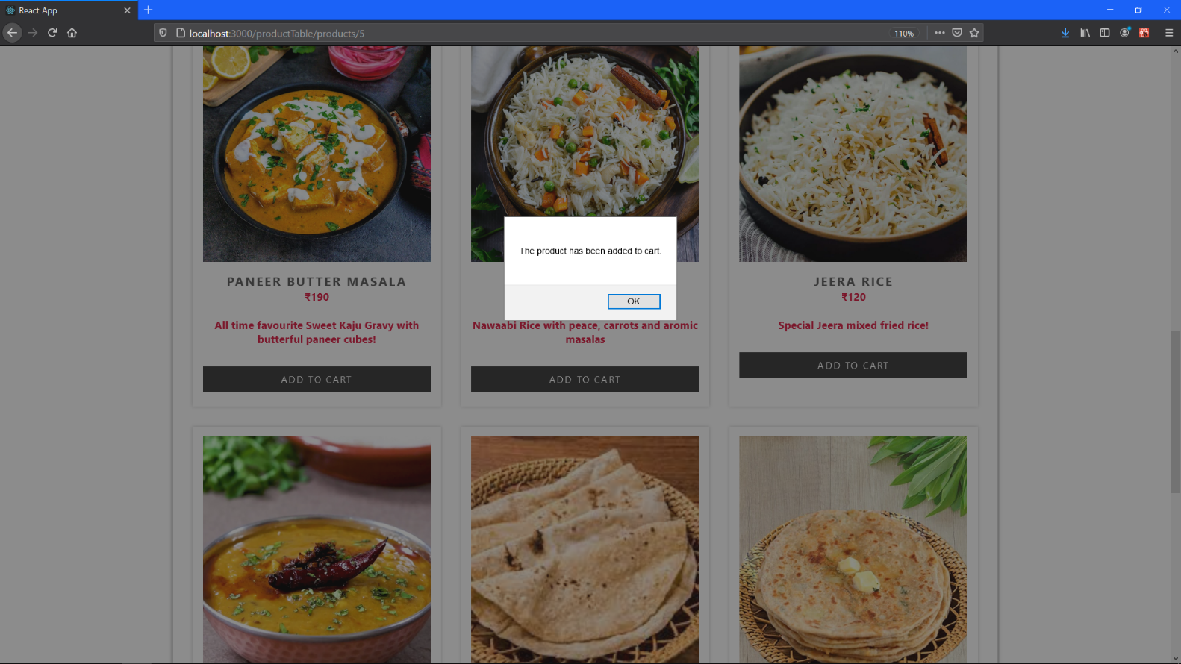Selecting the menu items (Jeera Rice).

Clicked on Jeera Rice again user gets a pop up saying he has already selected this item!

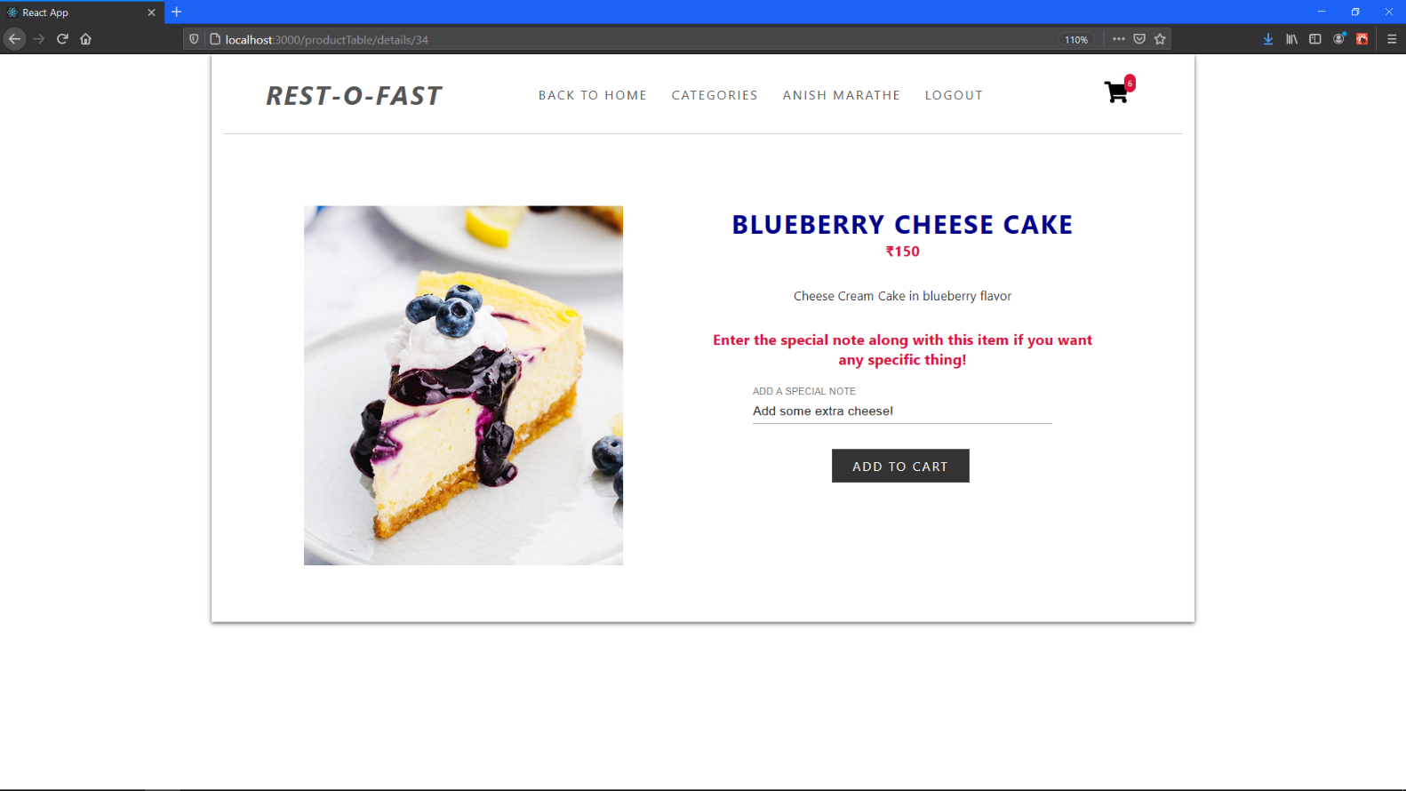

Selected Blueberry cheese cake from DESSERTS category! Option to add a special note along with every item!

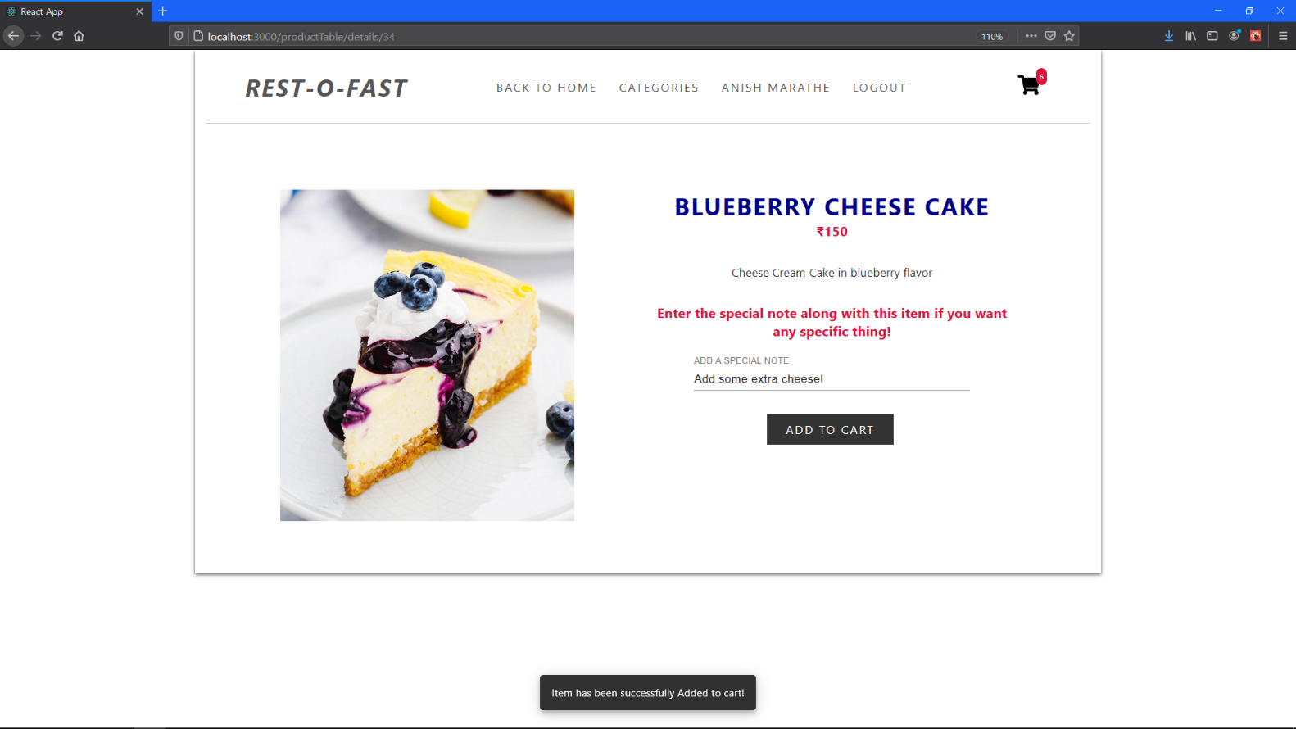

Added to the cart Message!

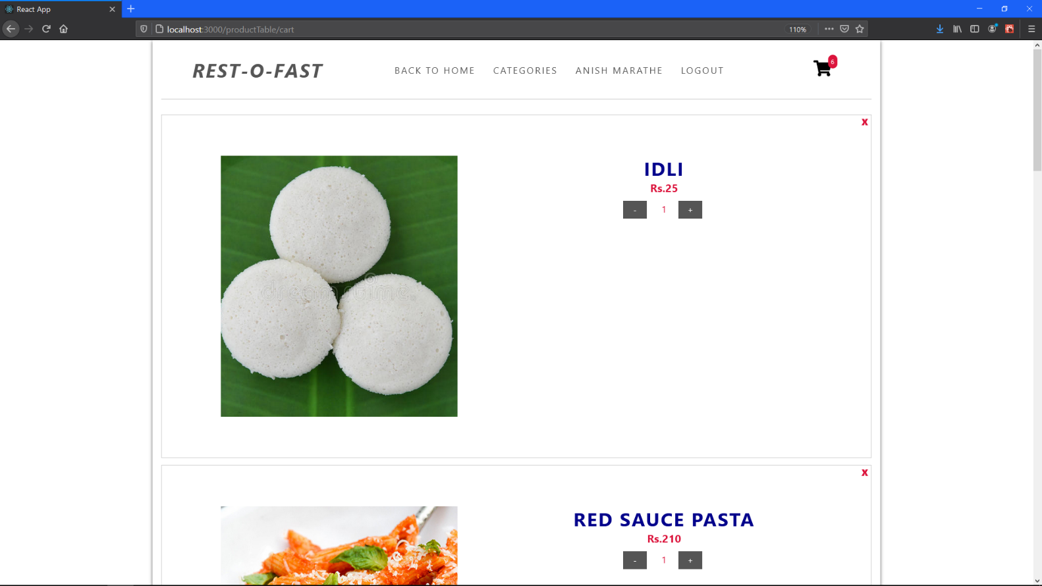

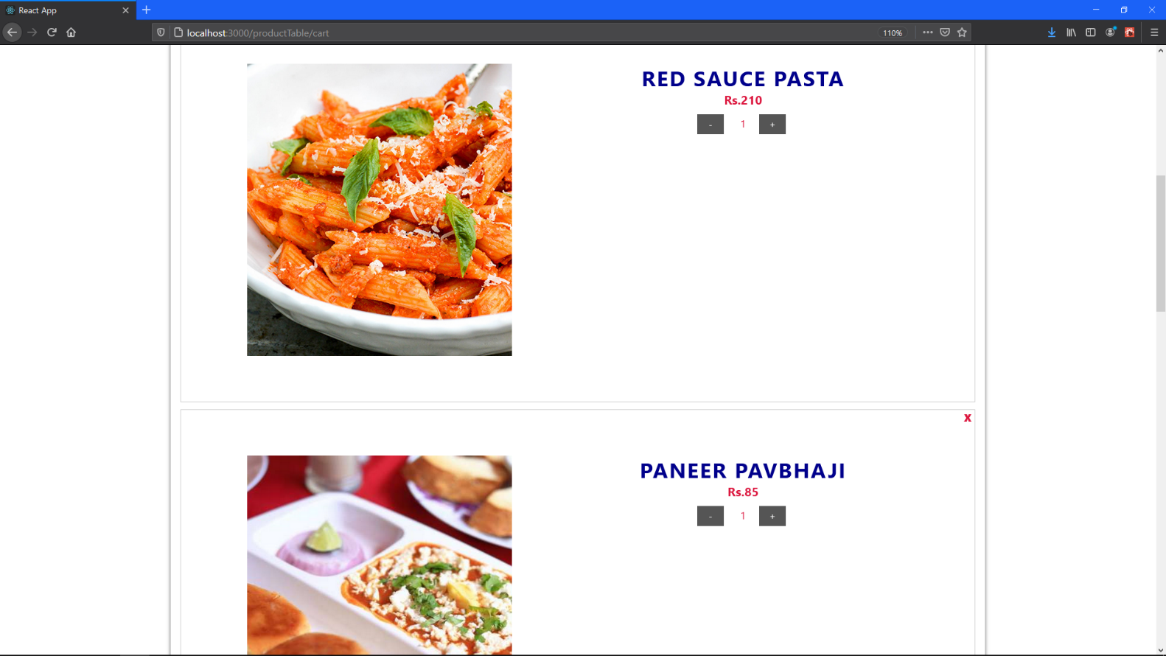

View Cart (Can modify the quantity as well as can remove items from cart over here!

View Cart (2)

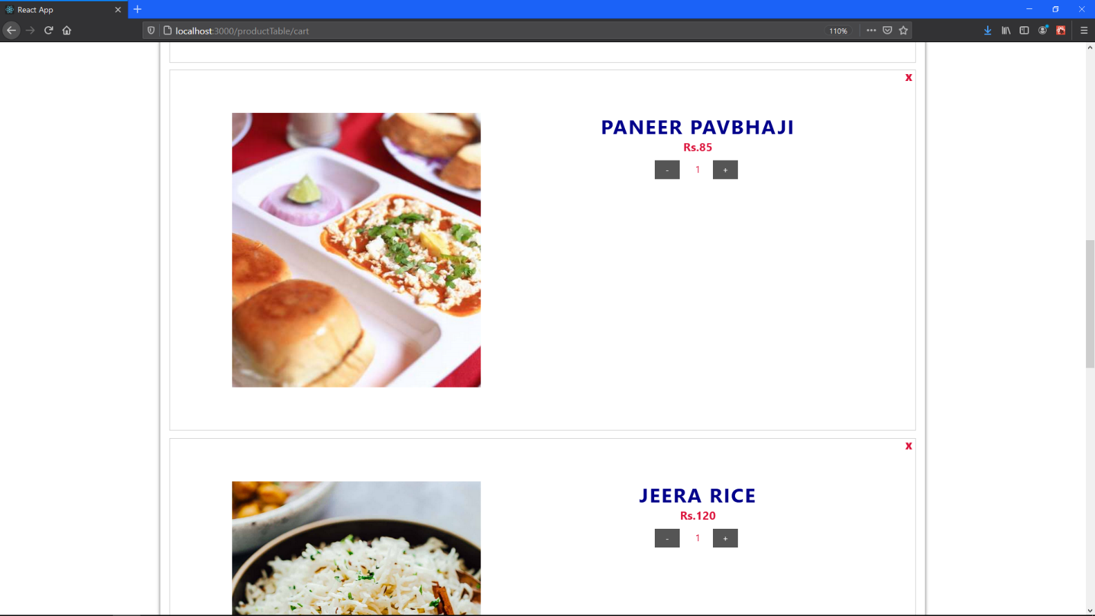

View Cart (3)

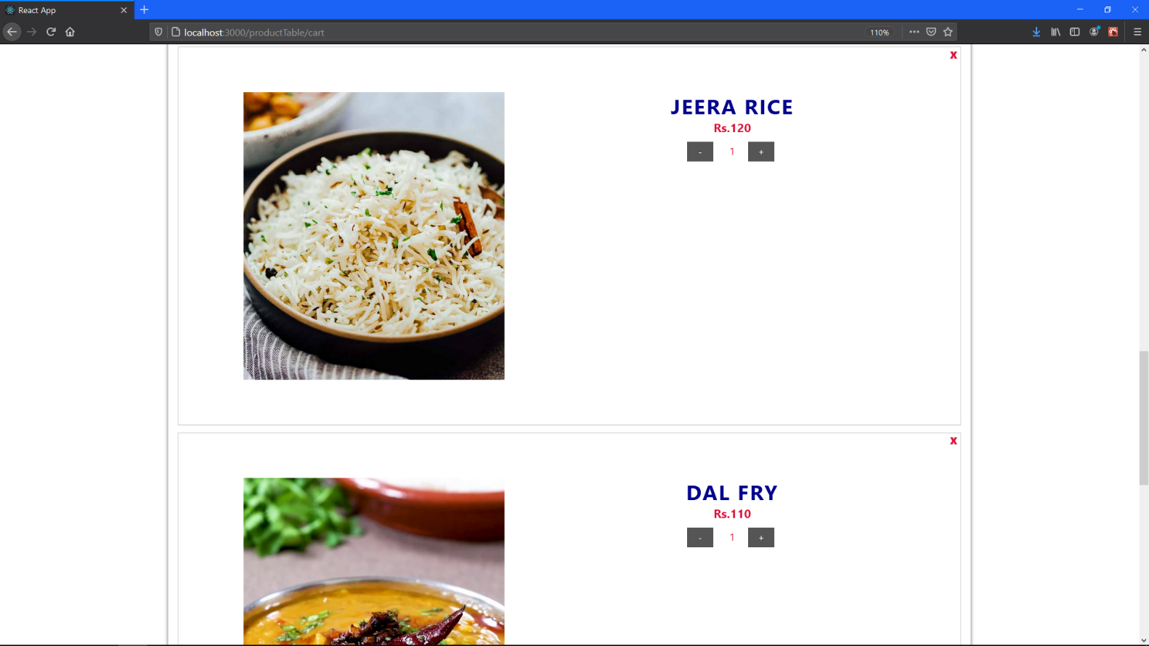

View Cart (4)

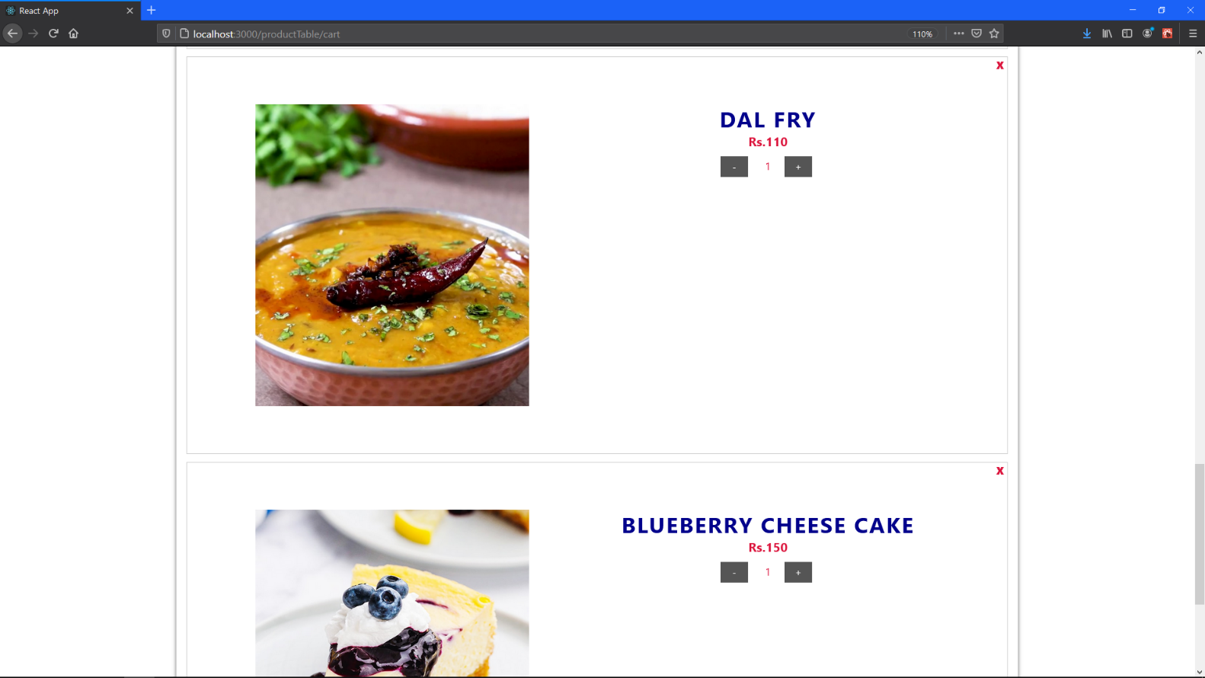

View Cart (5)

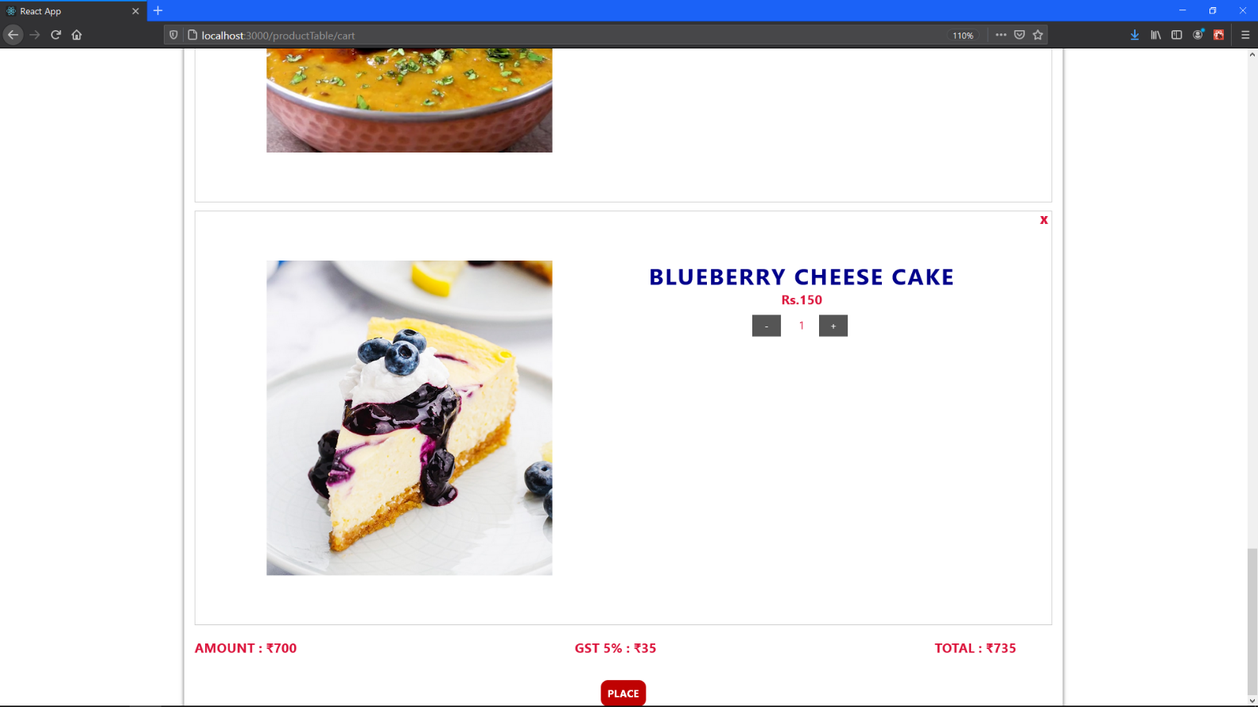

View Cart (6) AMOUNT + GST and Total Amount is displayed)

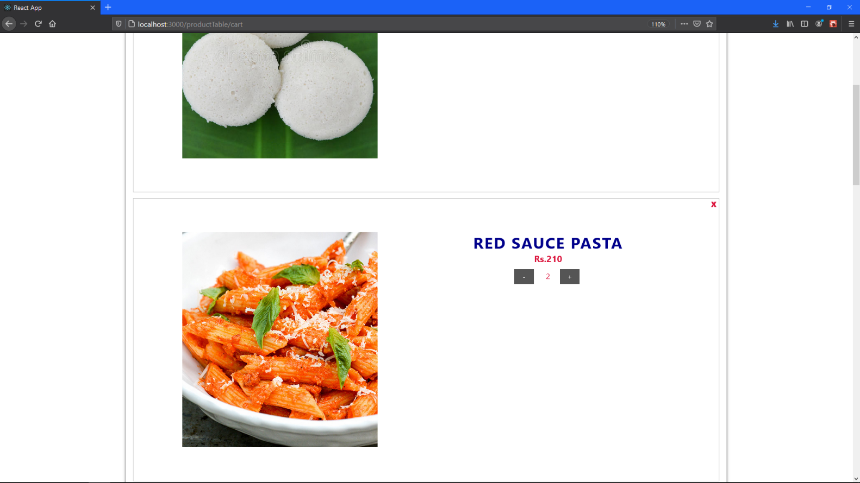

View Cart (7) Notice the Pasta Quantity has changed to 2 Plates!

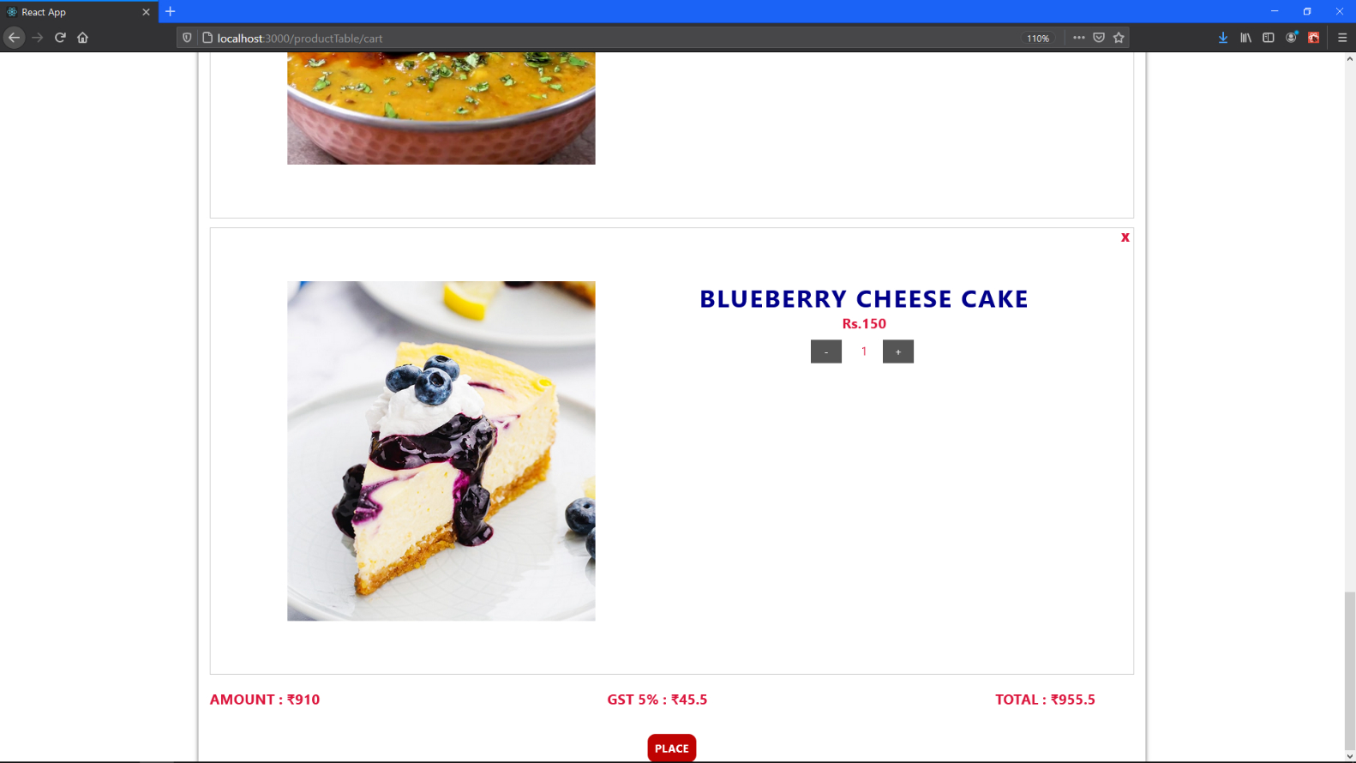

View Cart (8) Notice the Amount, GST and Total Amount reflects the new item quantity added

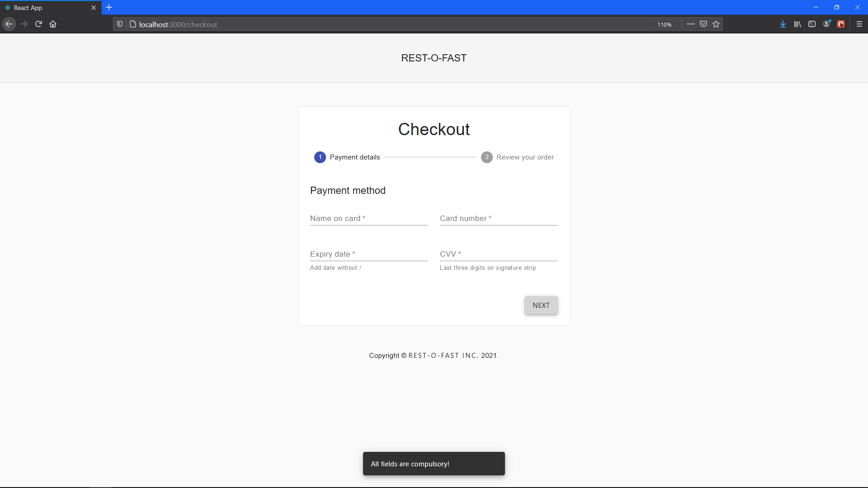

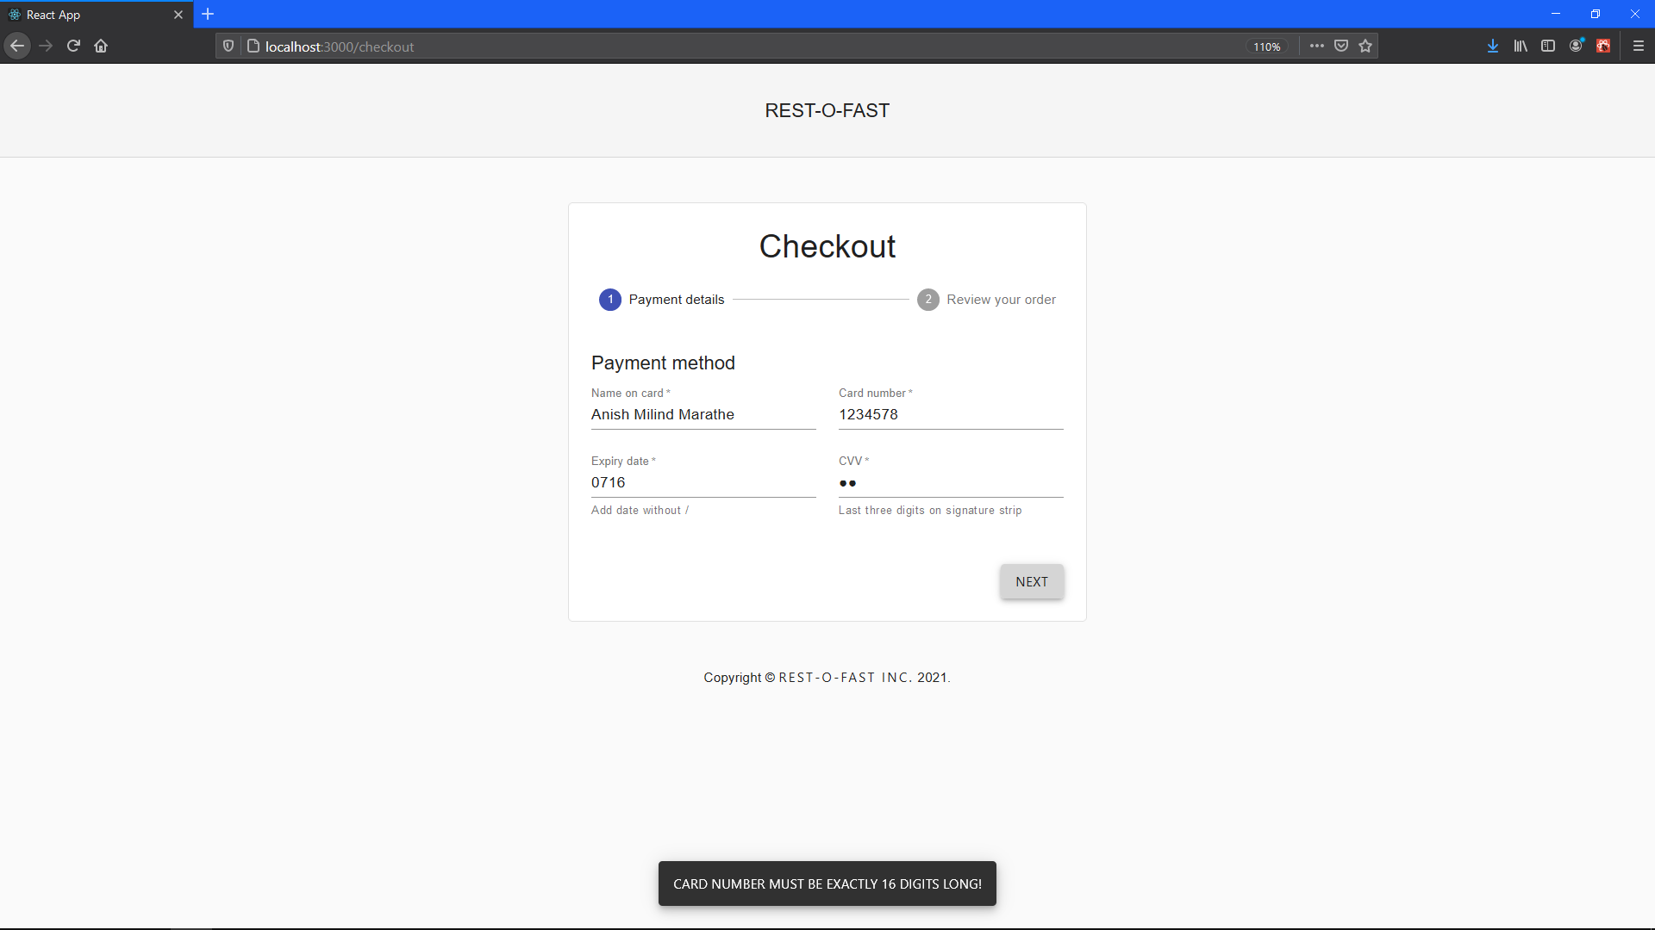

Checkout Page #Validation 1

Checkout Page #Validation 2

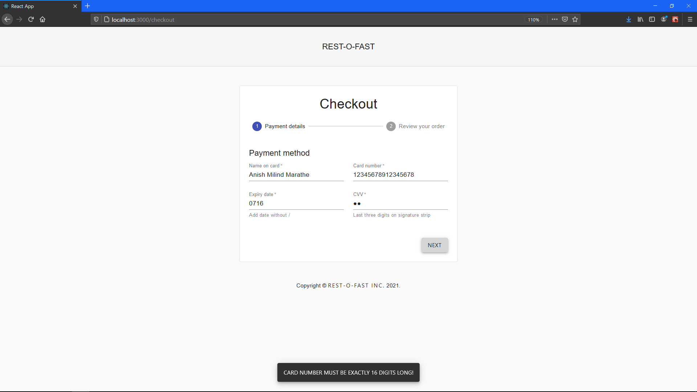

Checkout Page #Validation 3

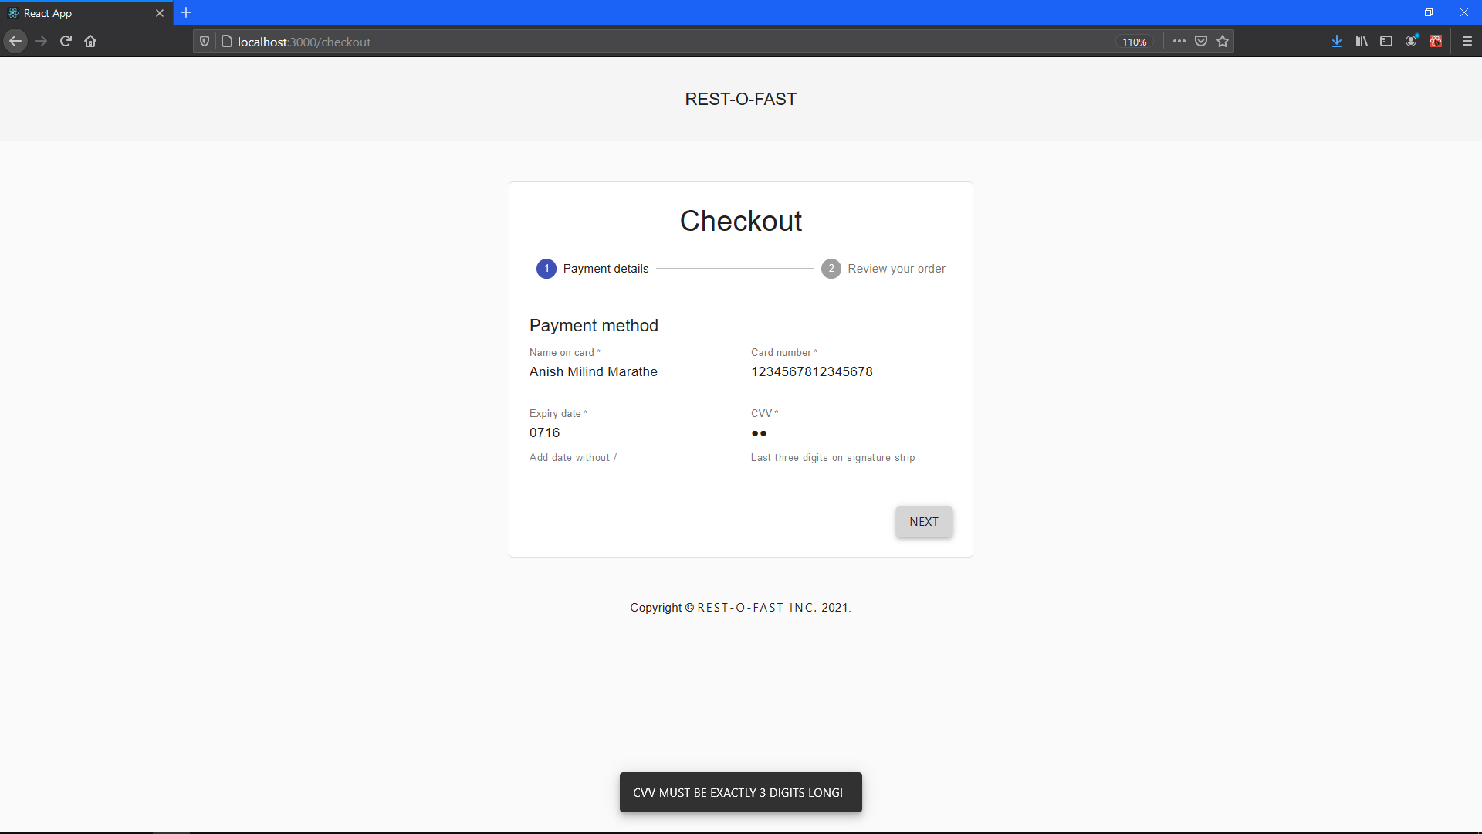

Checkout Page #Validation 4

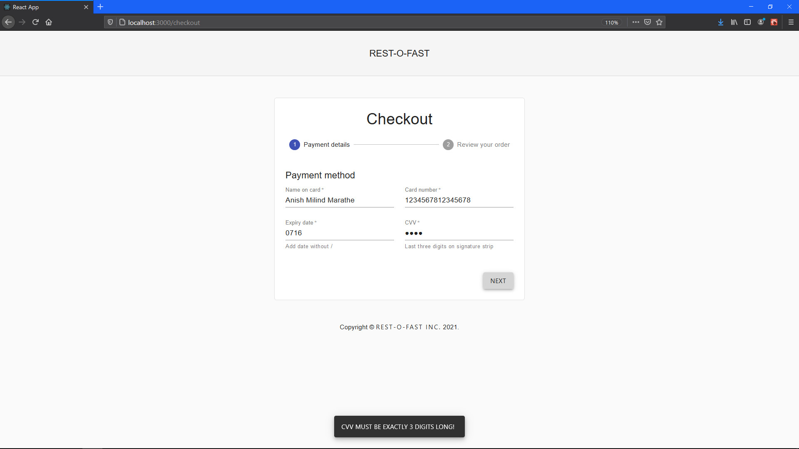

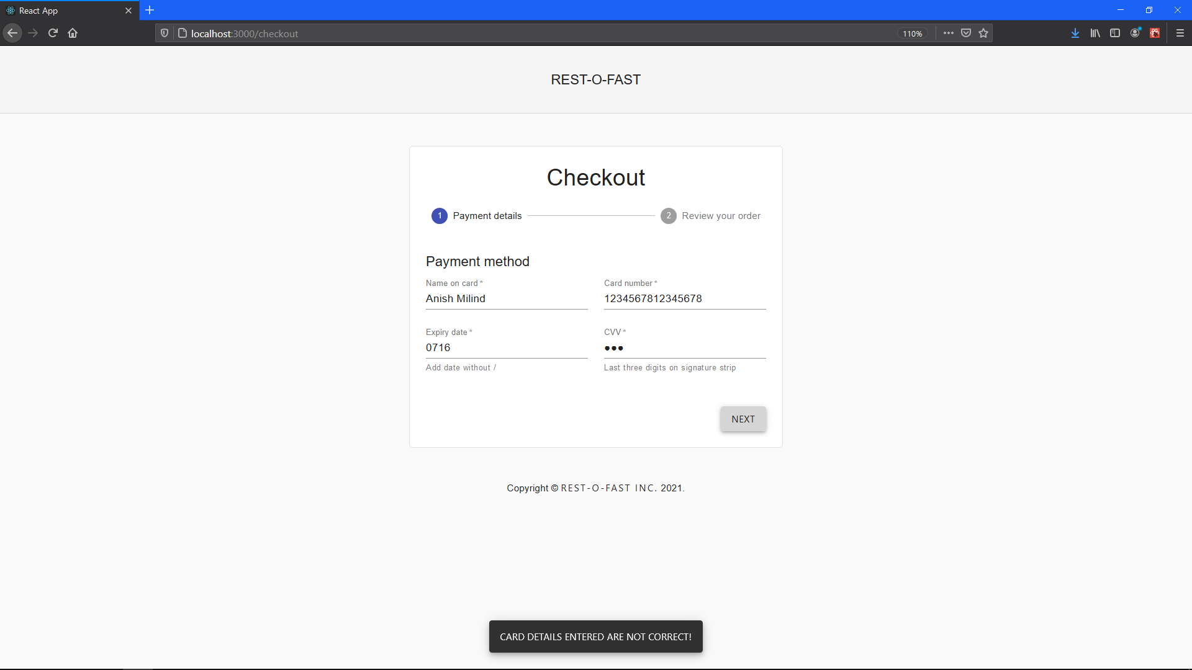 Checkout Page #Validation 5

Checkout Page #Validation 6

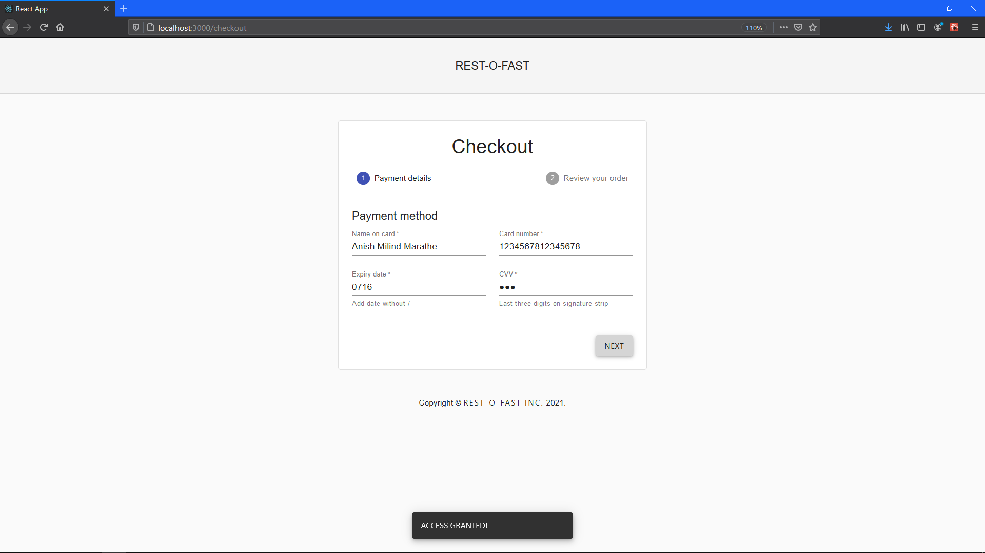

Card Details on correct input!

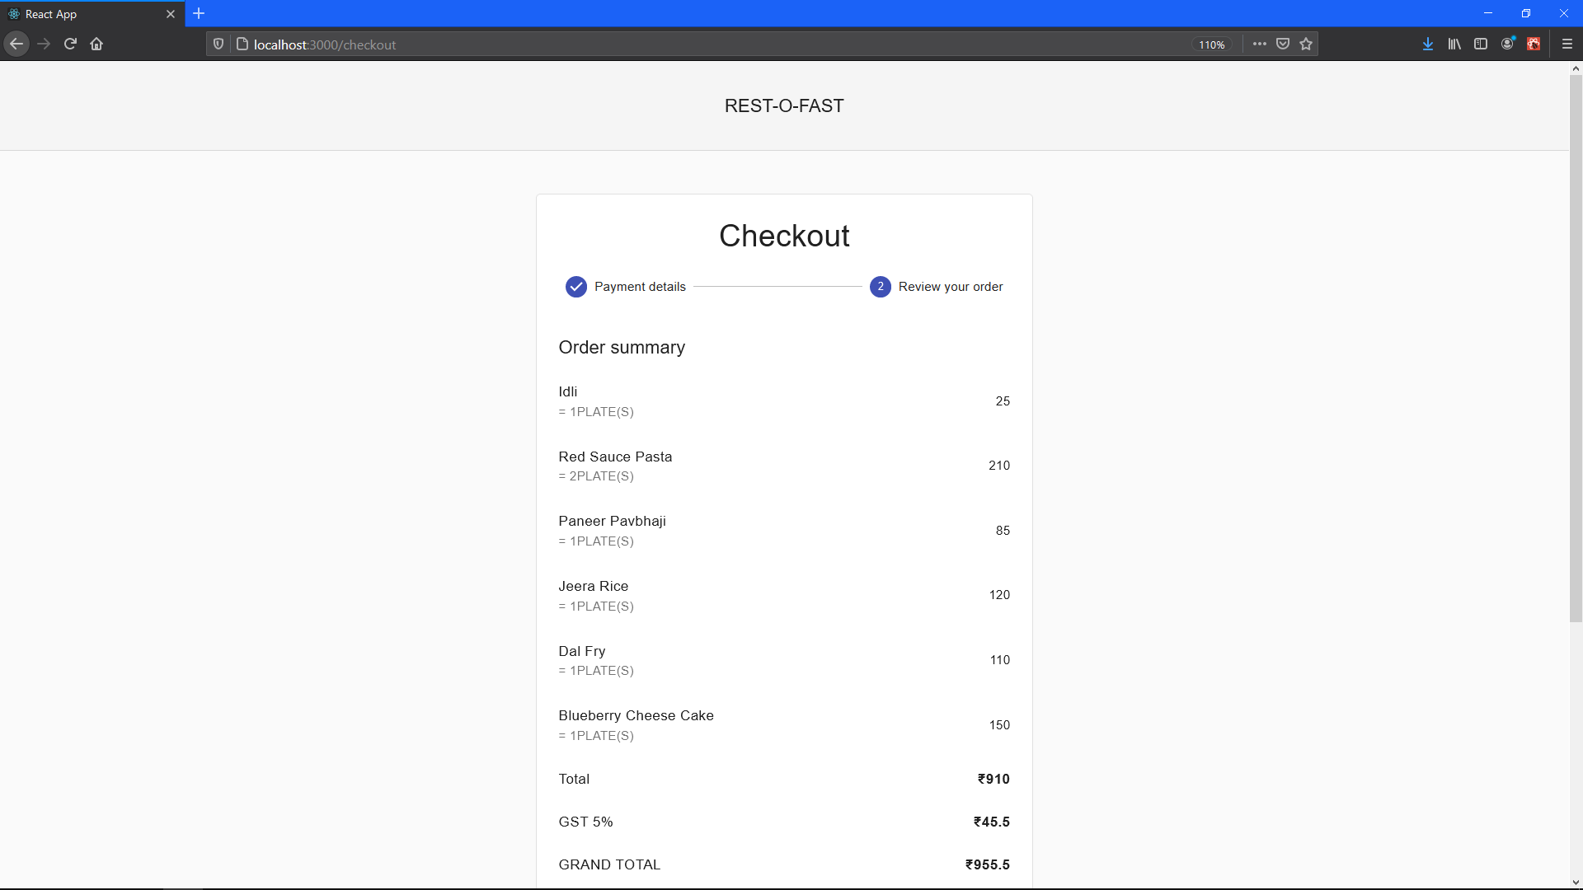

Order Summery (1)

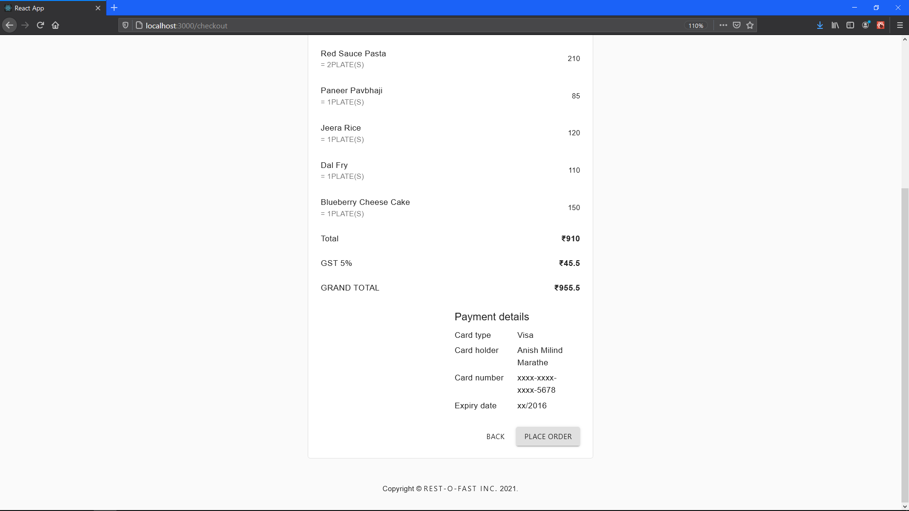

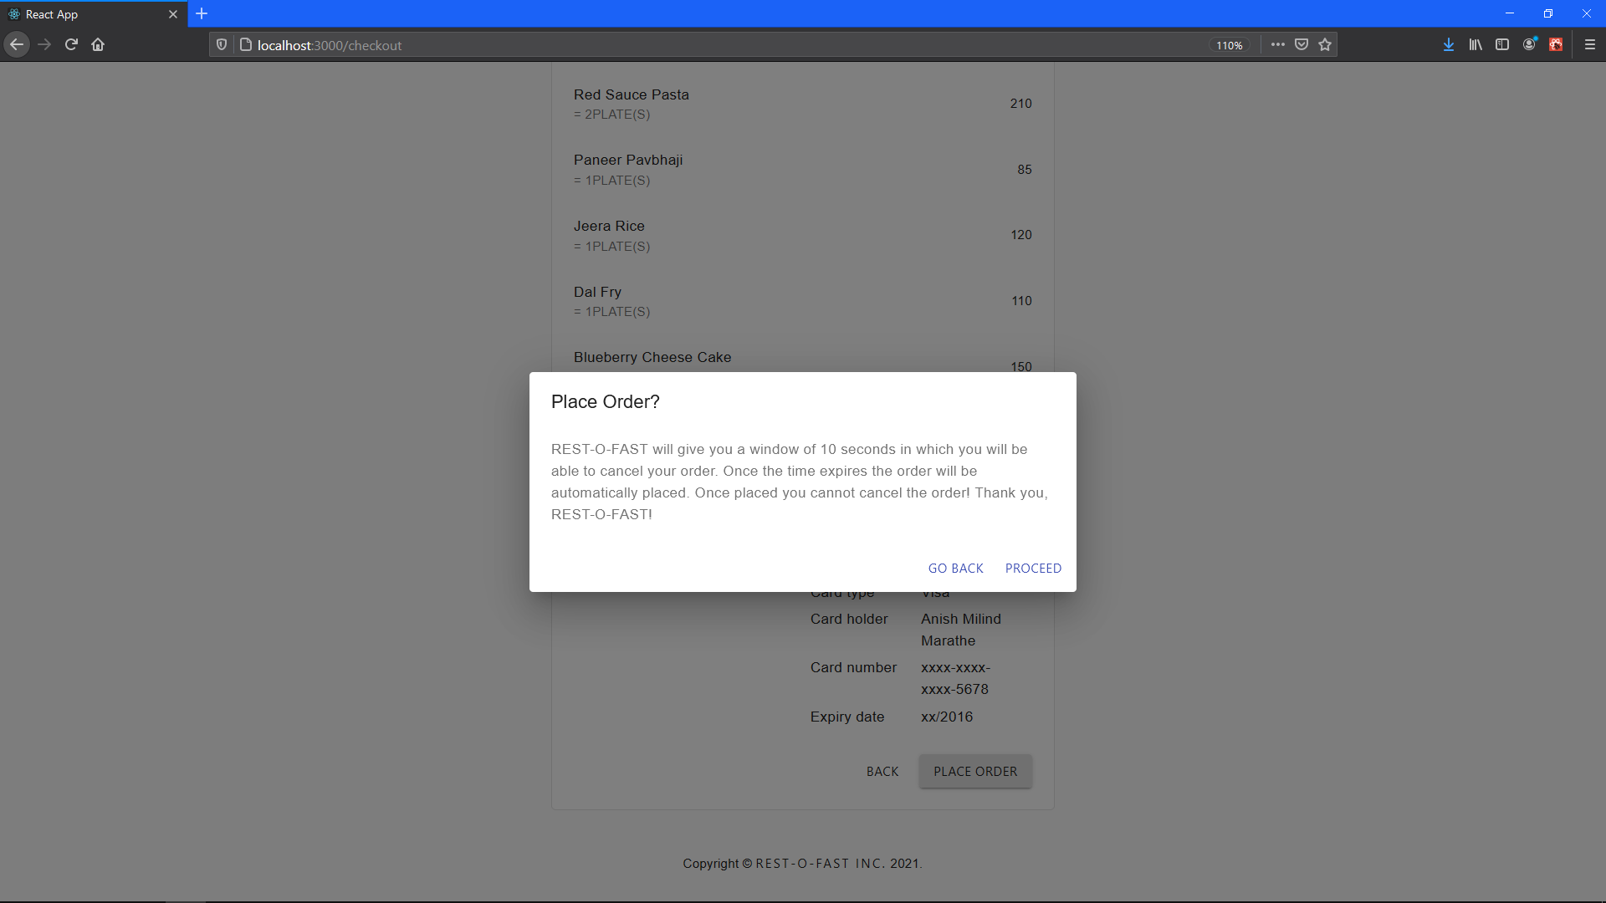

Order Summery (2)

Place Order Prompt

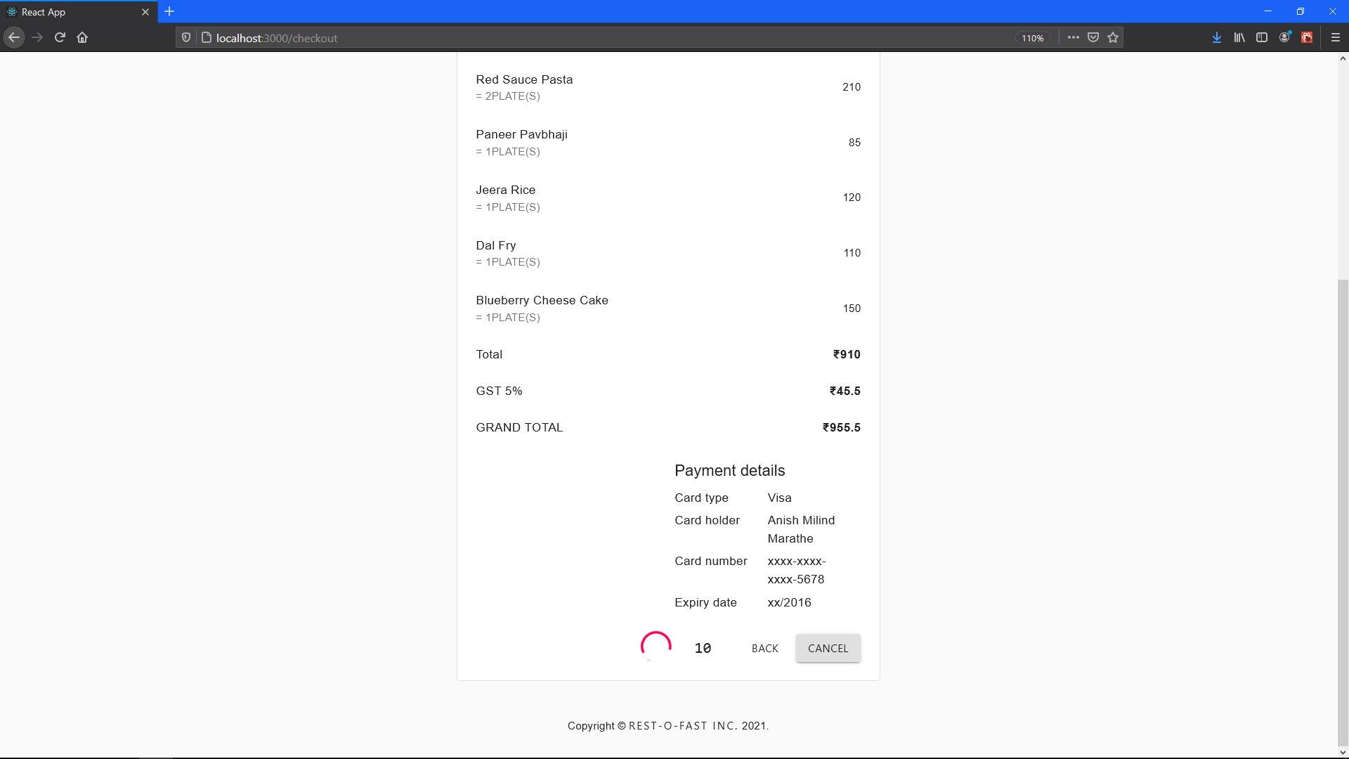

10 Seconds Window Display (1)

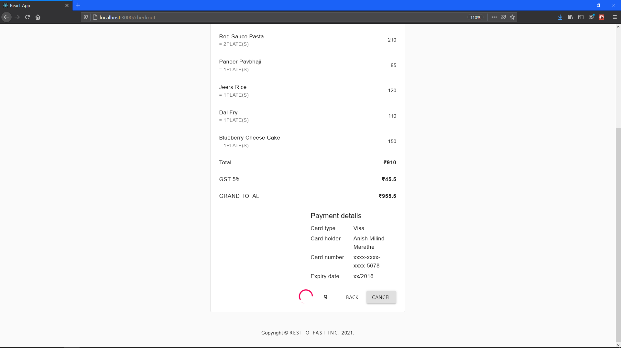

10 Seconds Window Display (2)

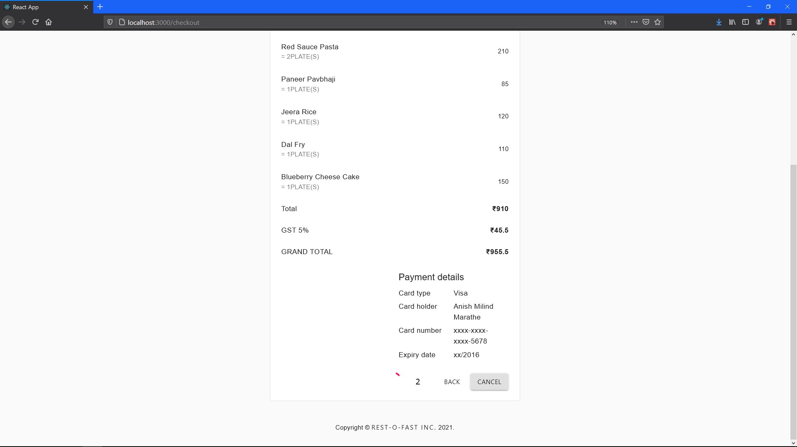

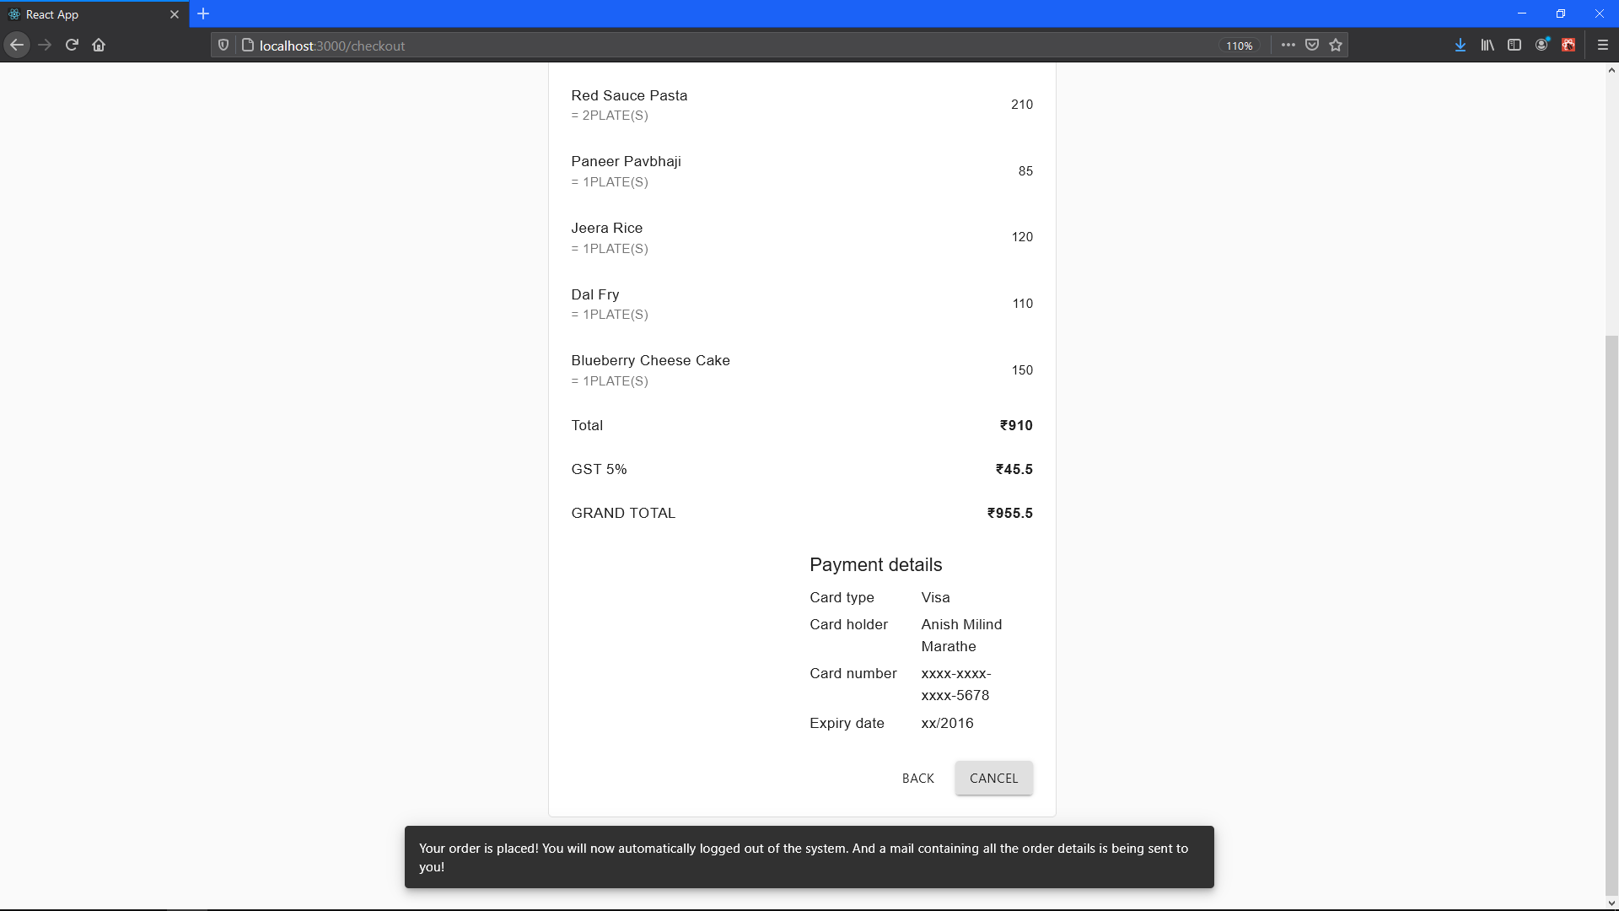10 Seconds Window Display (3)

Once 10 seconds are over! Order is placed, Payment is deducted and Invoice is sent to on to the registered Email-ID.

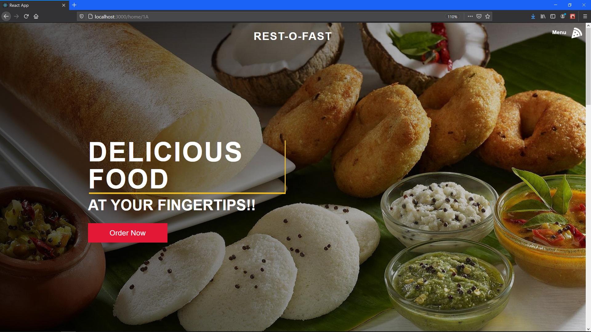

Once order is placed, Automatically Logged out of the system!

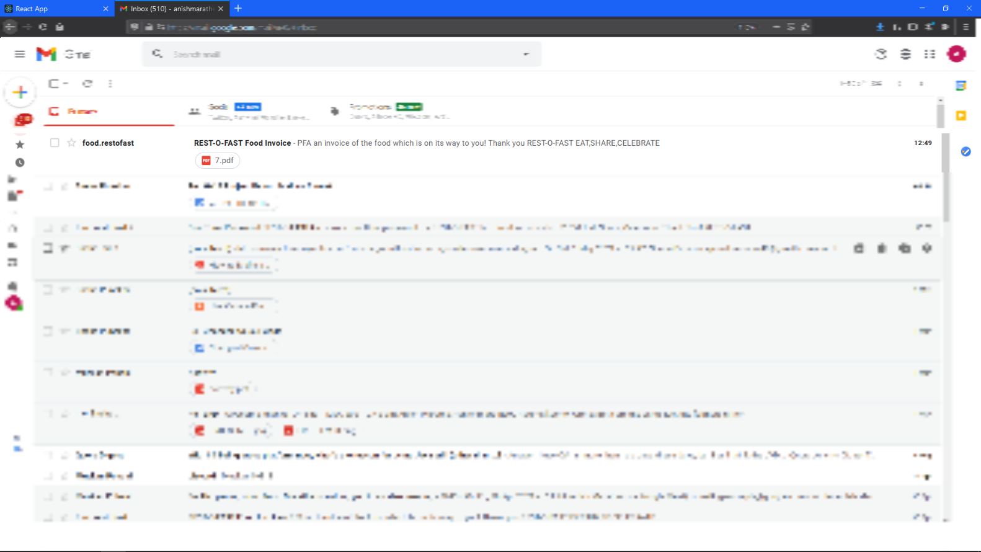

GMAIL window for showing the invoice has received!

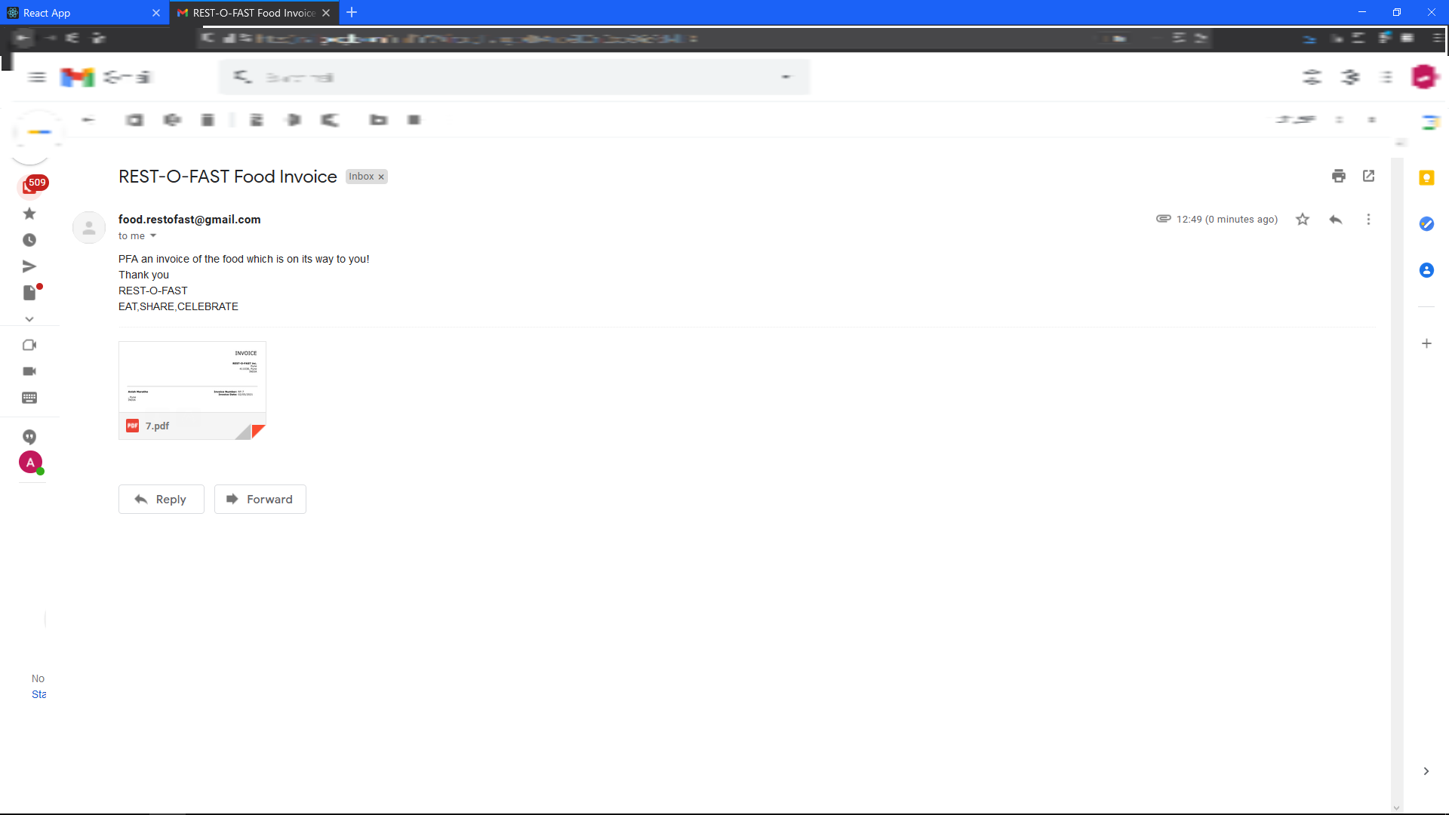

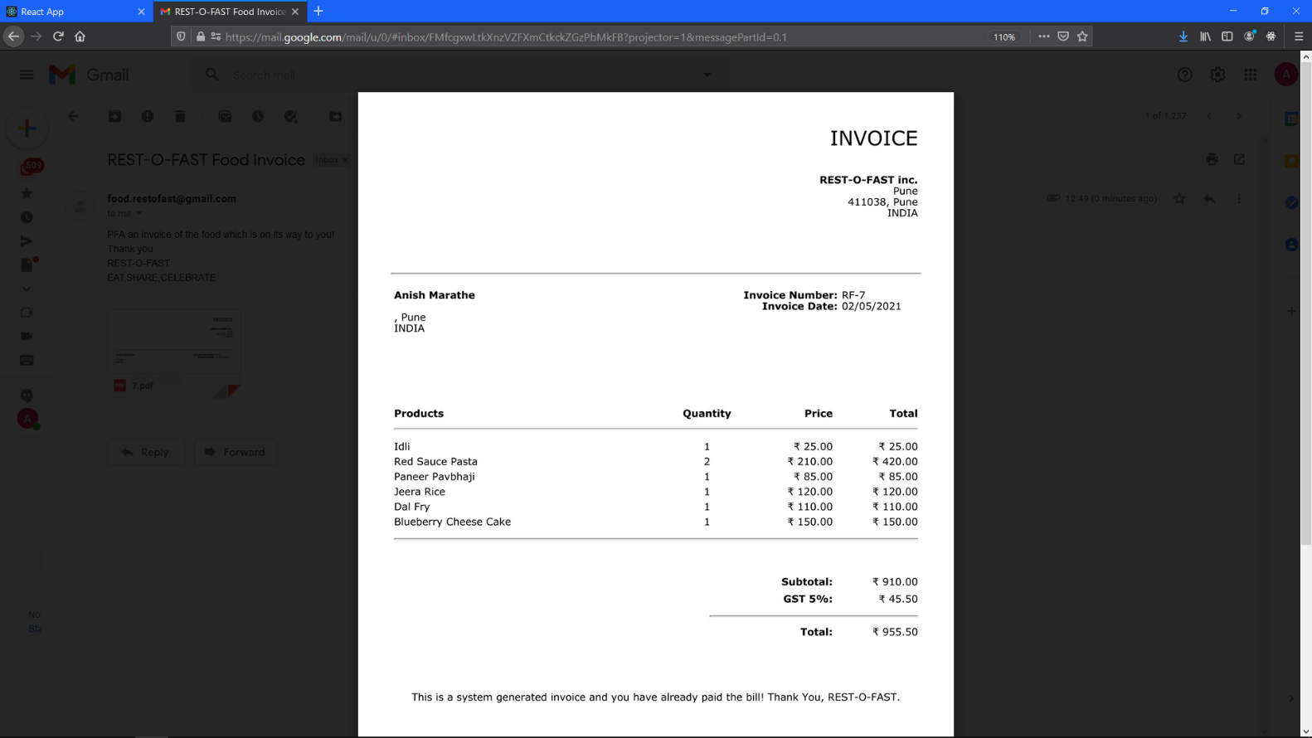GMAIL window for showing the invoice mail contents!

The actual dynamic invoice!

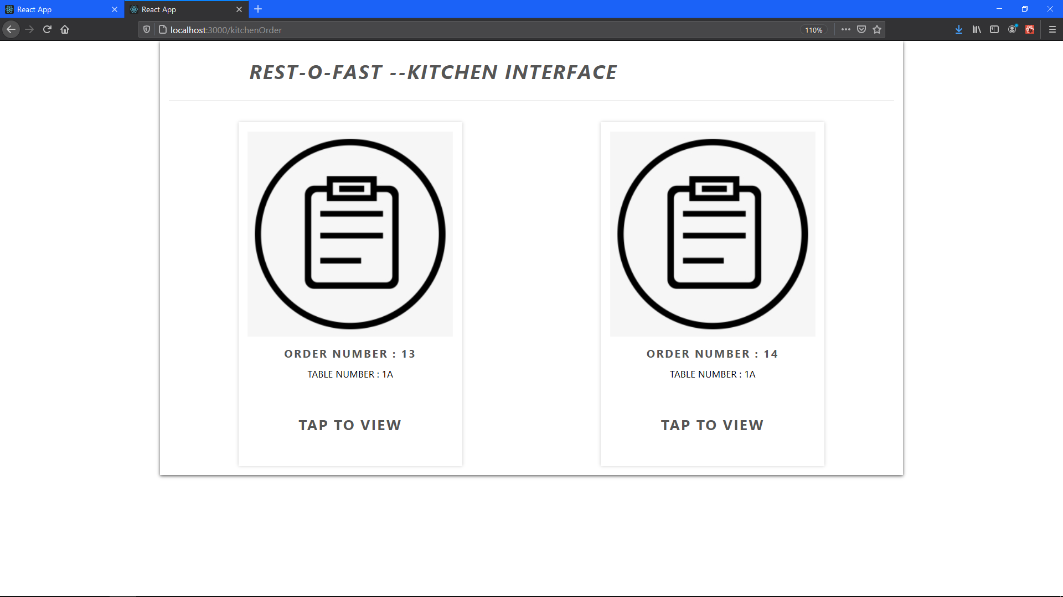

Kitchen Interface Displaying the list of orders along with table numbers

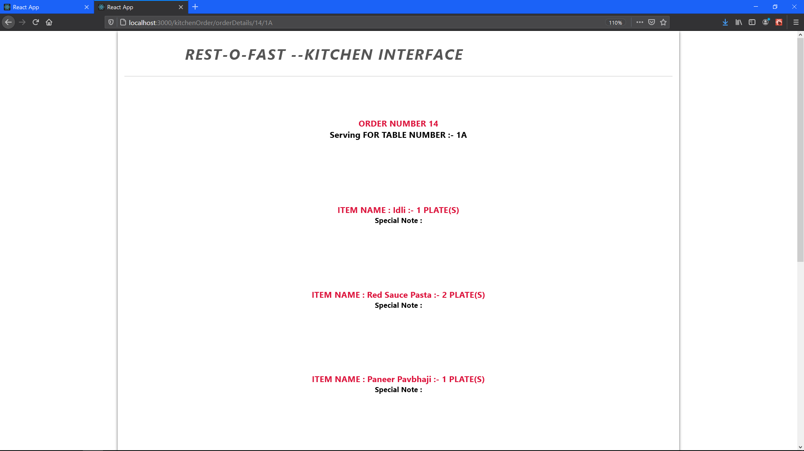

Kitchen Interface Displaying the order details (1)

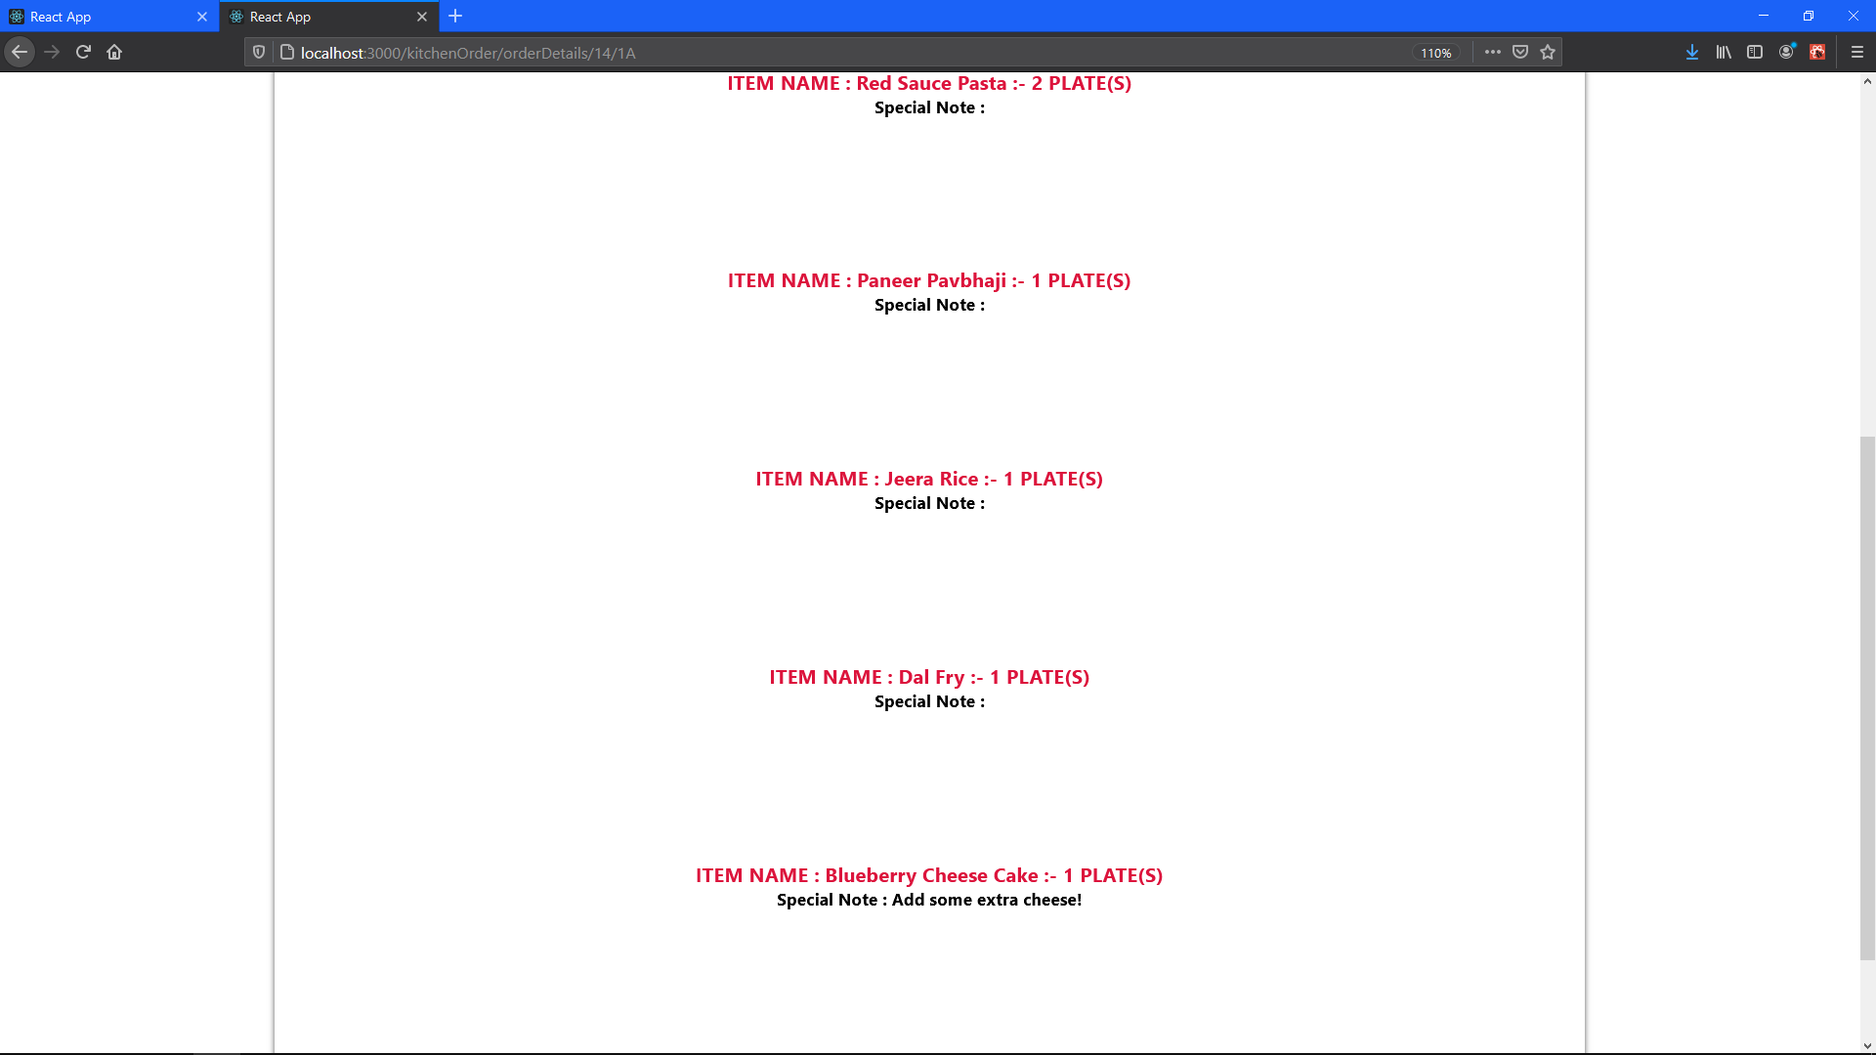

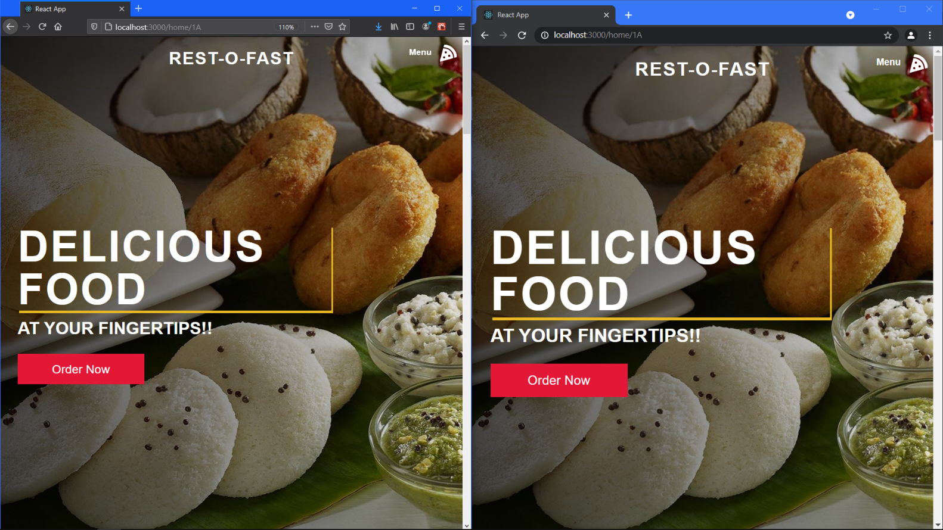Kitchen Interface Displaying the order details (2)

2 Different Browsers representing 2 different users if scan the same QR code placed in front of same seat. (Notice the same seat number i.e., 1A)

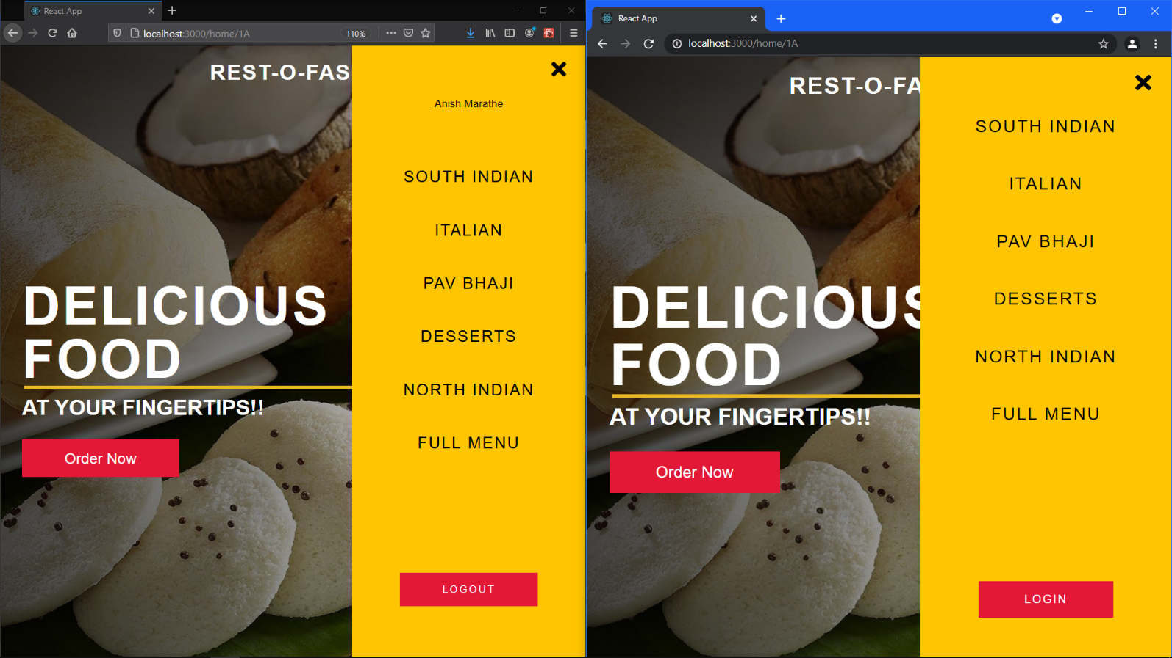

Left browser has logged in, while the right one is not!

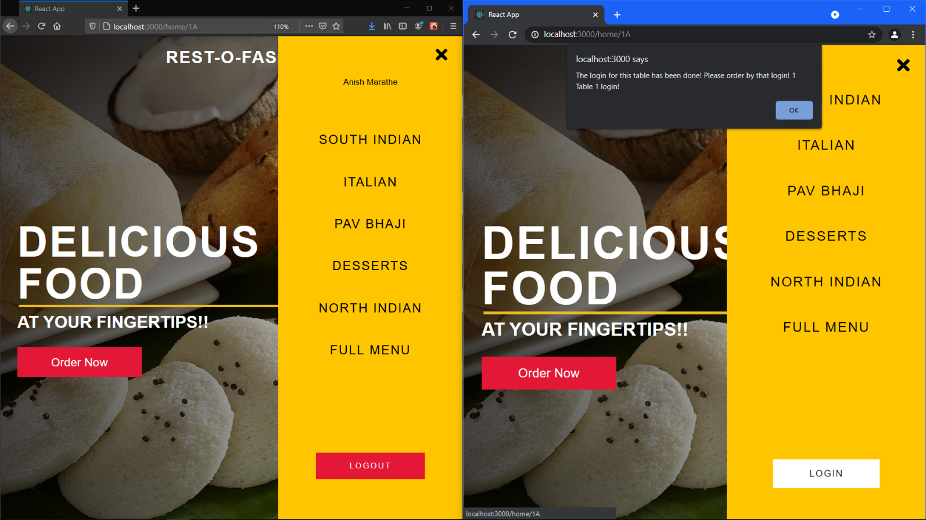

If the right browser also tries to log in at the time. It is prompted with an error!

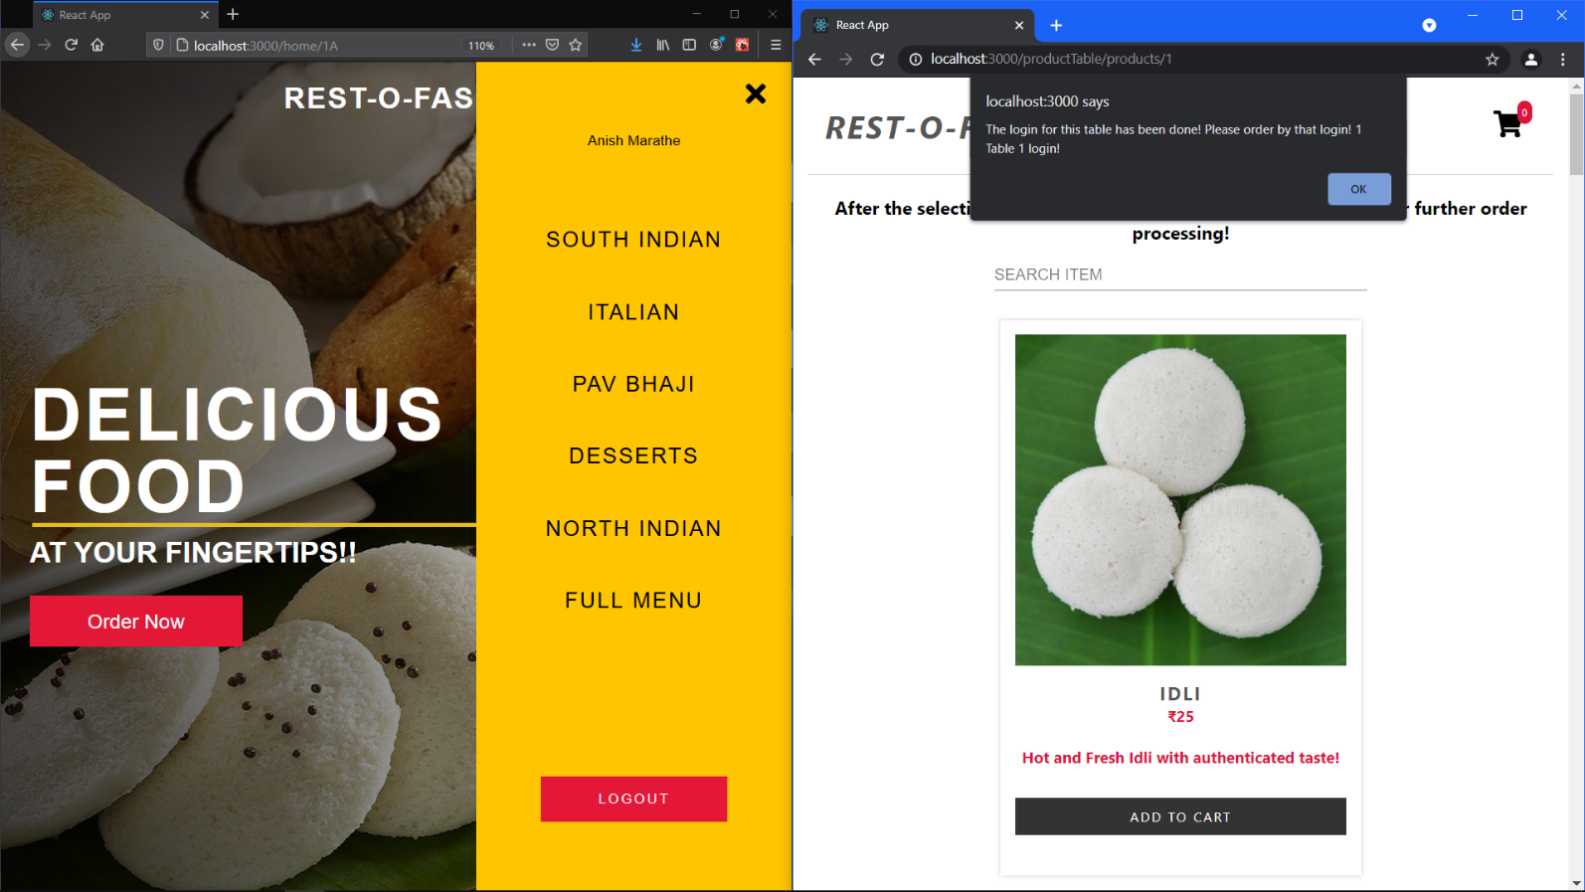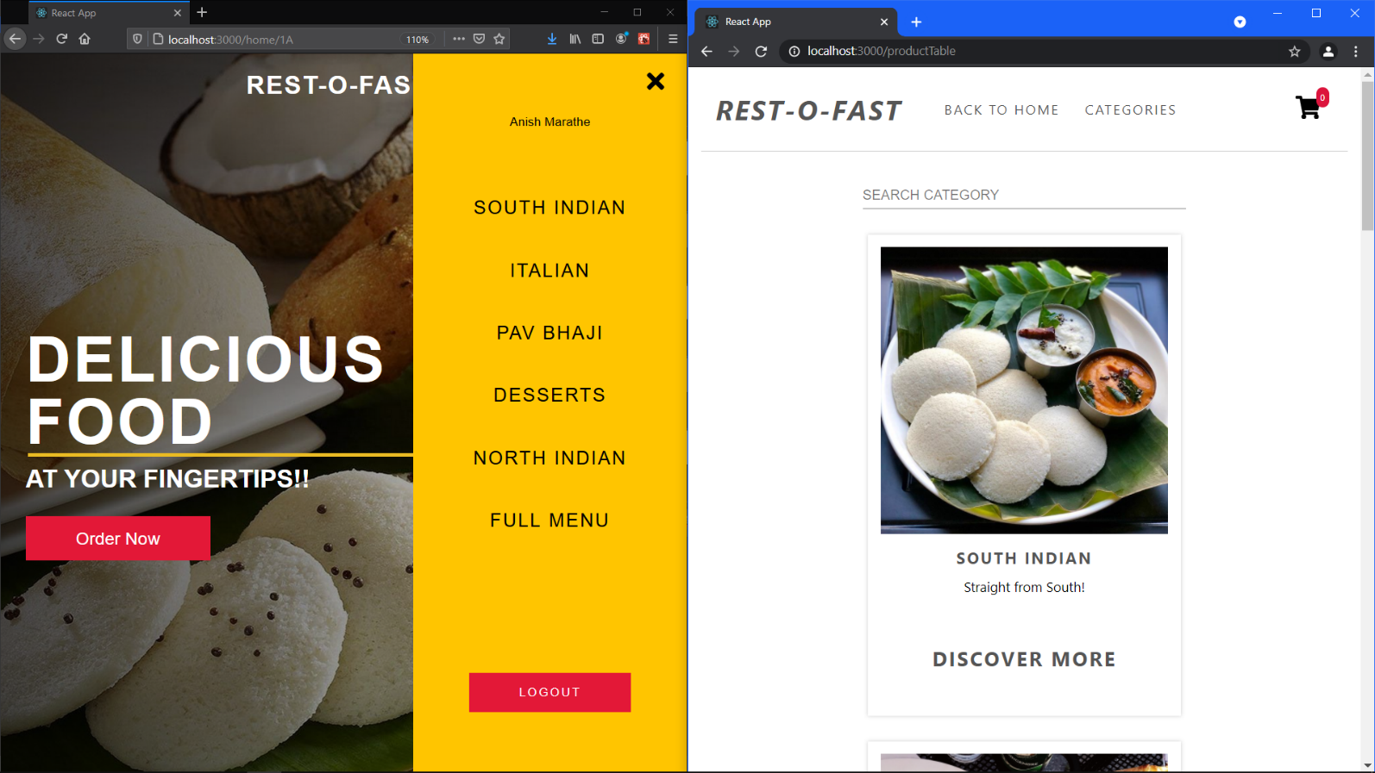

But the right one can still view the whole menu

As soon as the right browser tries to add something to the cart. It gets an error. Because the seat 1A has already booked by some other user.

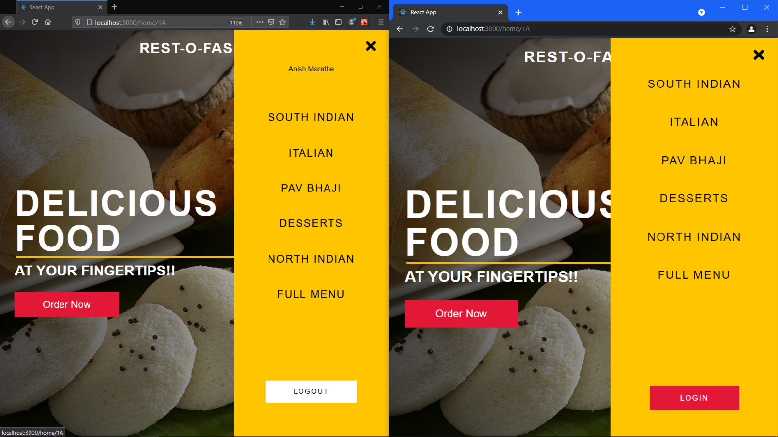

But as soon as the left browser logs out of the session. Seat at Table is freed! i.e., seat 1A is no longer occupied

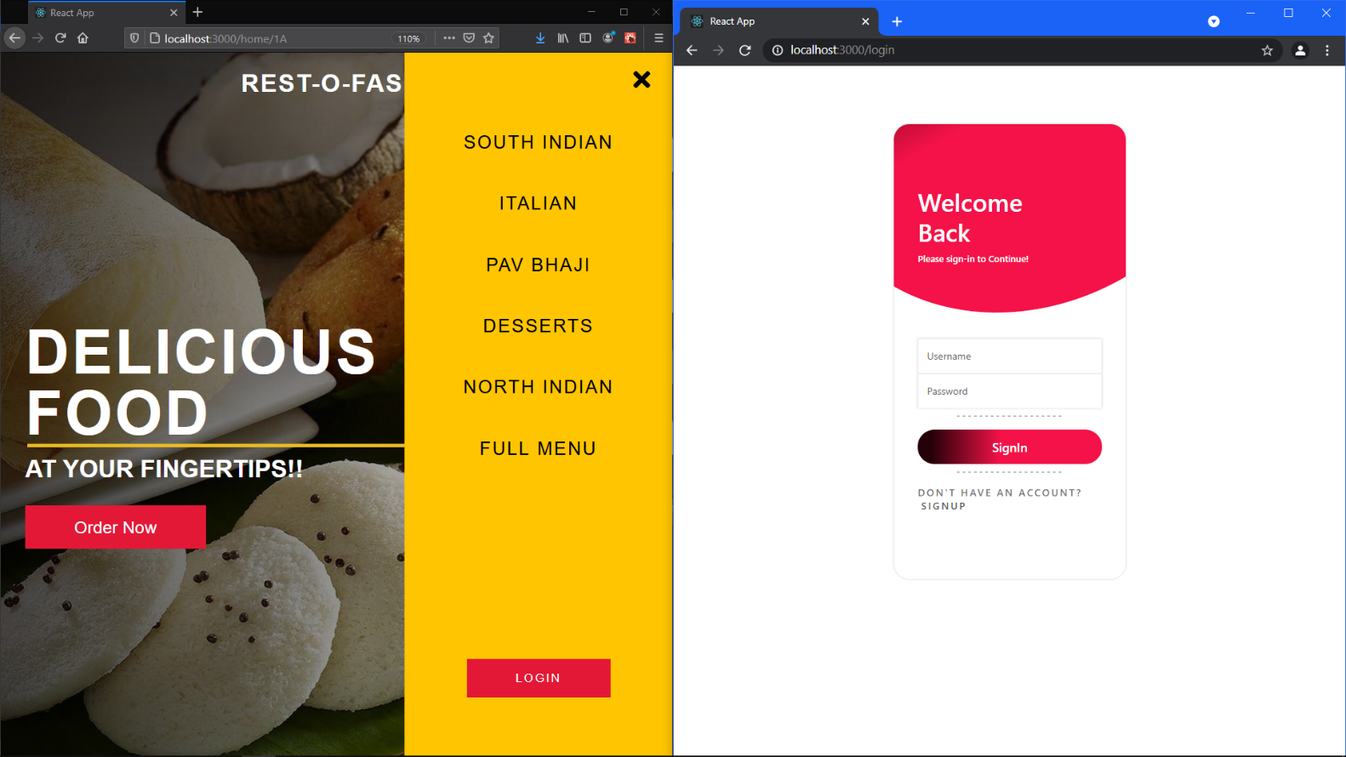

Now if the right browser wishes to log in, it can login now.

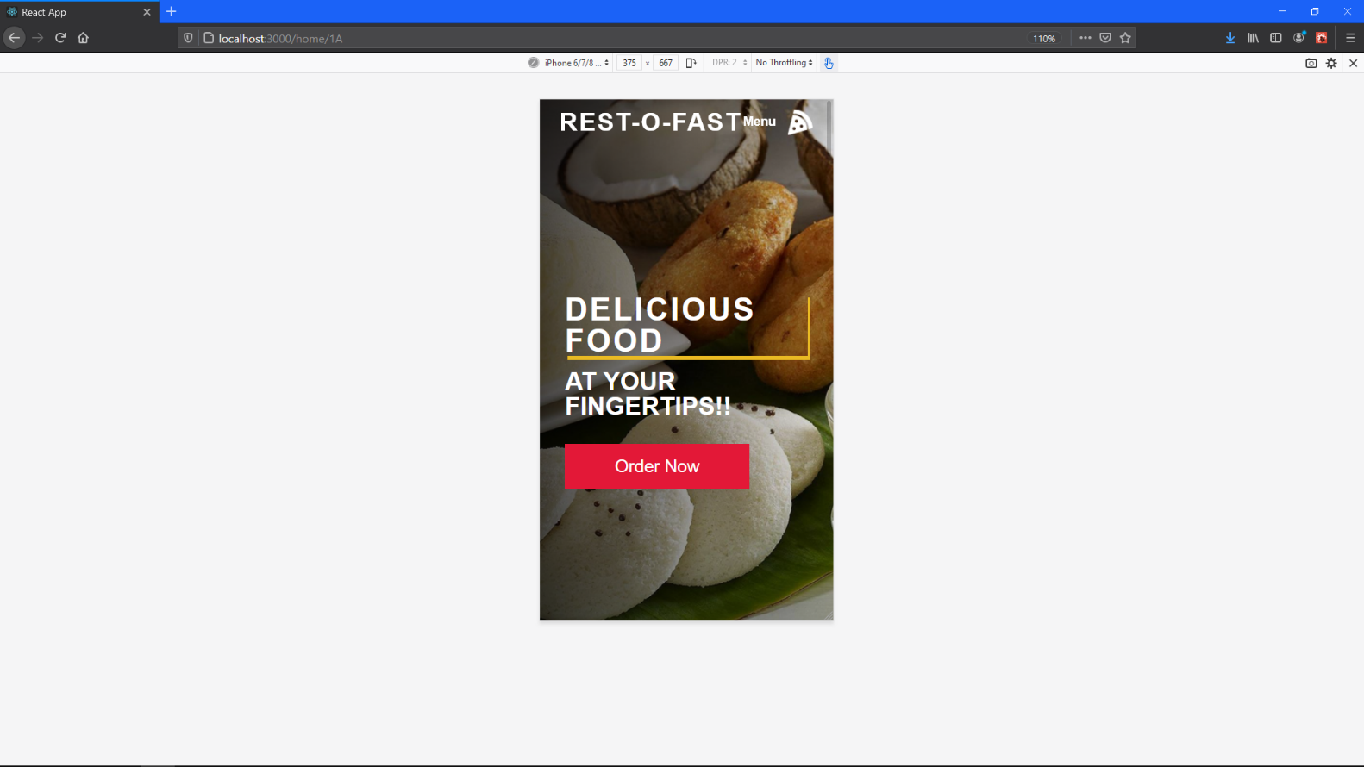

How the site loads up on the mobile screens! (Responsive (1))

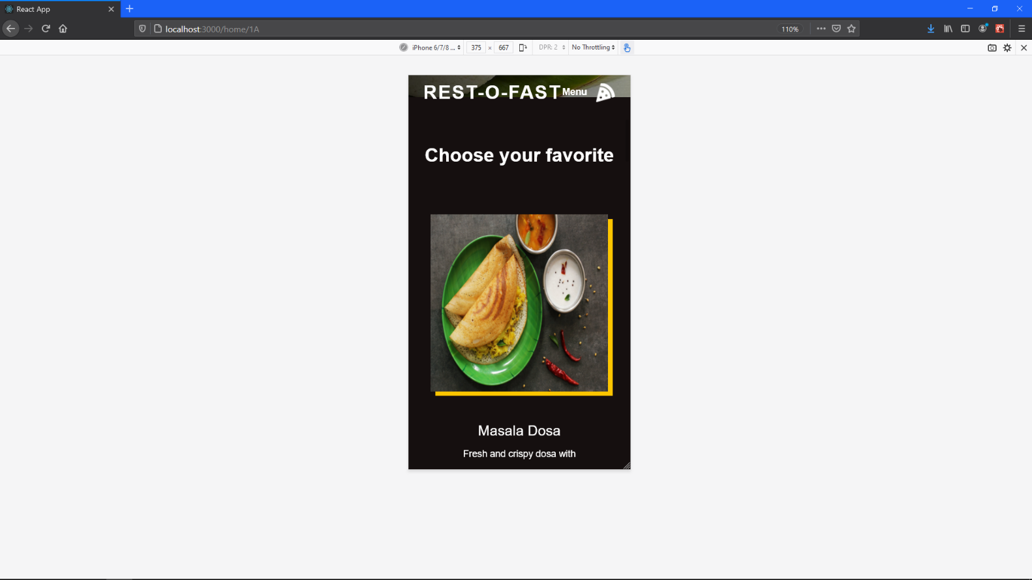

Responsive (2)

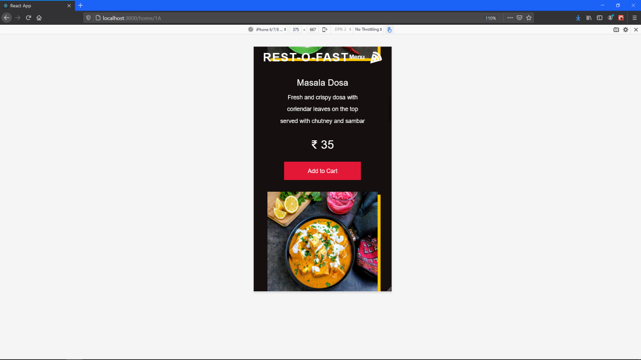

Responsive (3)

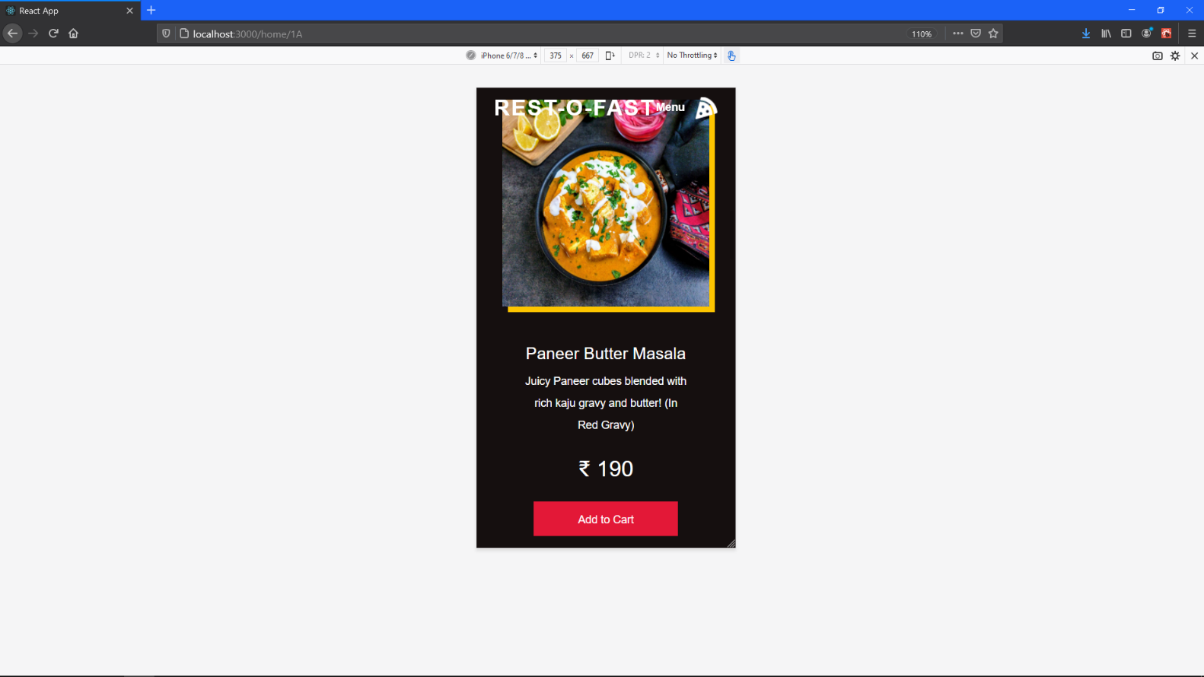

Responsive (4)

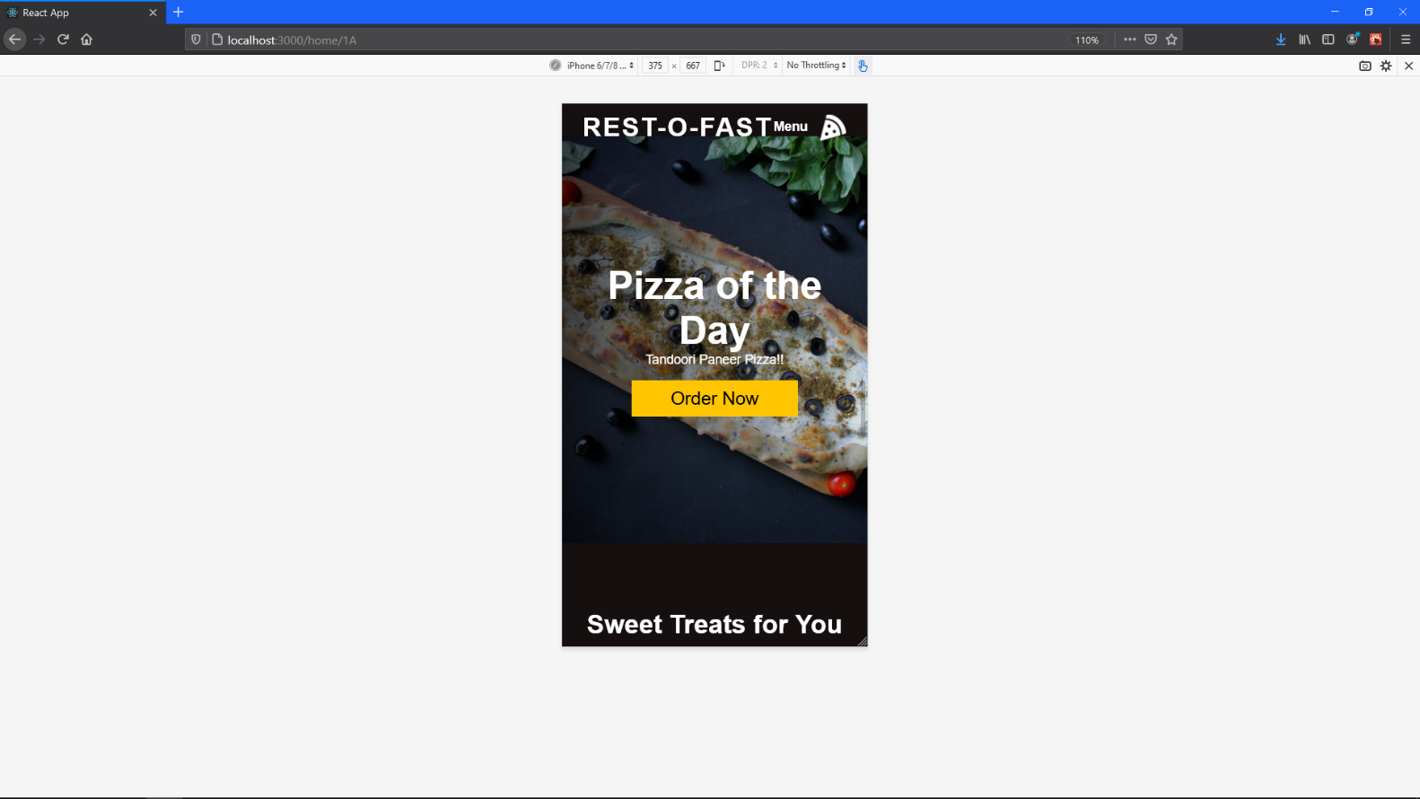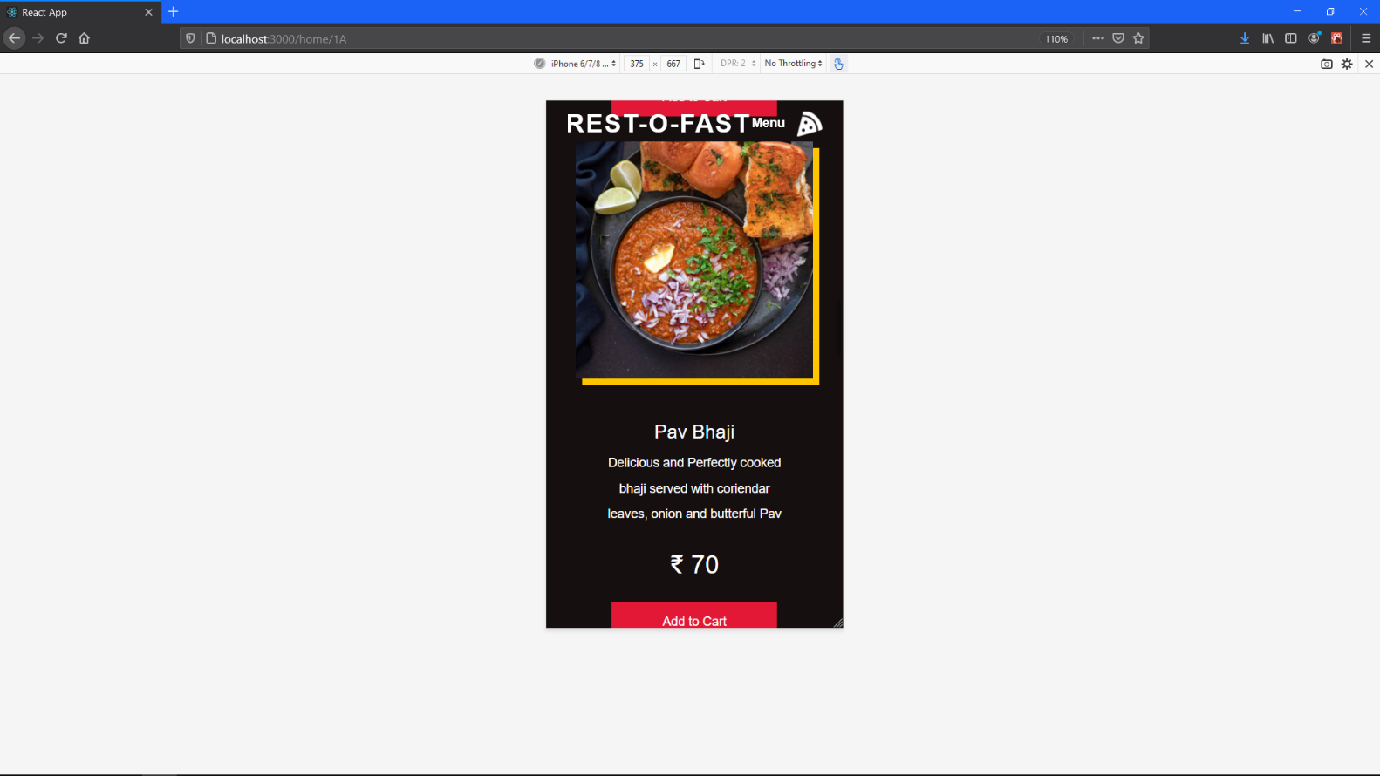

Responsive (5)

Responsive (6)

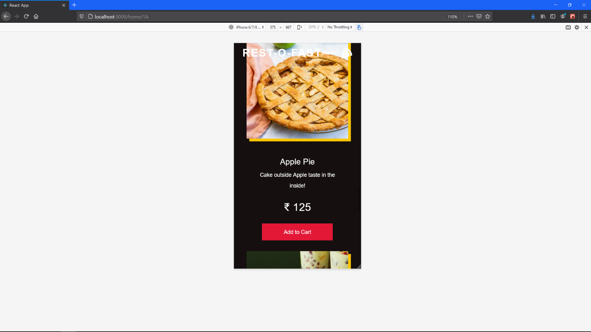

Responsive (7)

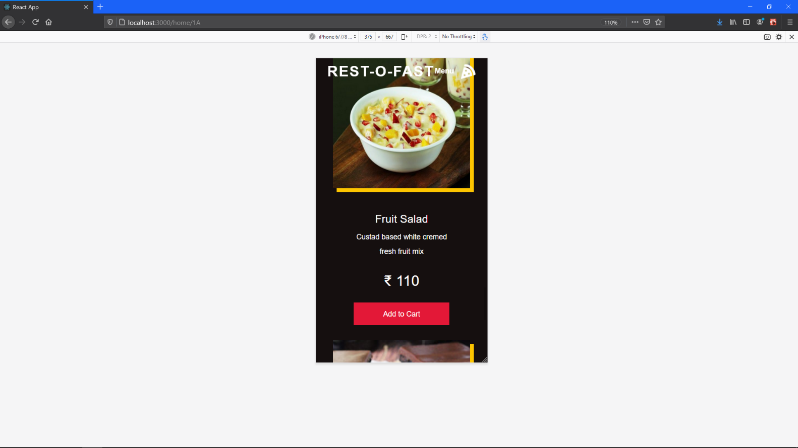

Responsive (8)

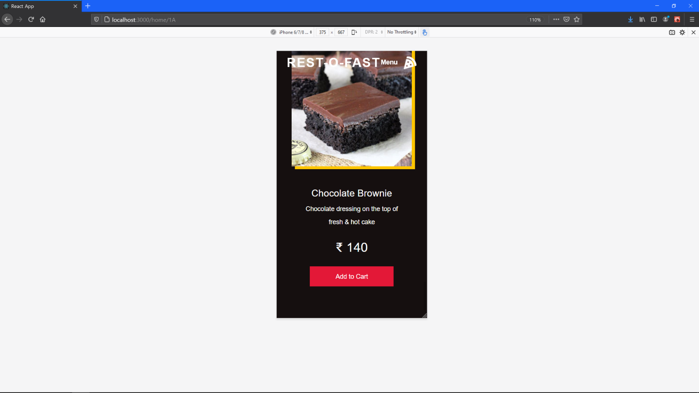

Responsive (9)

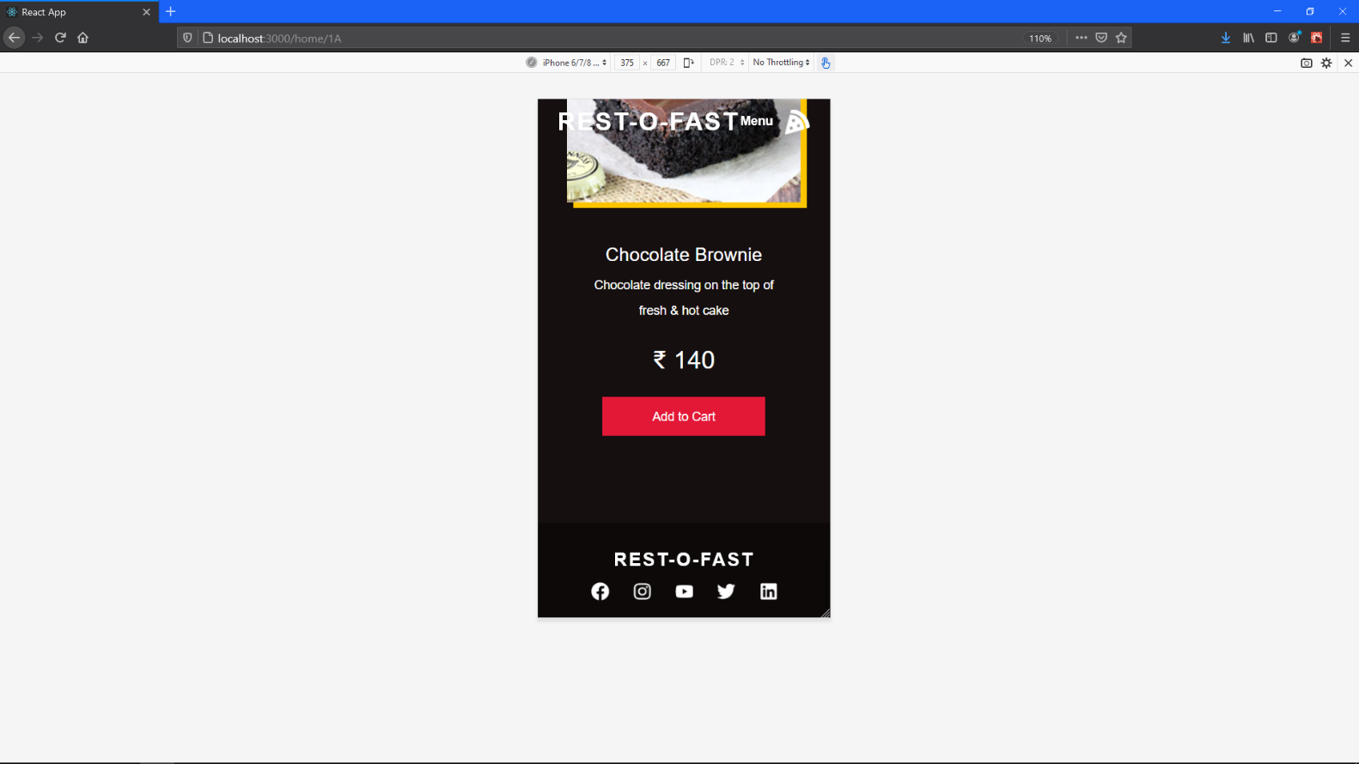

Responsive (10)

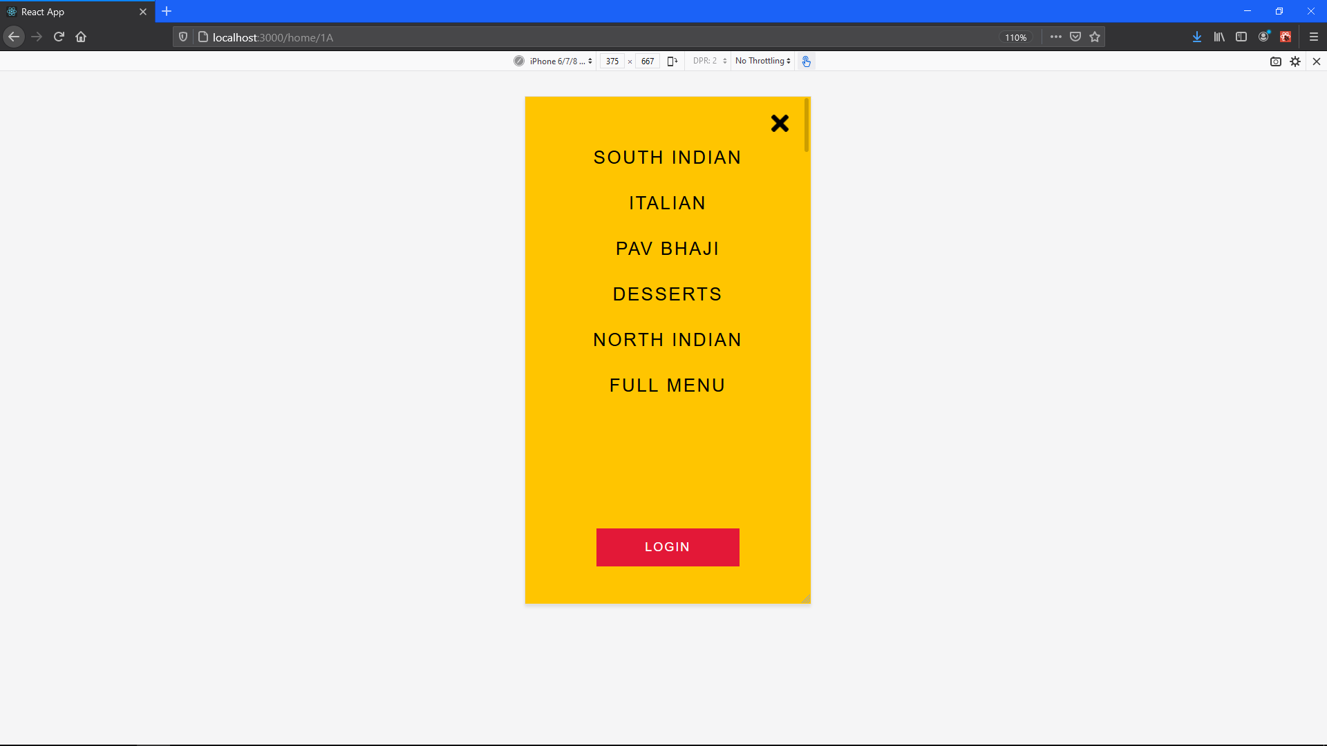

Responsive (11)

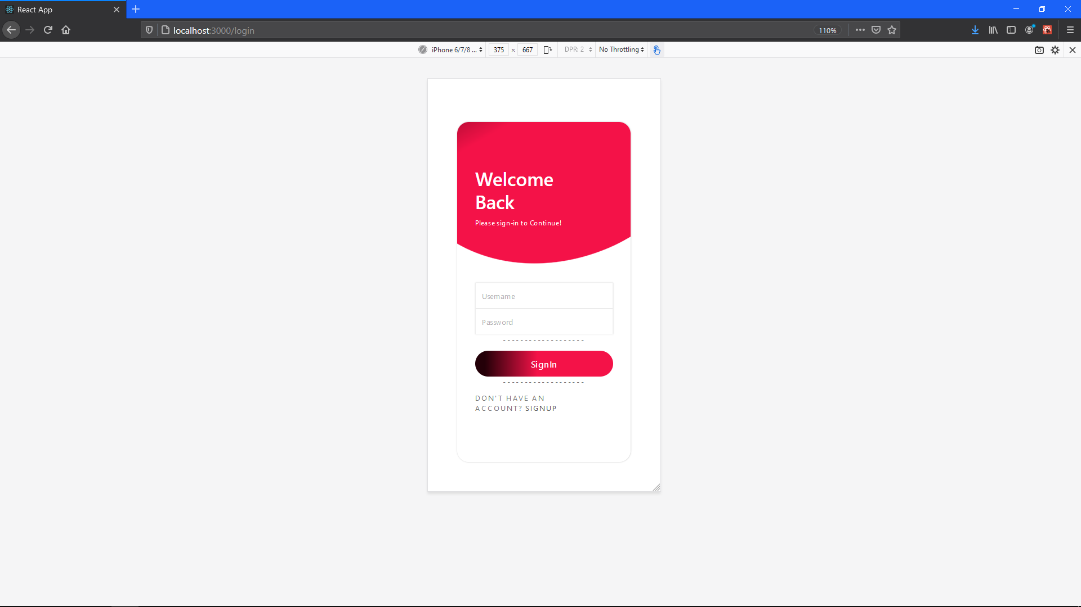

Responsive (12) Login Screen

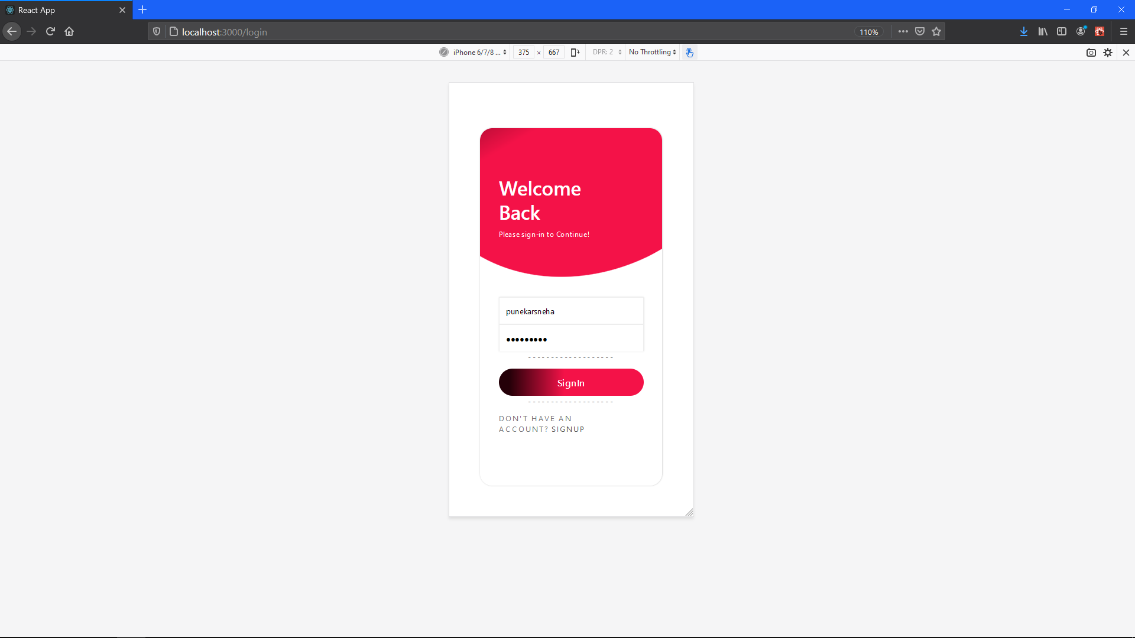

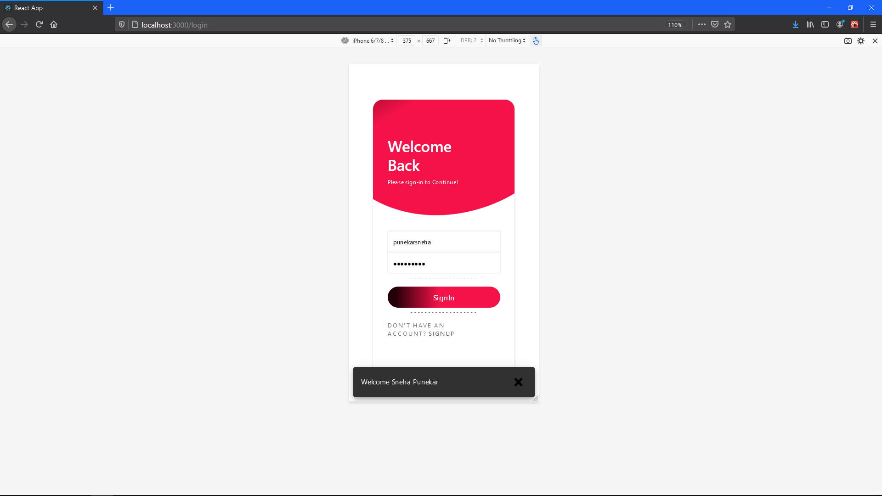 Responsive (13) Login Screen

Responsive (13) Login Screen

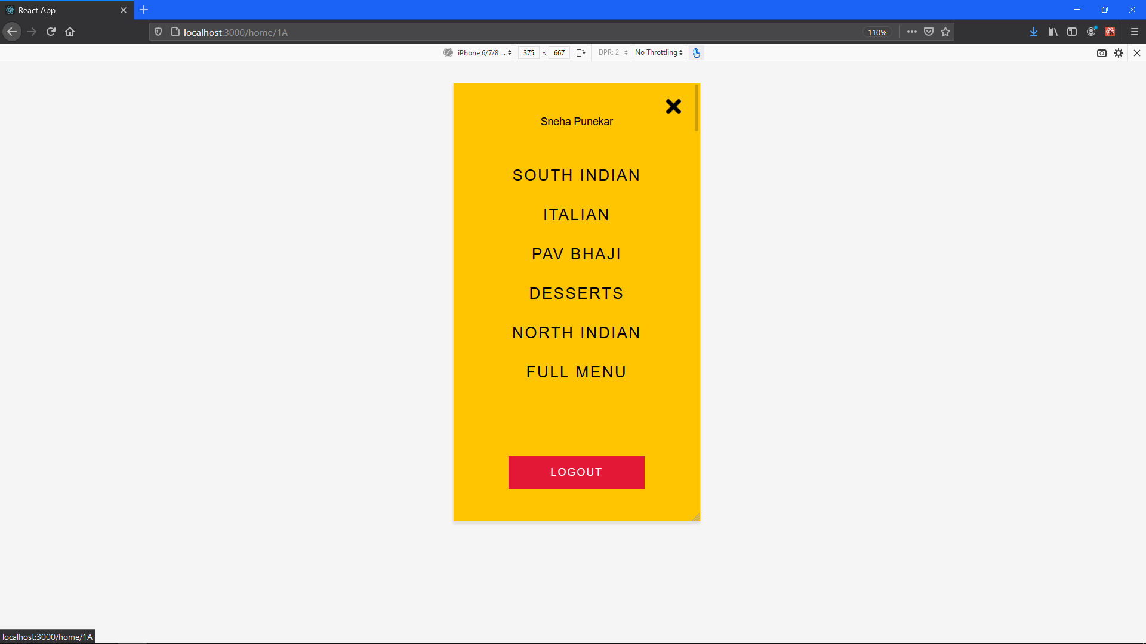

Responsive (14) Logged in Status

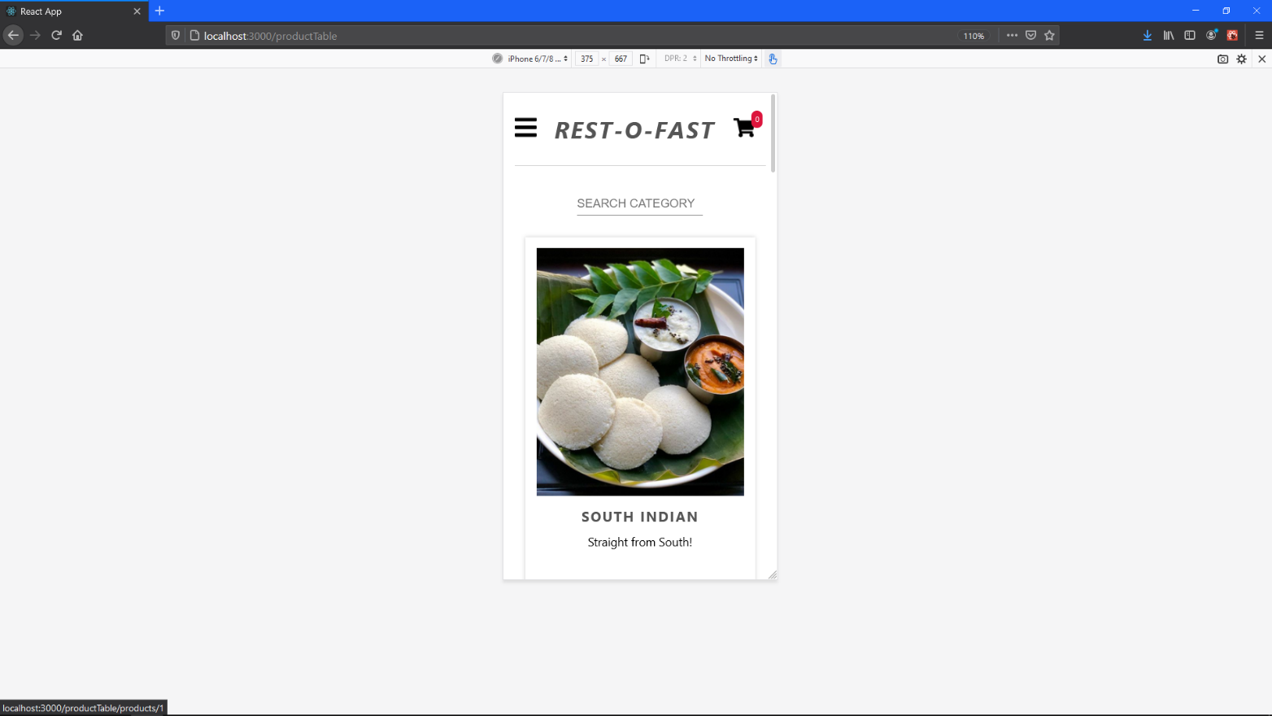

Responsive (15) Category Menu

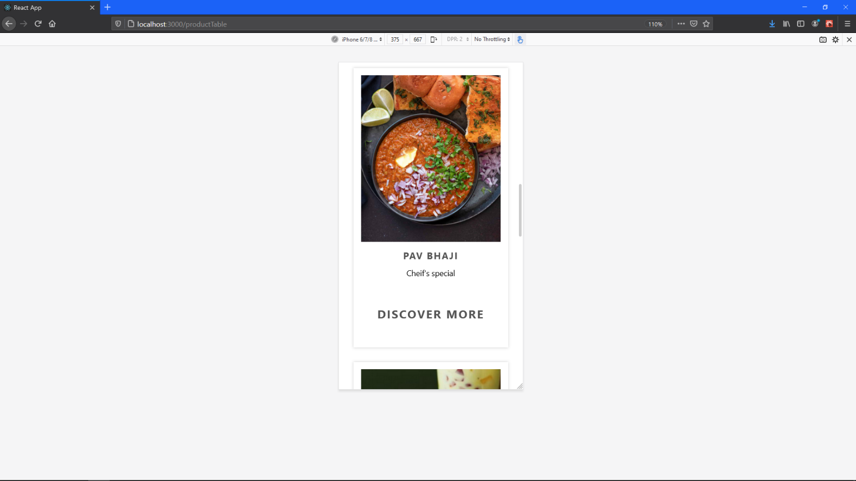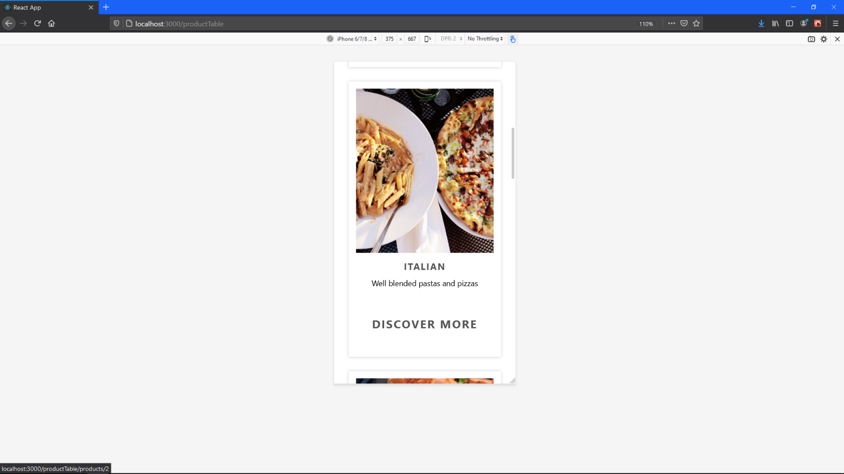

Responsive (16) Category Menu

Responsive (17) Category Menu

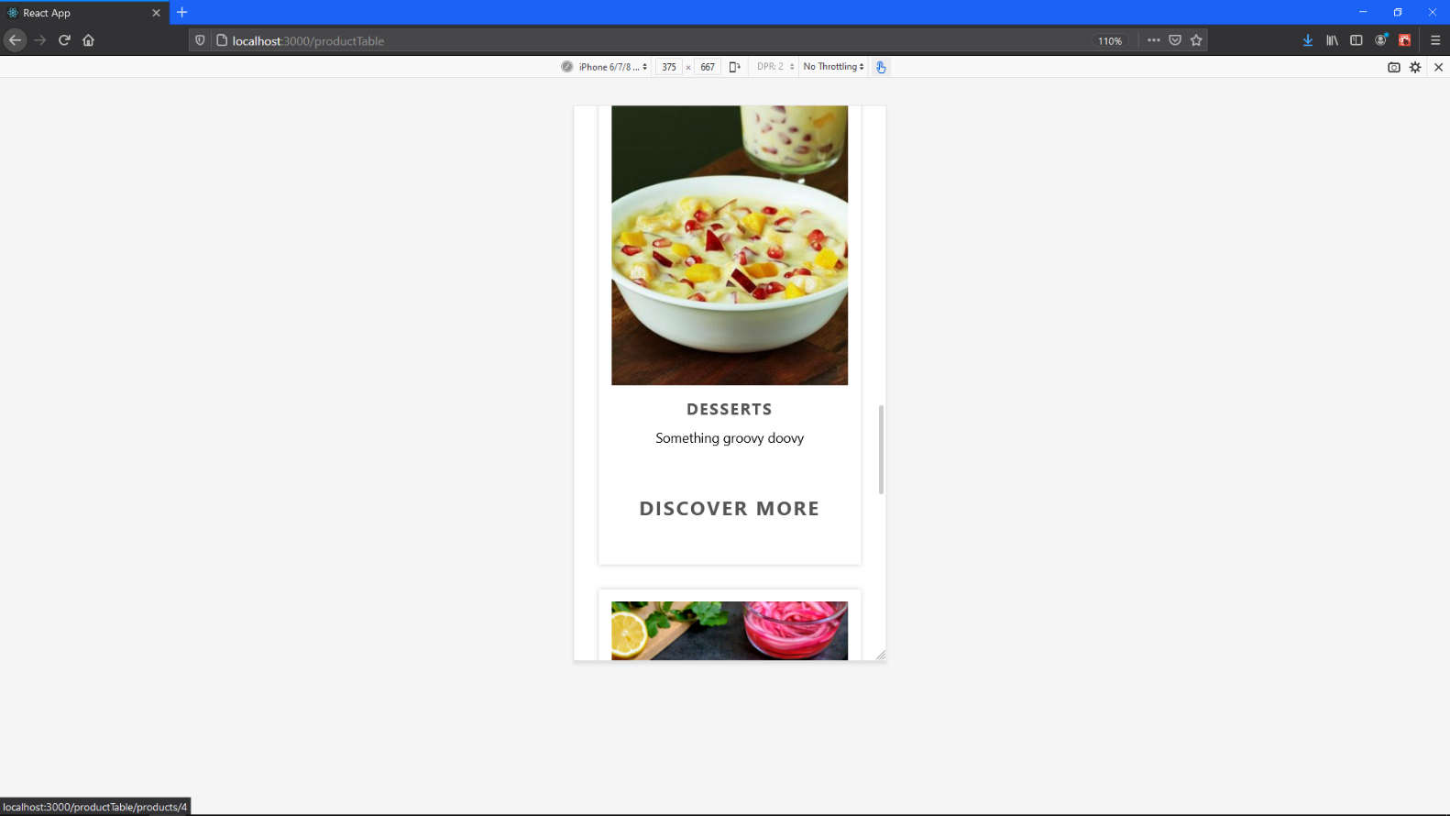

Responsive (18) Category Menu

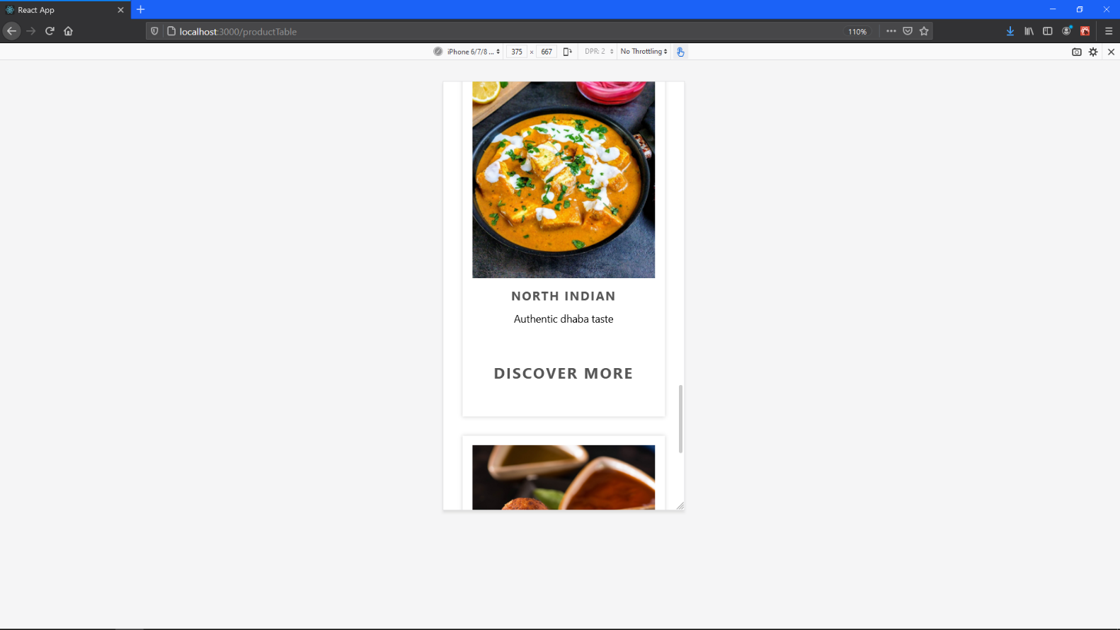

Responsive (19) Category Menu

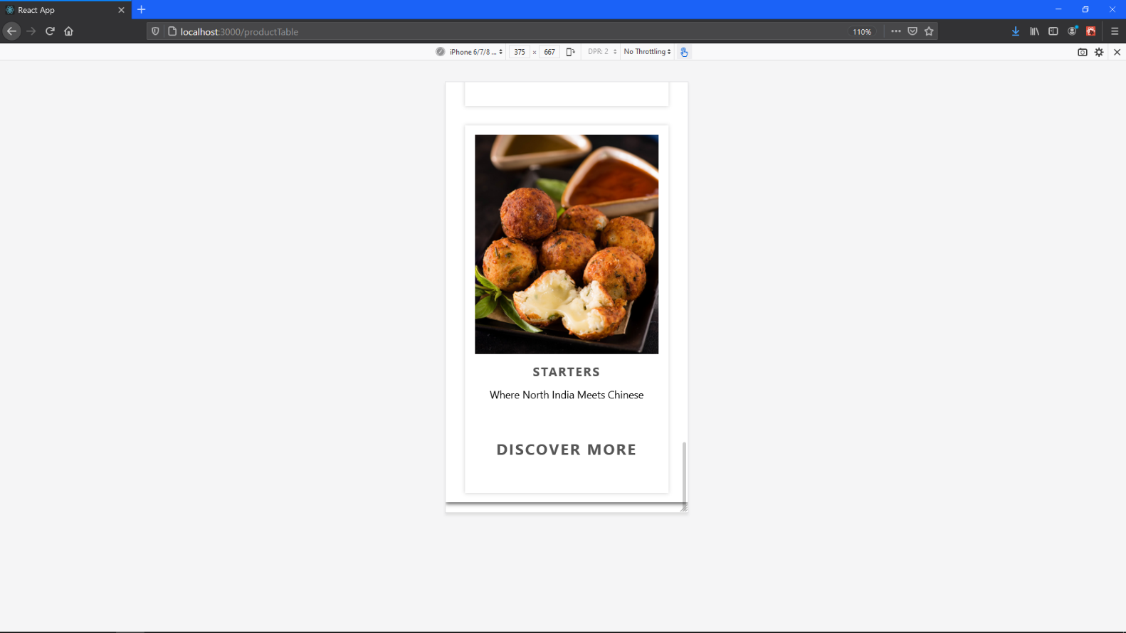

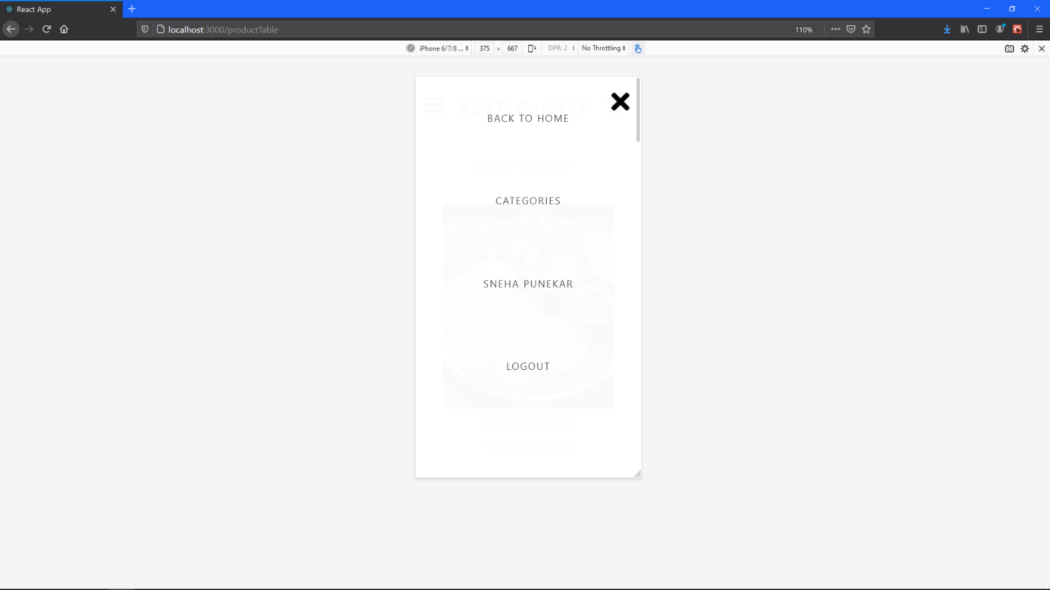

Responsive (20) Category Menu

Responsive (21) Menu

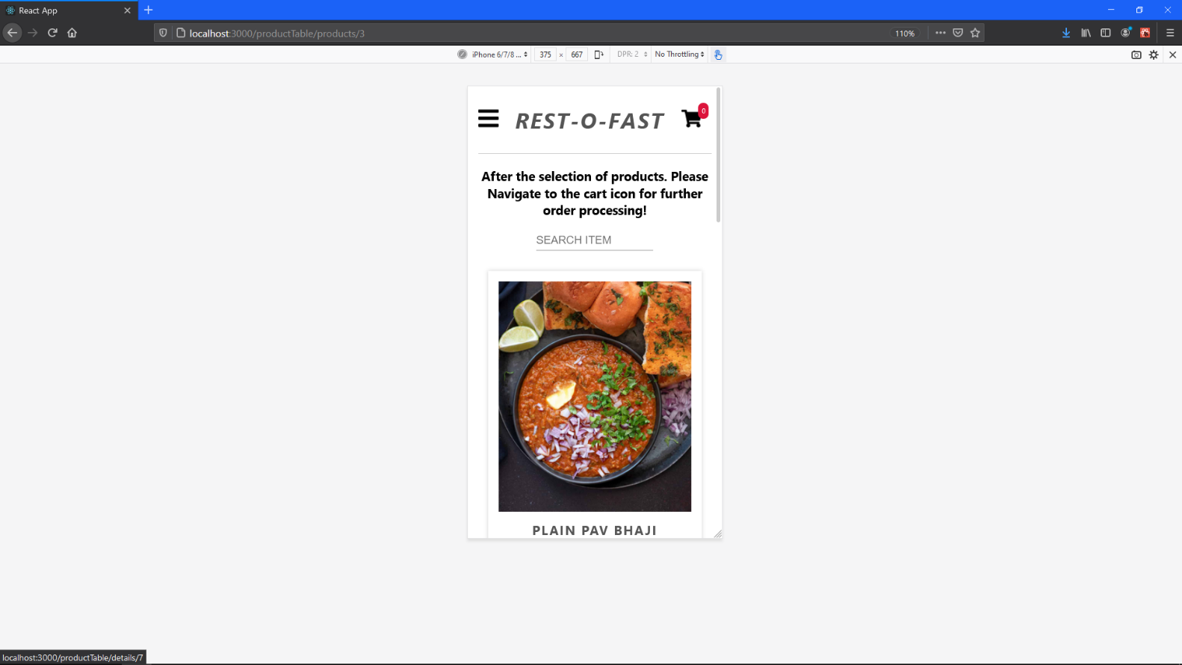

Responsive (22) Category Pav Bhaji Selected

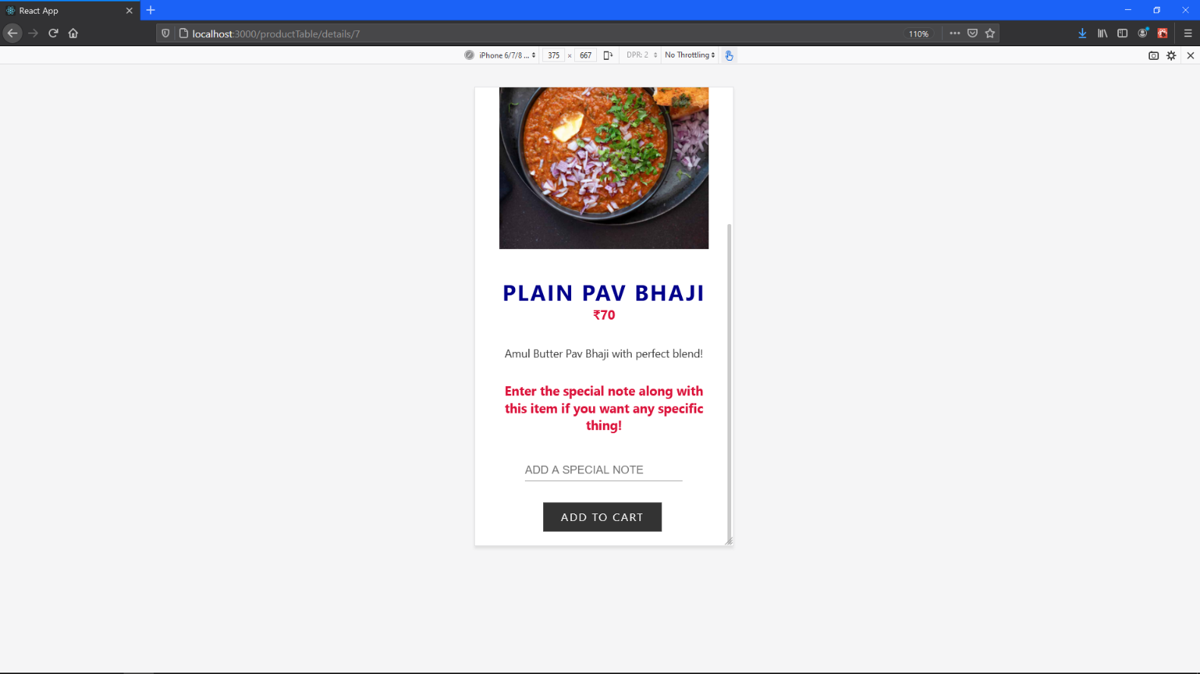

Responsive (23)

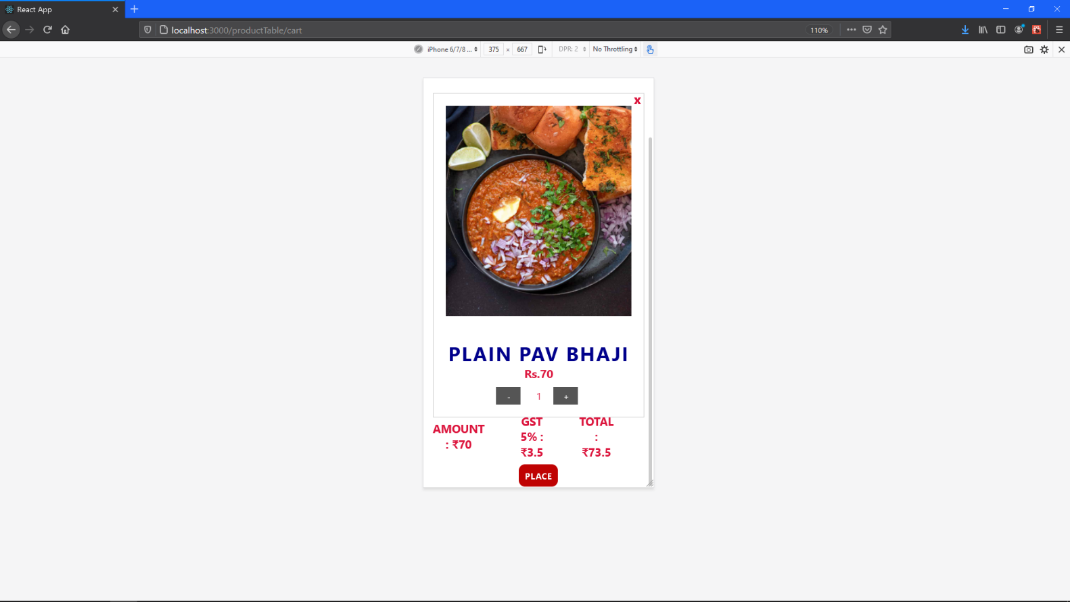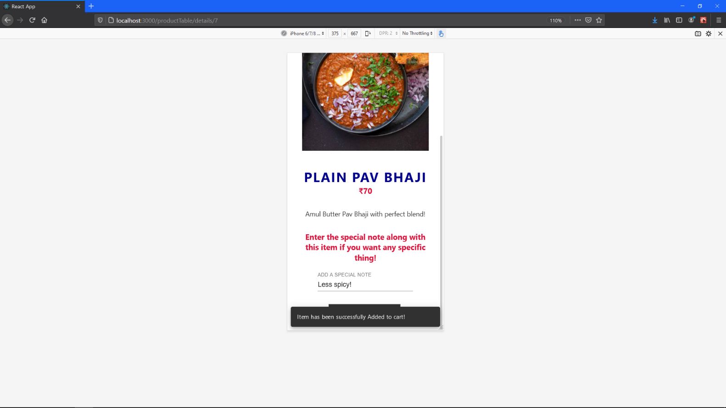

Responsive (24)

Responsive (25) GST and Total Amount

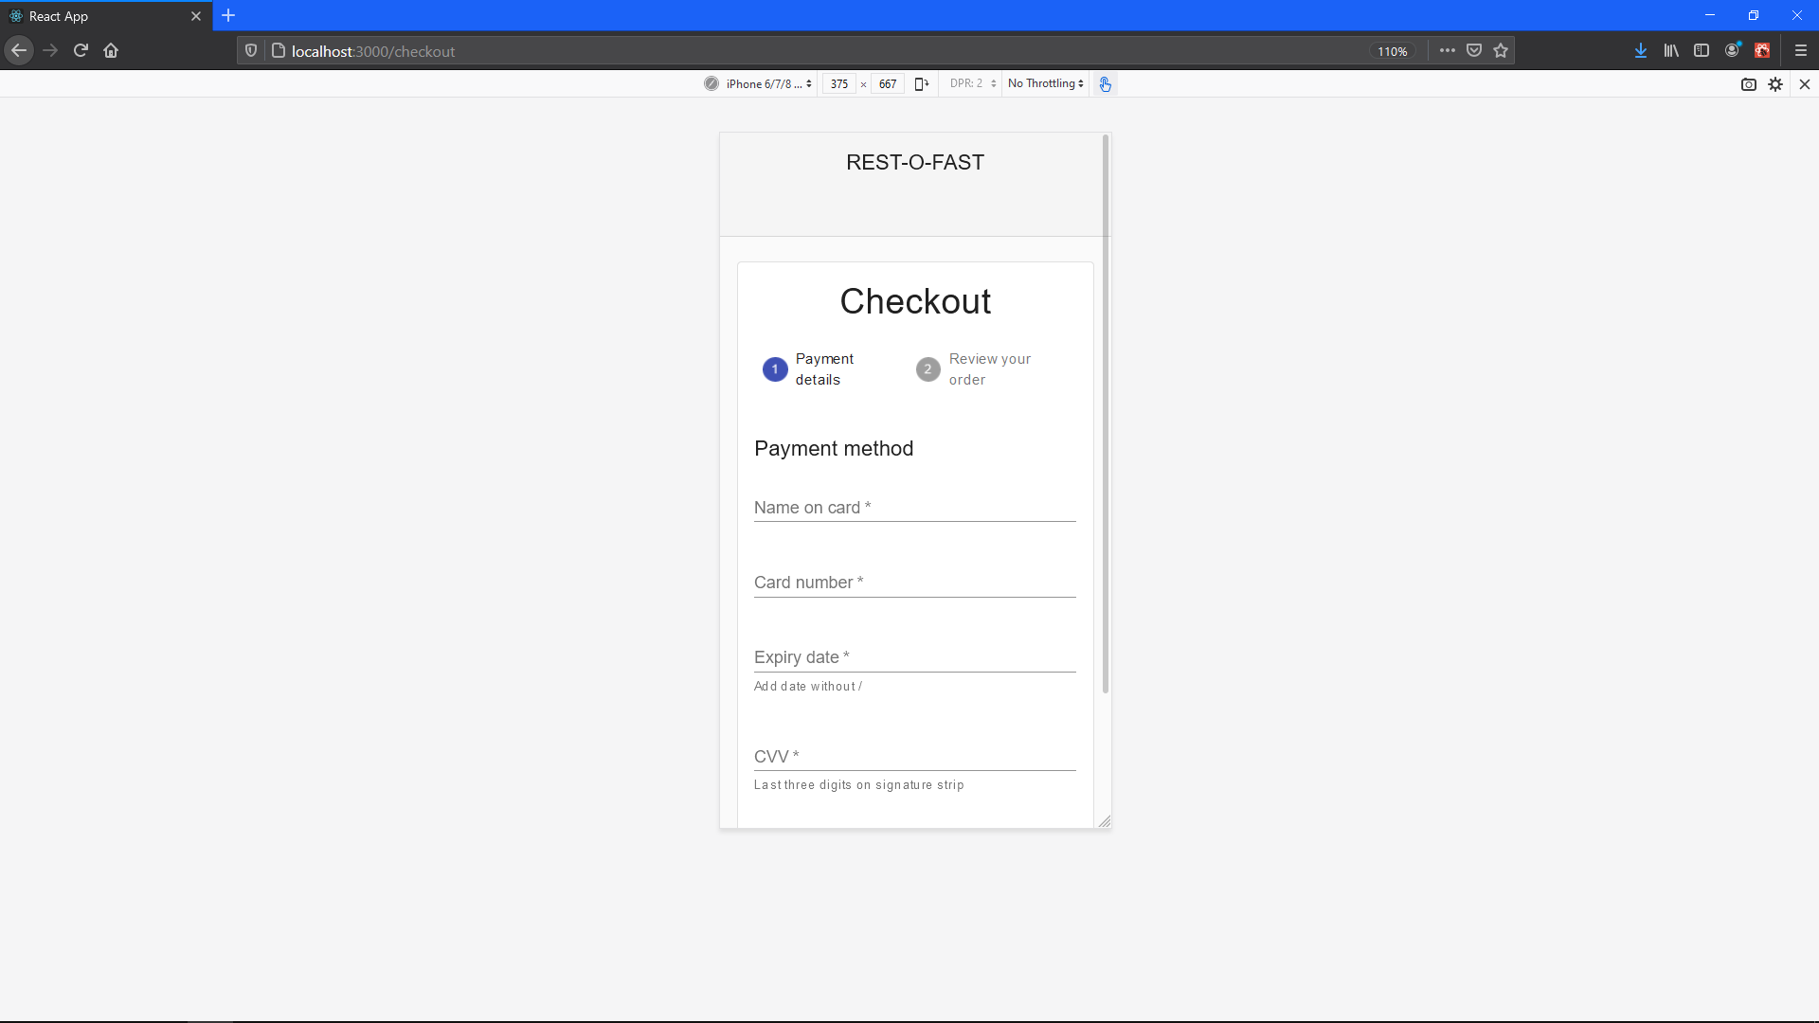

Responsive (26) Checkout Window

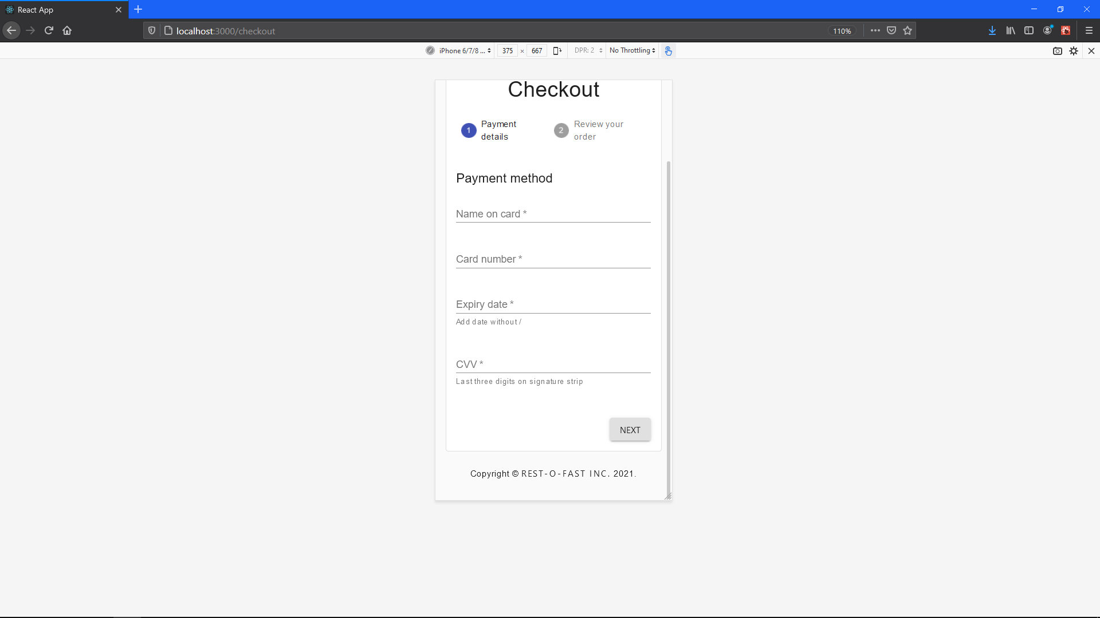

Responsive (27) Checkout Window

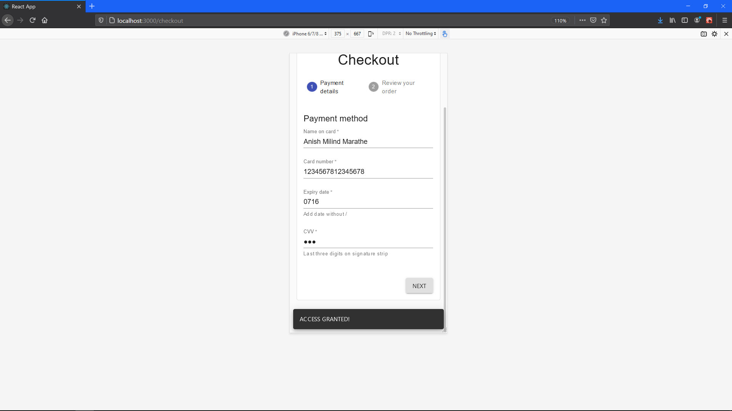

Responsive (28) Checkout Window

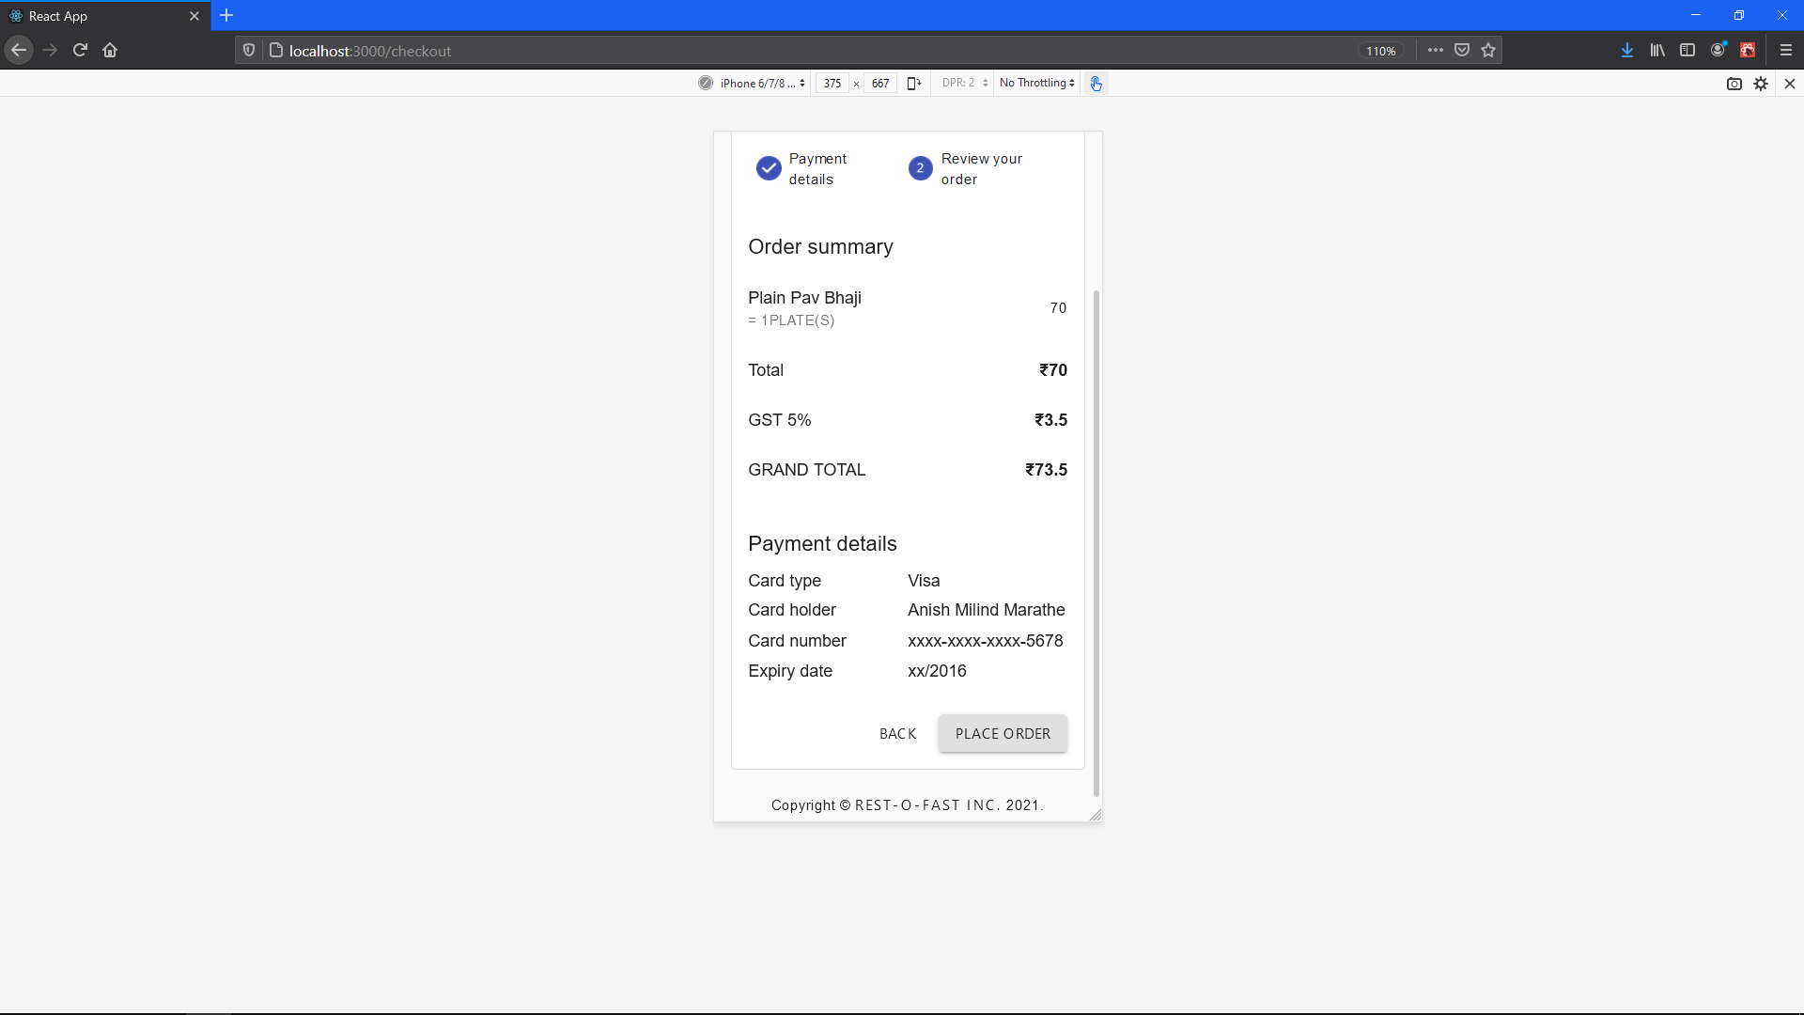

Responsive (29) Order Summery

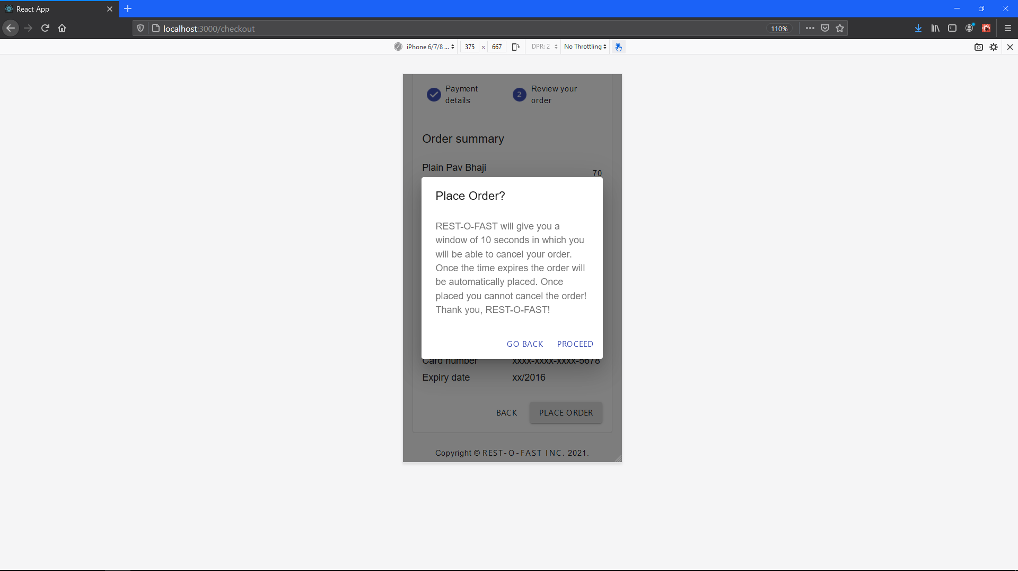

Responsive (30)

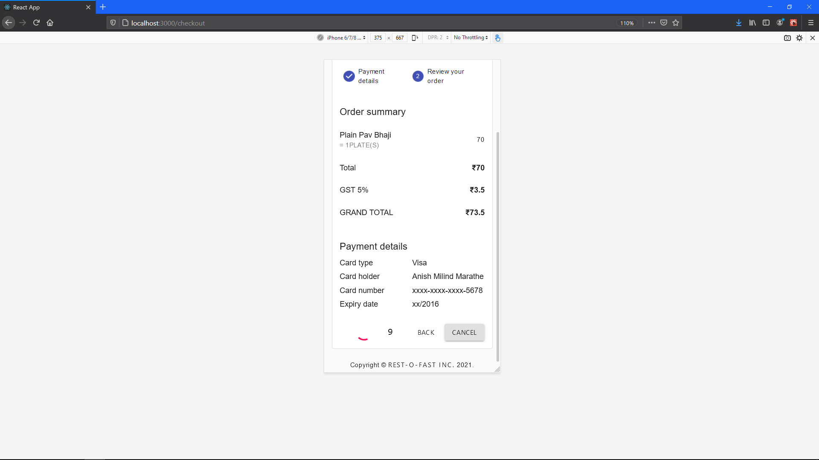

Responsive (31)

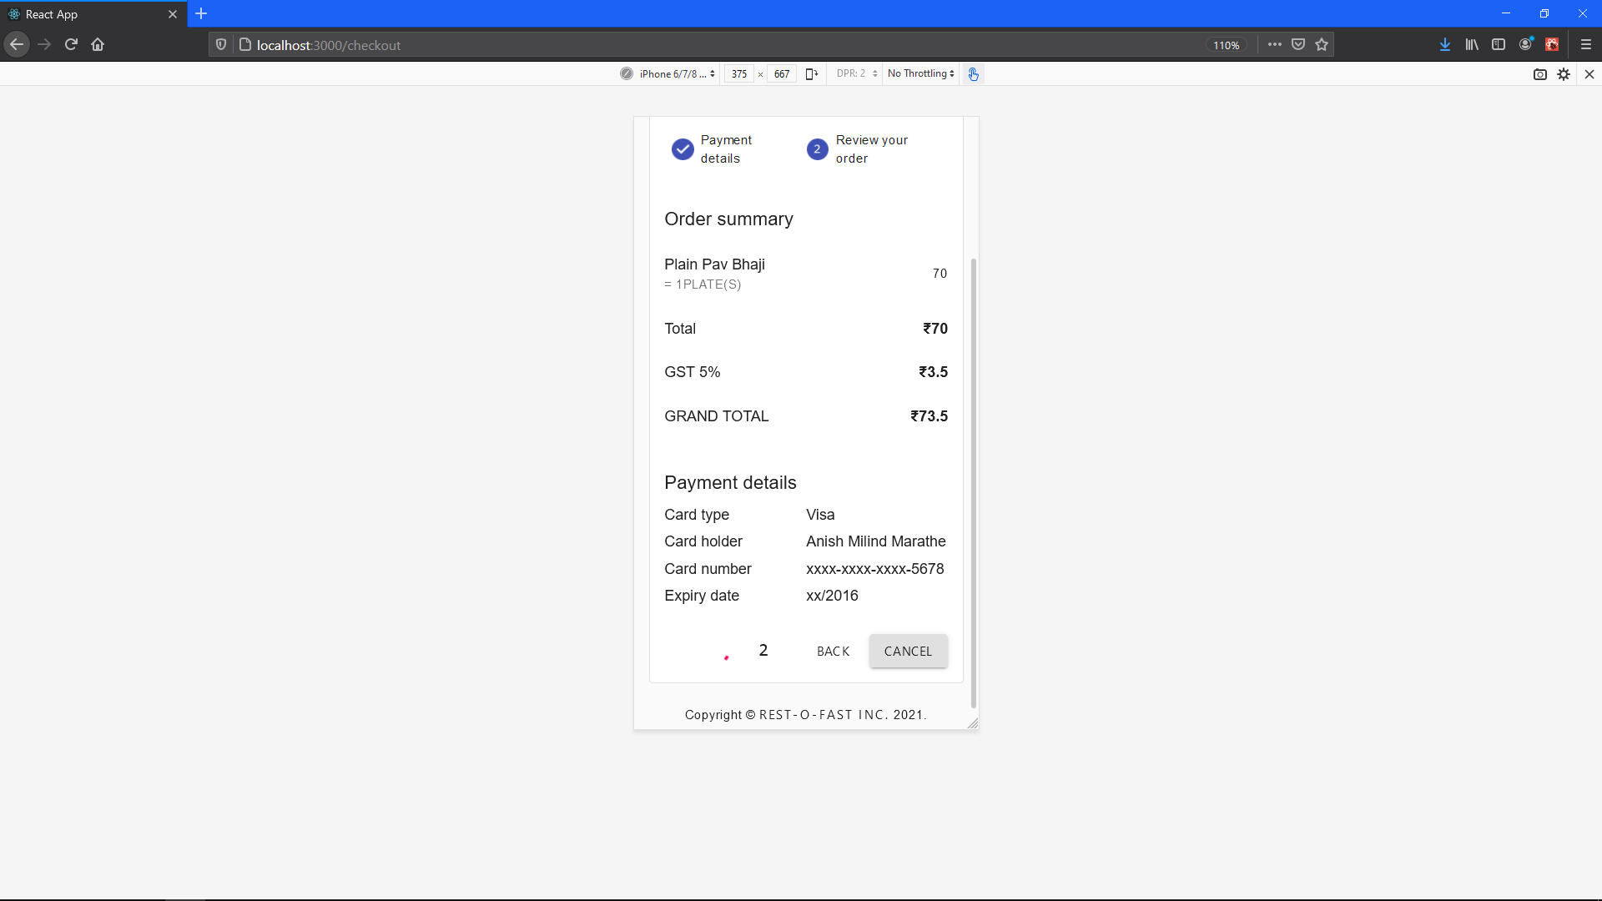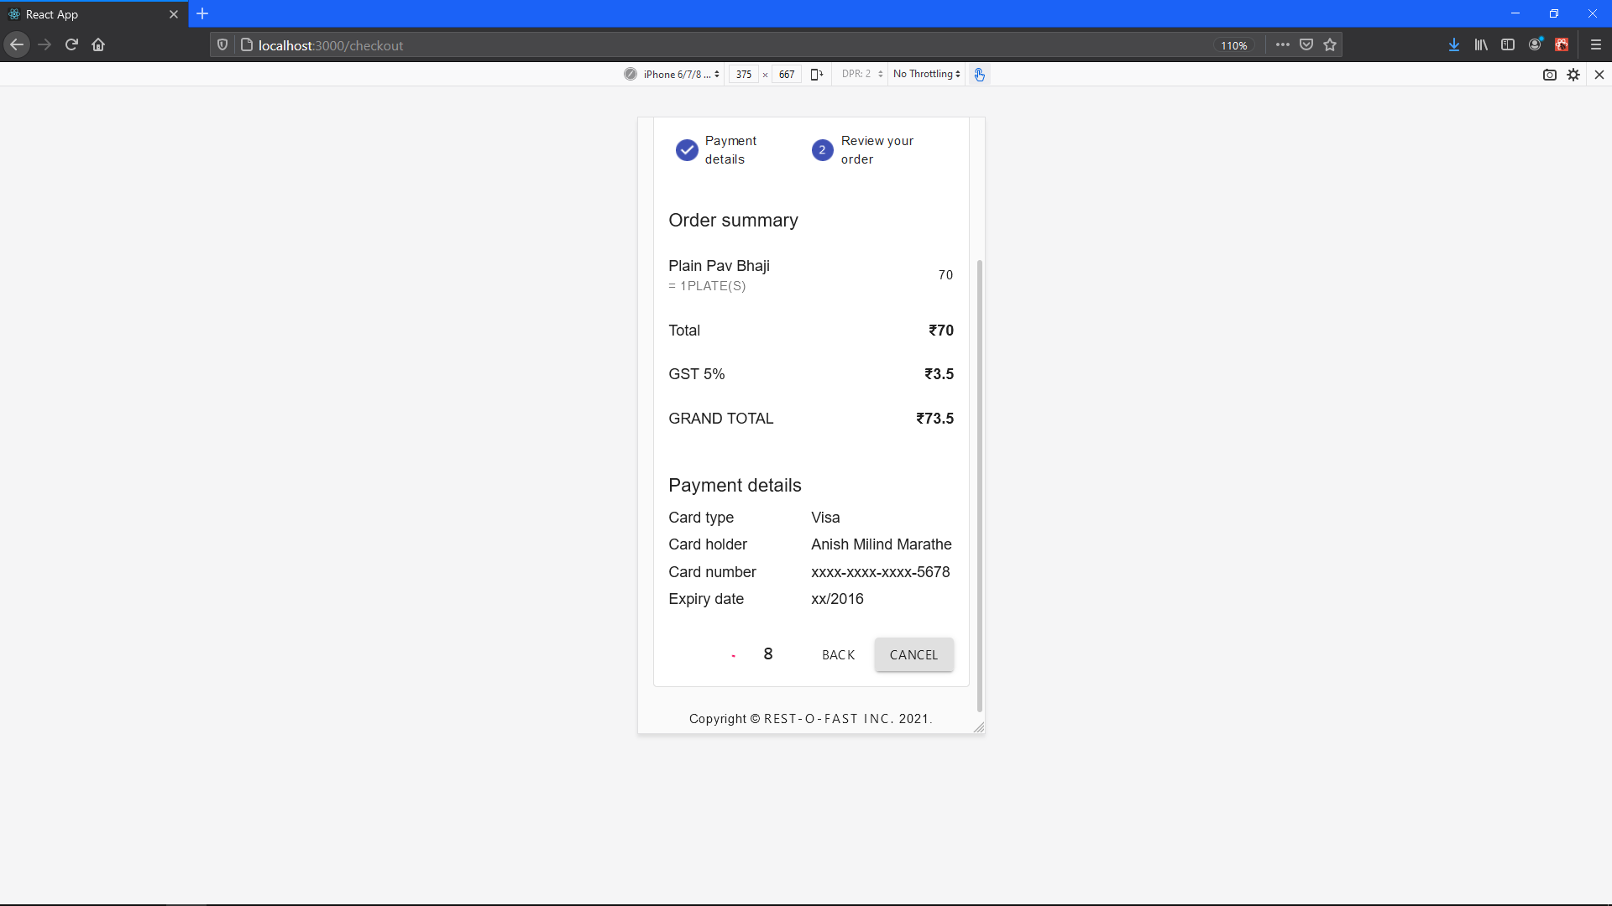

Responsive (32)

Responsive (33)

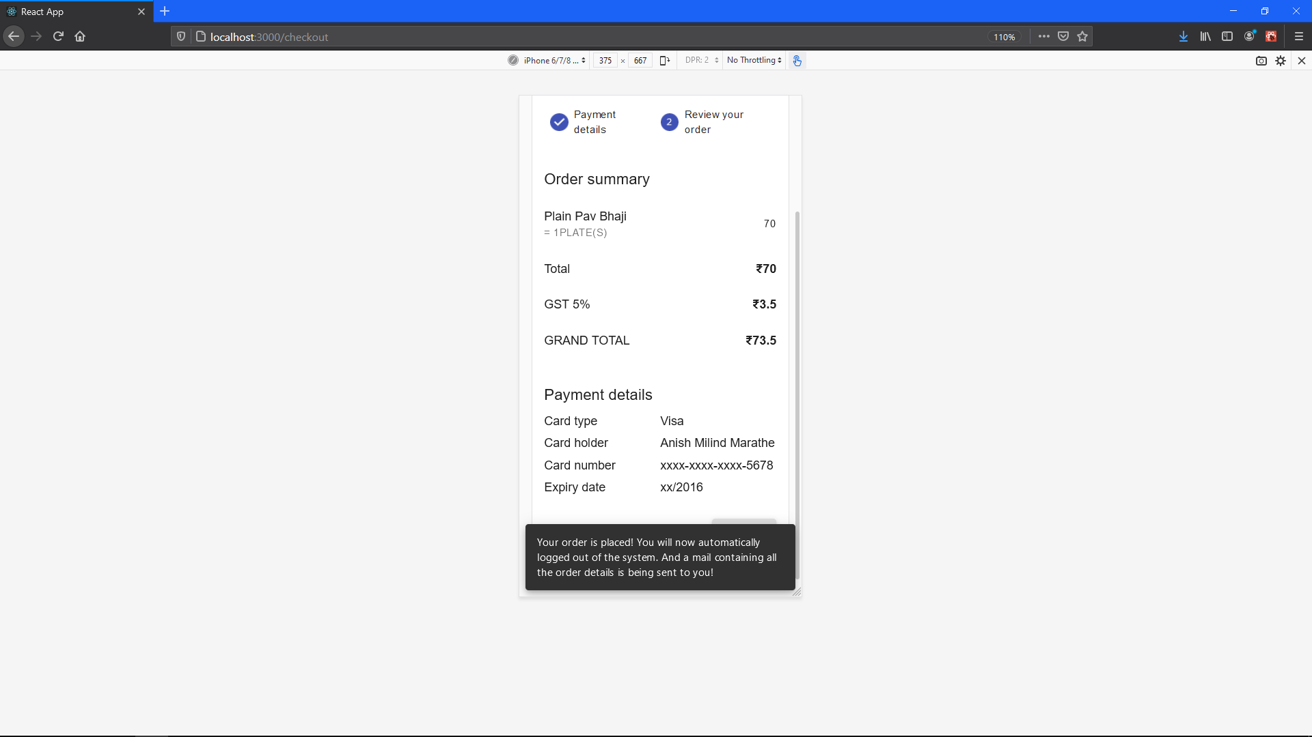

 Responsive (34)

Responsive (35) Back to home page

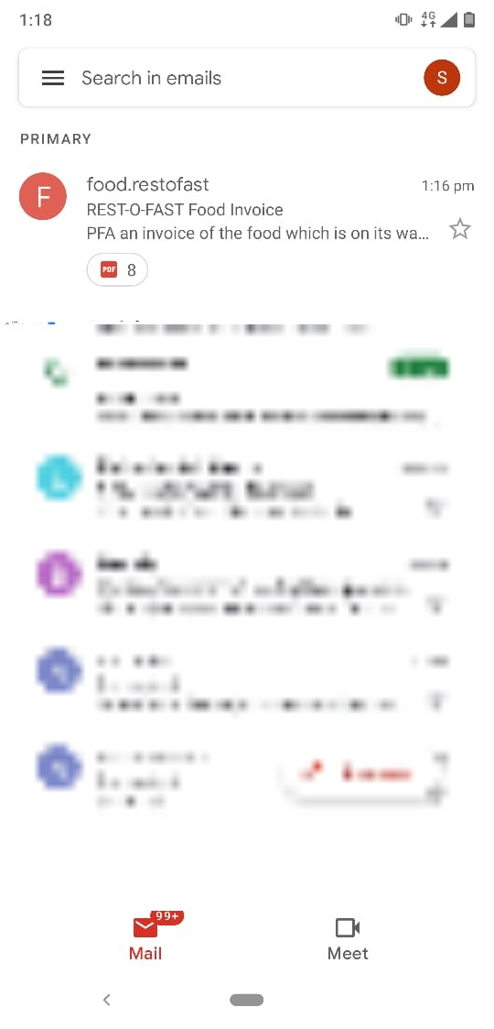

Invoice mail received on a smart phone!

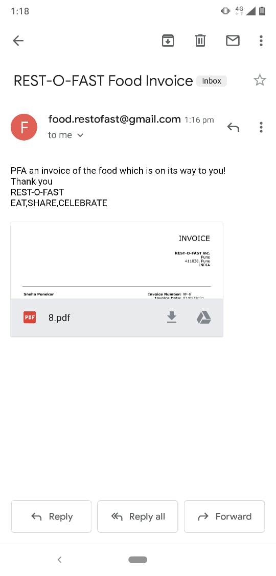

Email Contents

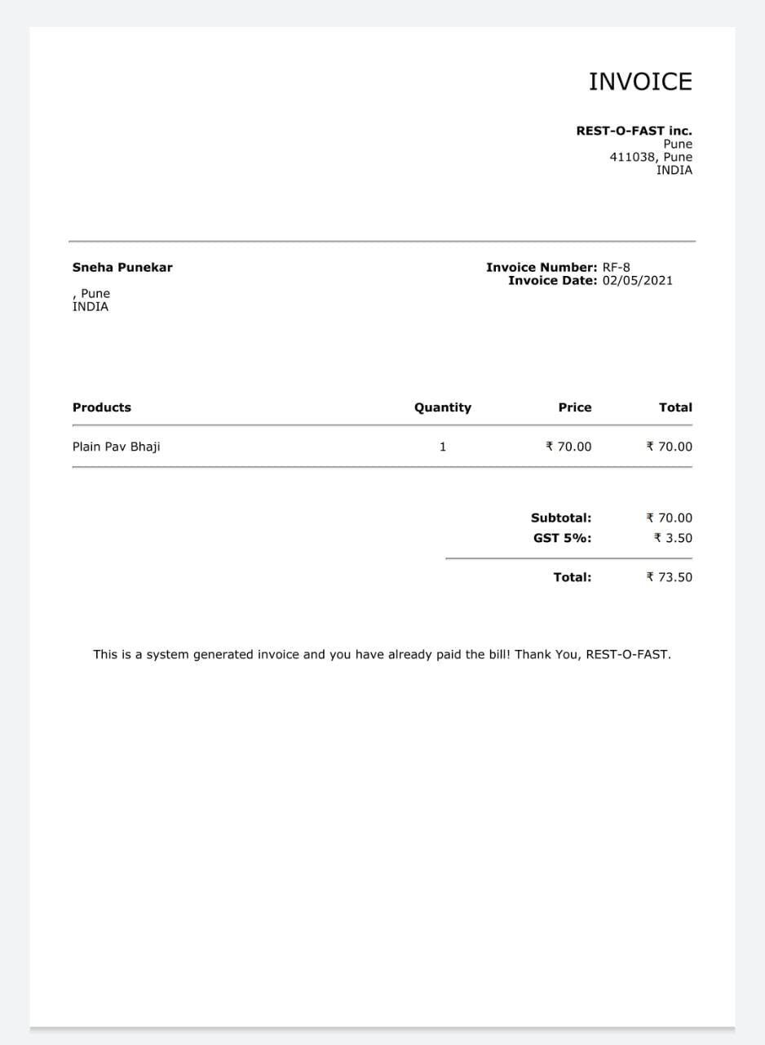

Invoice in pdf form



Each QR code represents a seat. E.g., Table Number 1 has A and B seats, so above 2 QR codes are table number 1A and 1B respectively! And below mentioned are the two codes 2A and 2B respectively!